Mia Watts April 23, 2024

**MATLAB**



**MATLAB Tutorial Report**

In learning about MATLAB and how it works, I used the MATLAB Onramp tutorial shell. The tutorial can be found by following this link:

* <https://matlabacademy.mathworks.com/details/matlab-onramp/gettingstarted>

I was able to complete the course by following tasks, starting first with simple math commands that were then printed within the console.

**Section 1**

**Task 1 – Multiply 3 * 5 in the Console**

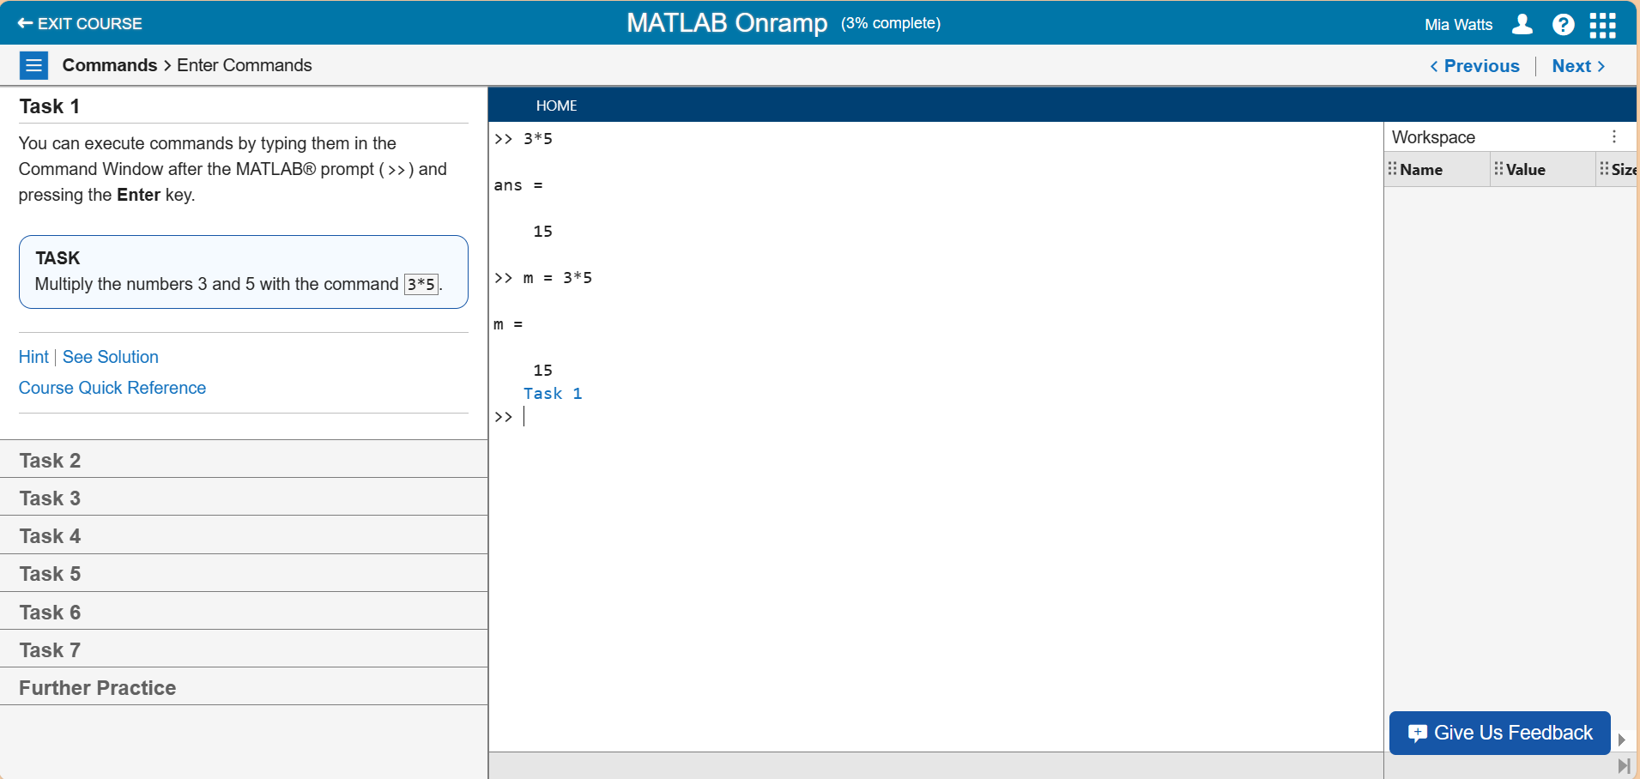

**Task 2 – Multiply 3 * 5 and Assign Result to a Variable**

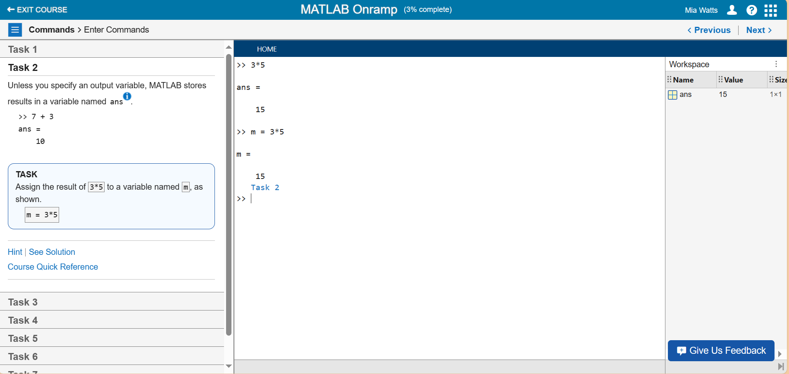

**Task 3 – Assigning Variable to Said Variable Added by One**

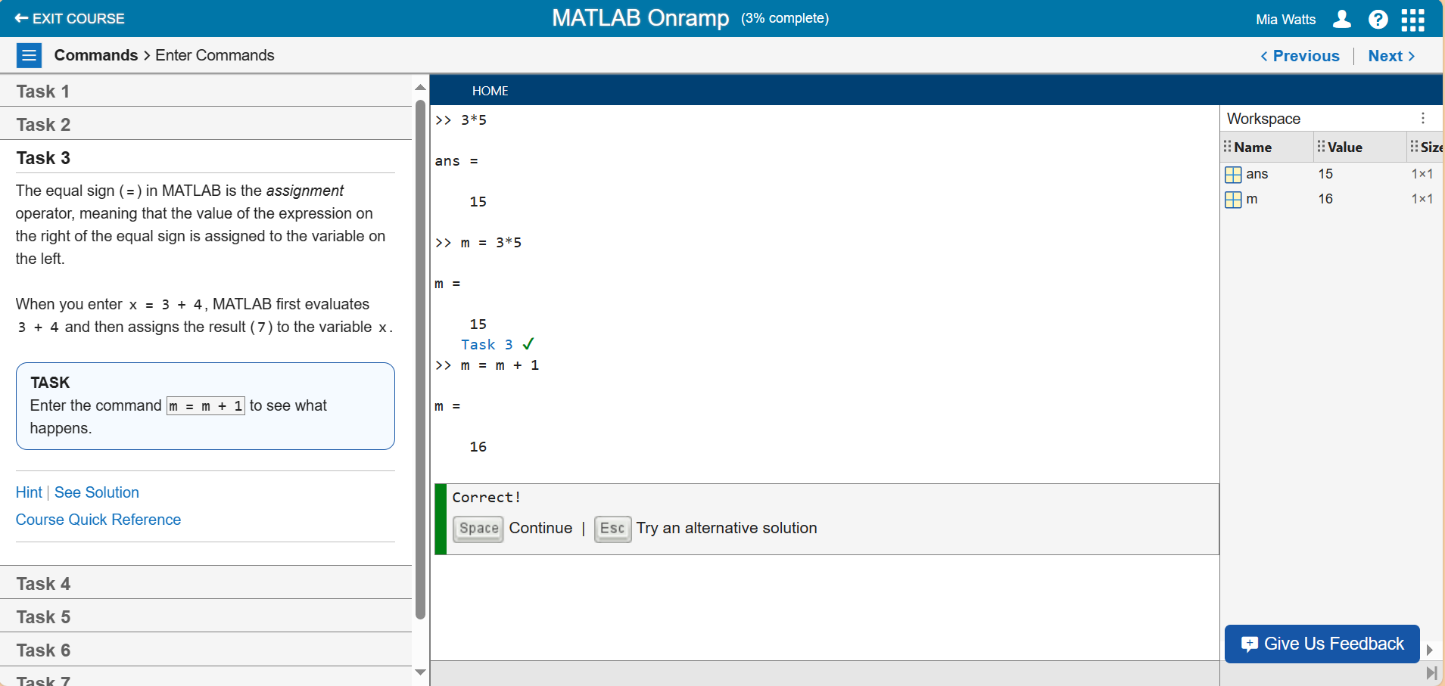

**Task 4 – Create a Variable Named “y” Equal to “m/2”**

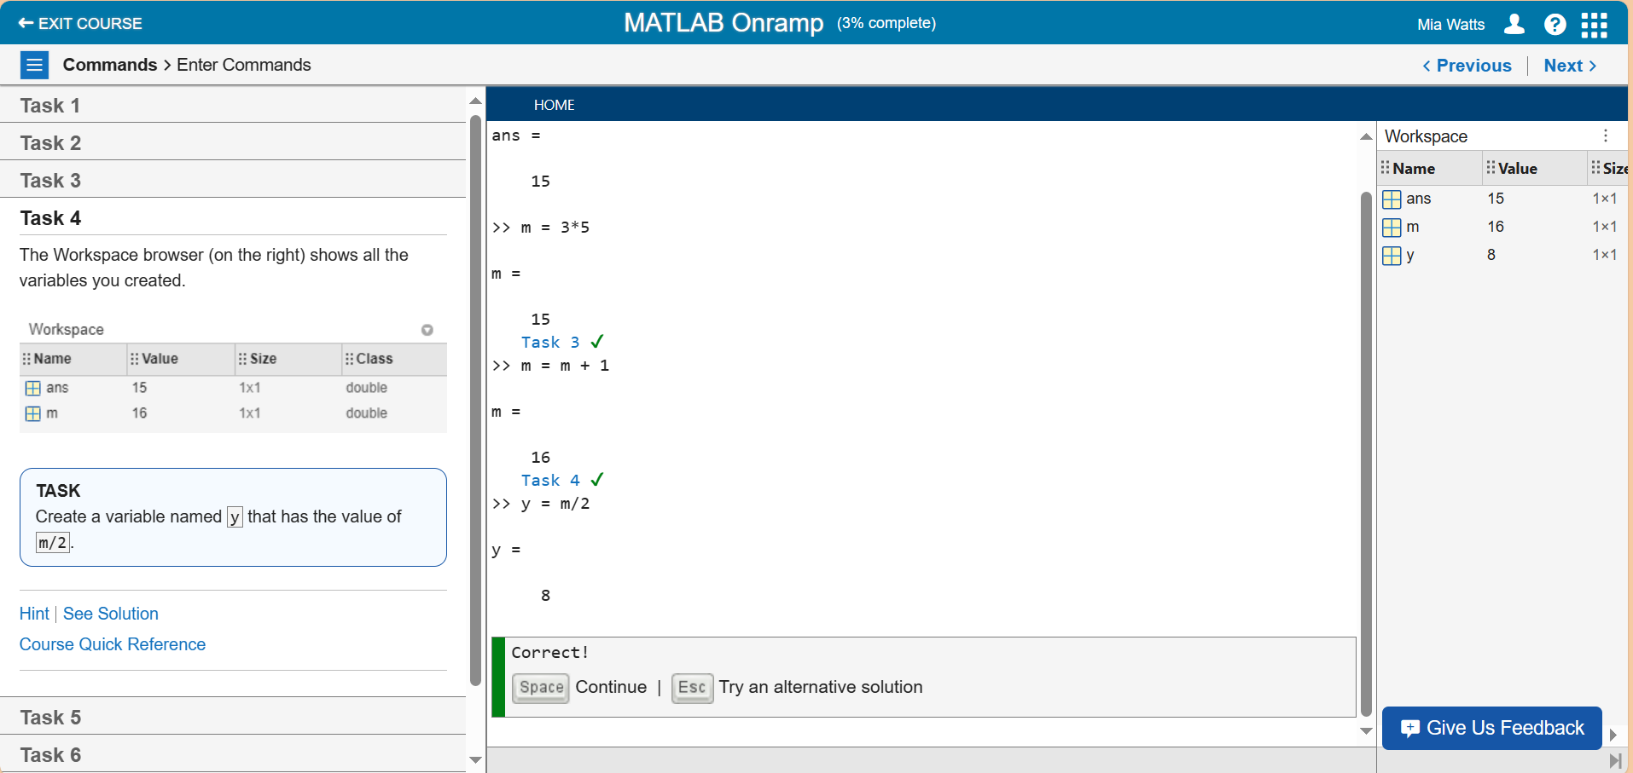

**Task 5 – Practiced Entering a Semicolon Command**

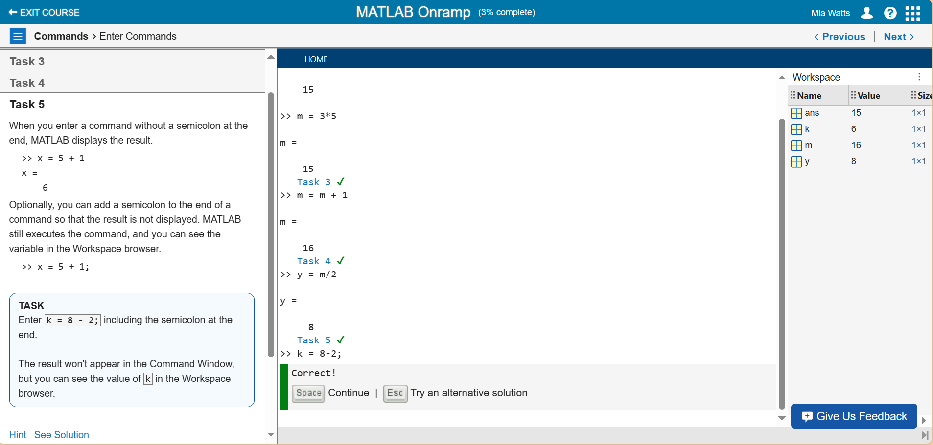

**Task 6 – Pressing the Up Arrow to Navigate to a Previous Command**

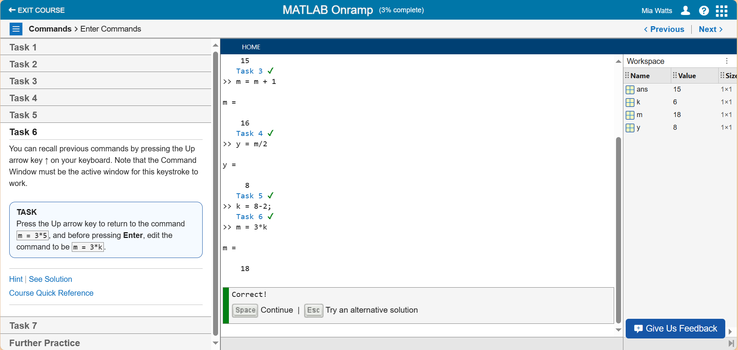

**Task 7 – Entering the Name of a Variable to View Results**

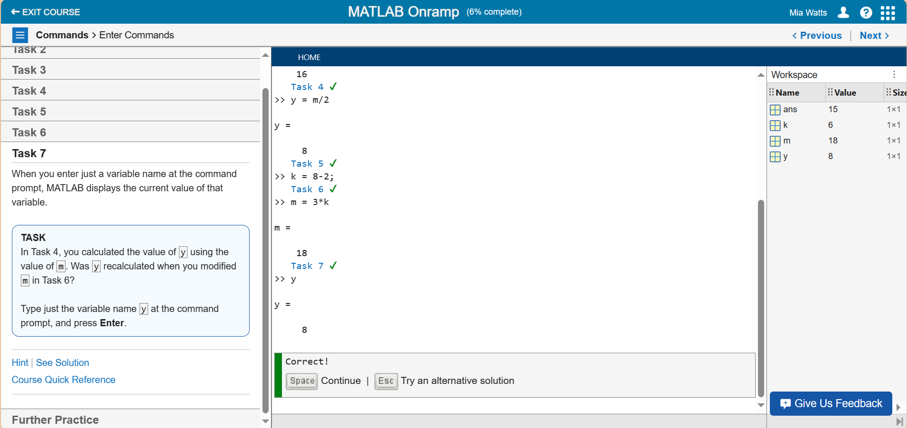

**Further Practice**

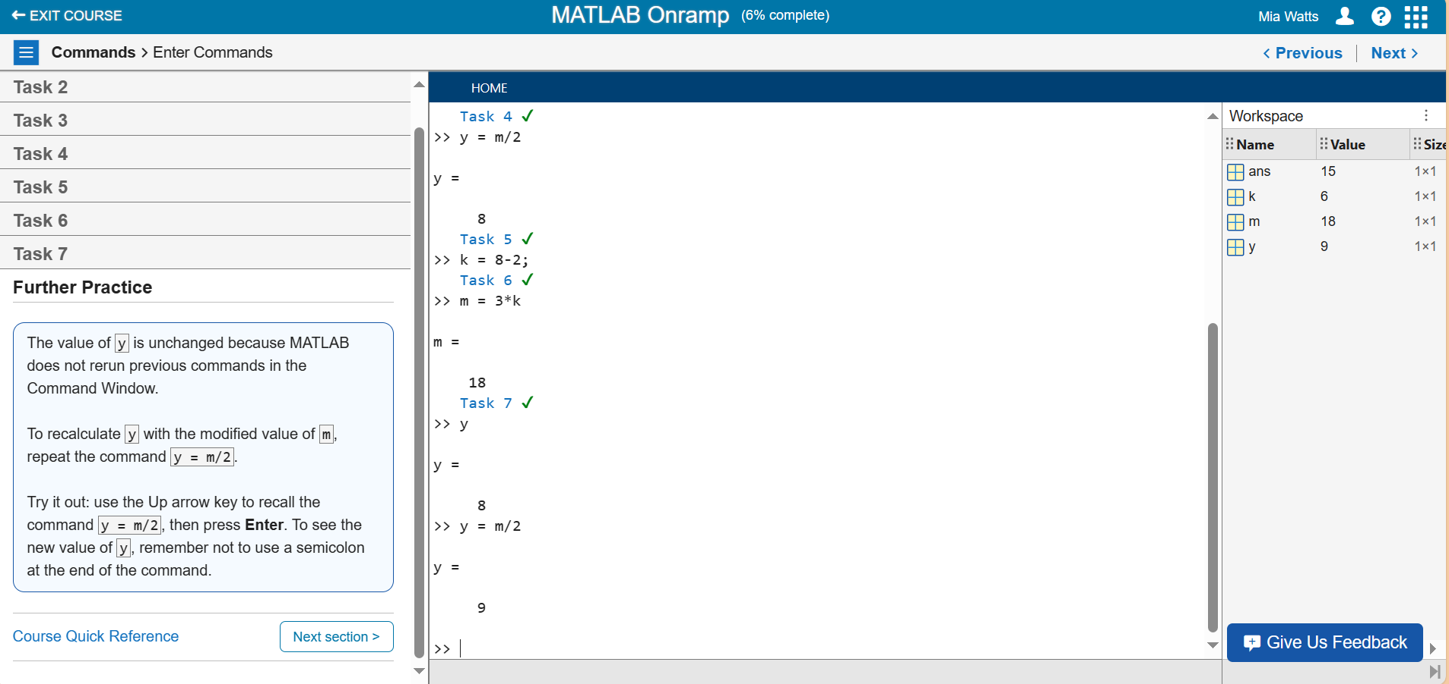

**Section 2**

**Task 1 – Create a Variable with a Negative Value**

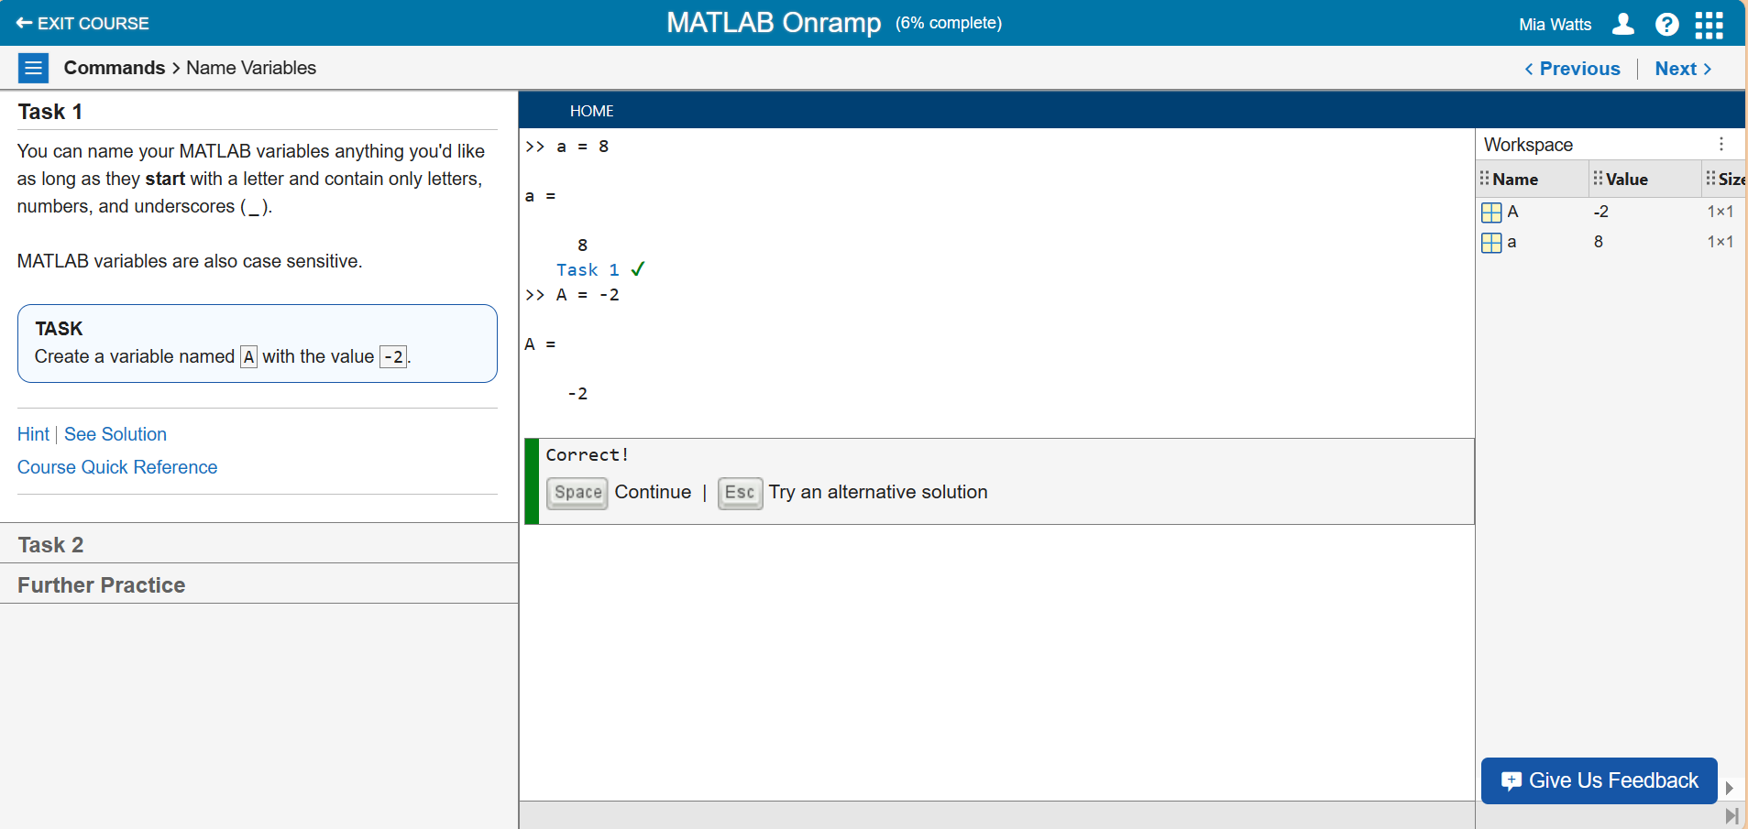

**Task 2 – Calculating the Mean**

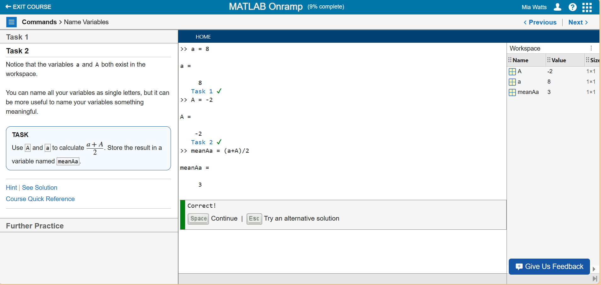

**Further Practice**

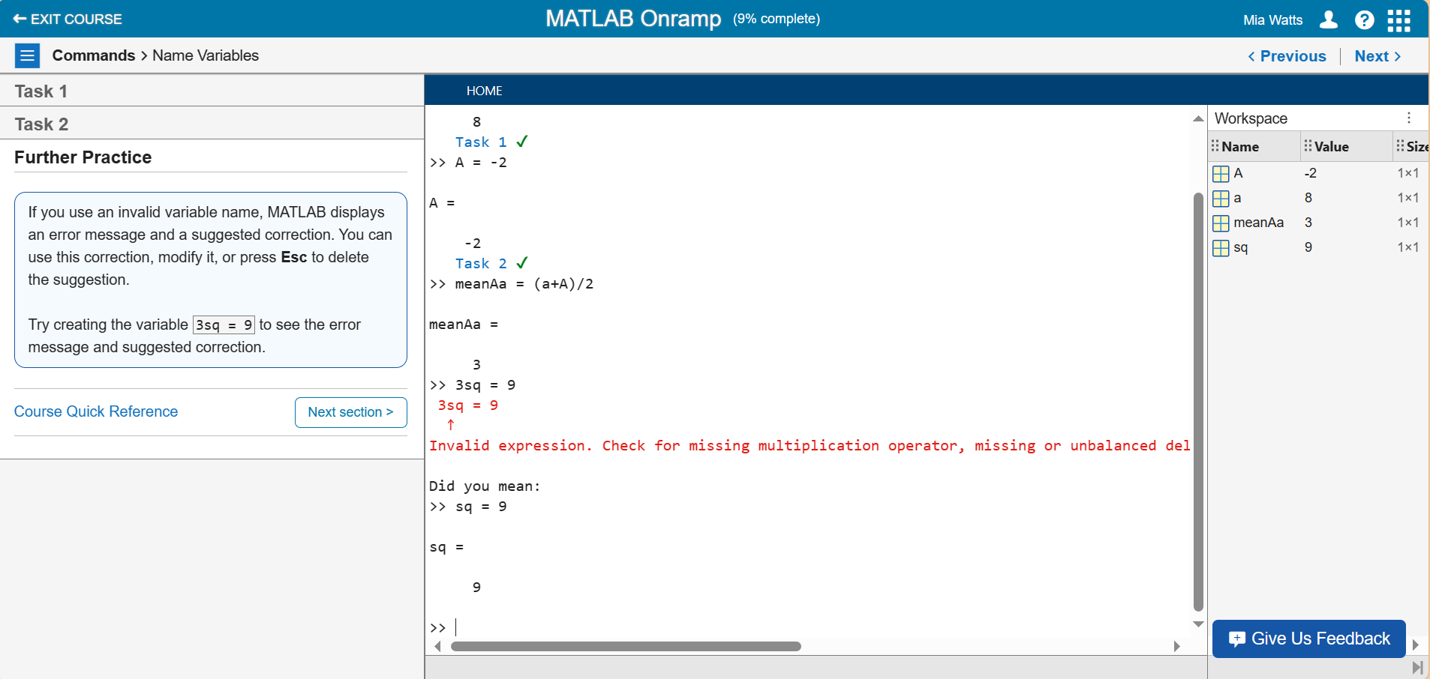

**Section 3**

**Task 1 – Saving Variables in a File**

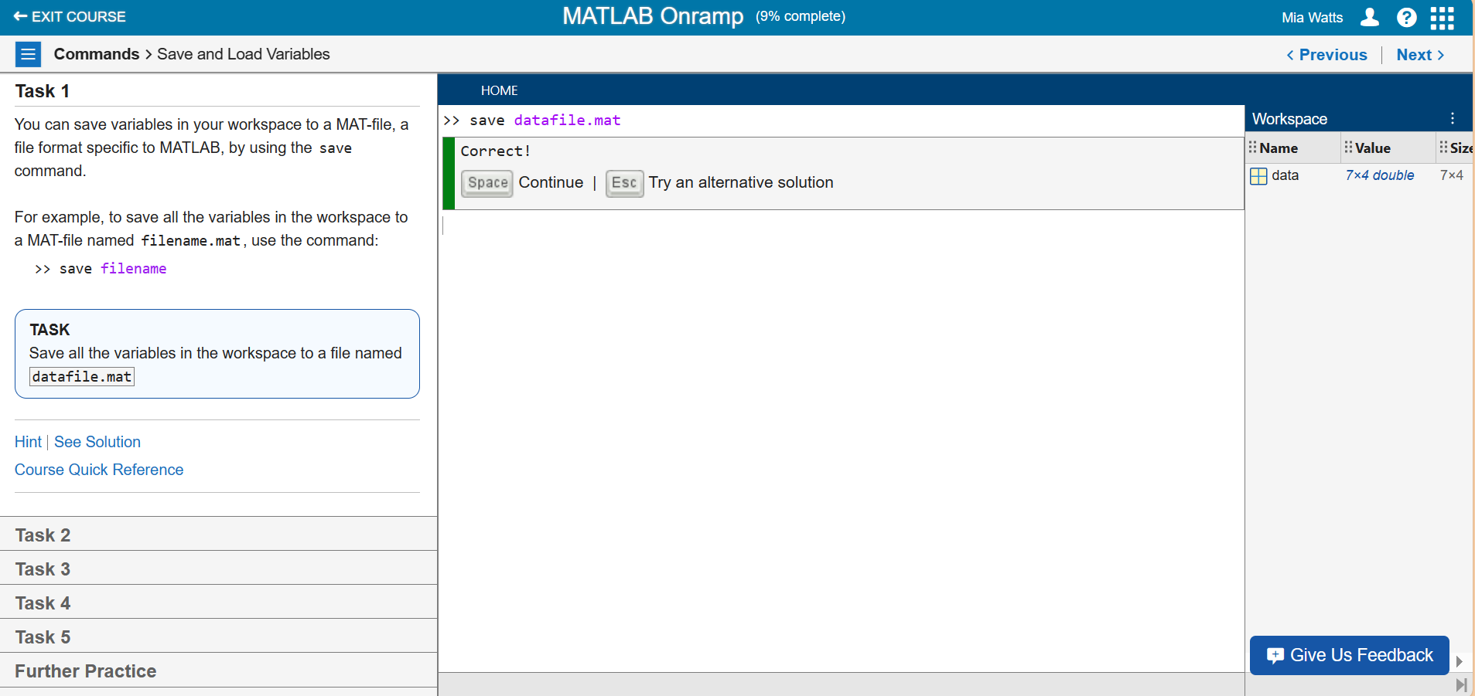

**Task 2 – Using the Clear Command**

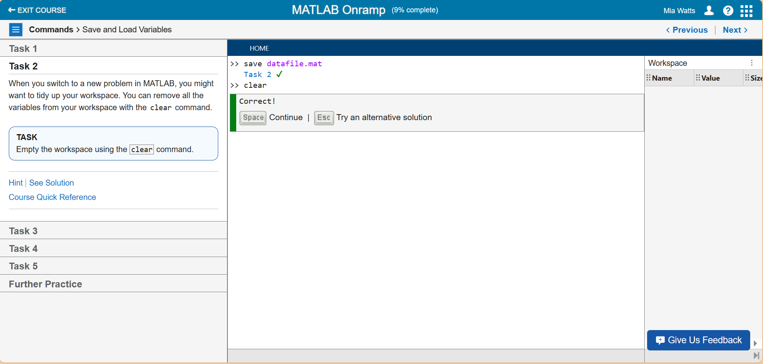

**Task 3 – Loading Files**

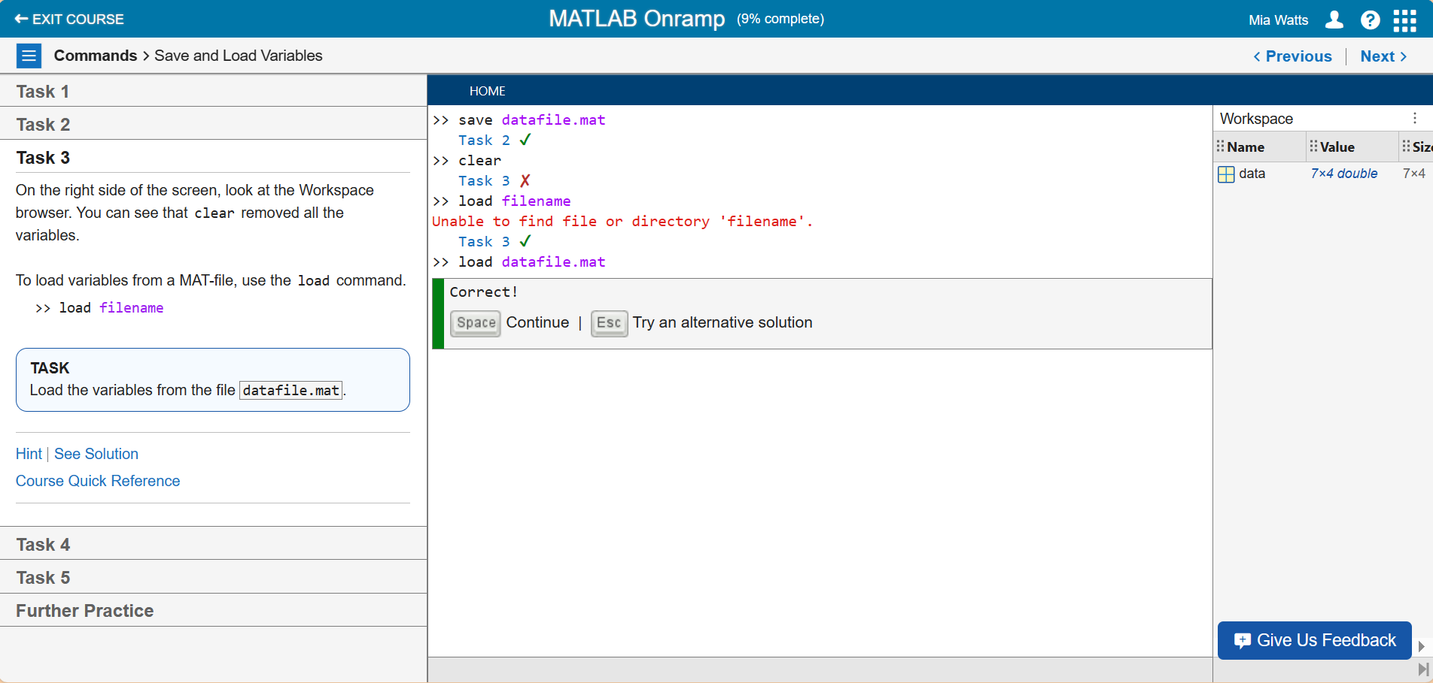

**Task 4 – Seeing Variable Contents**

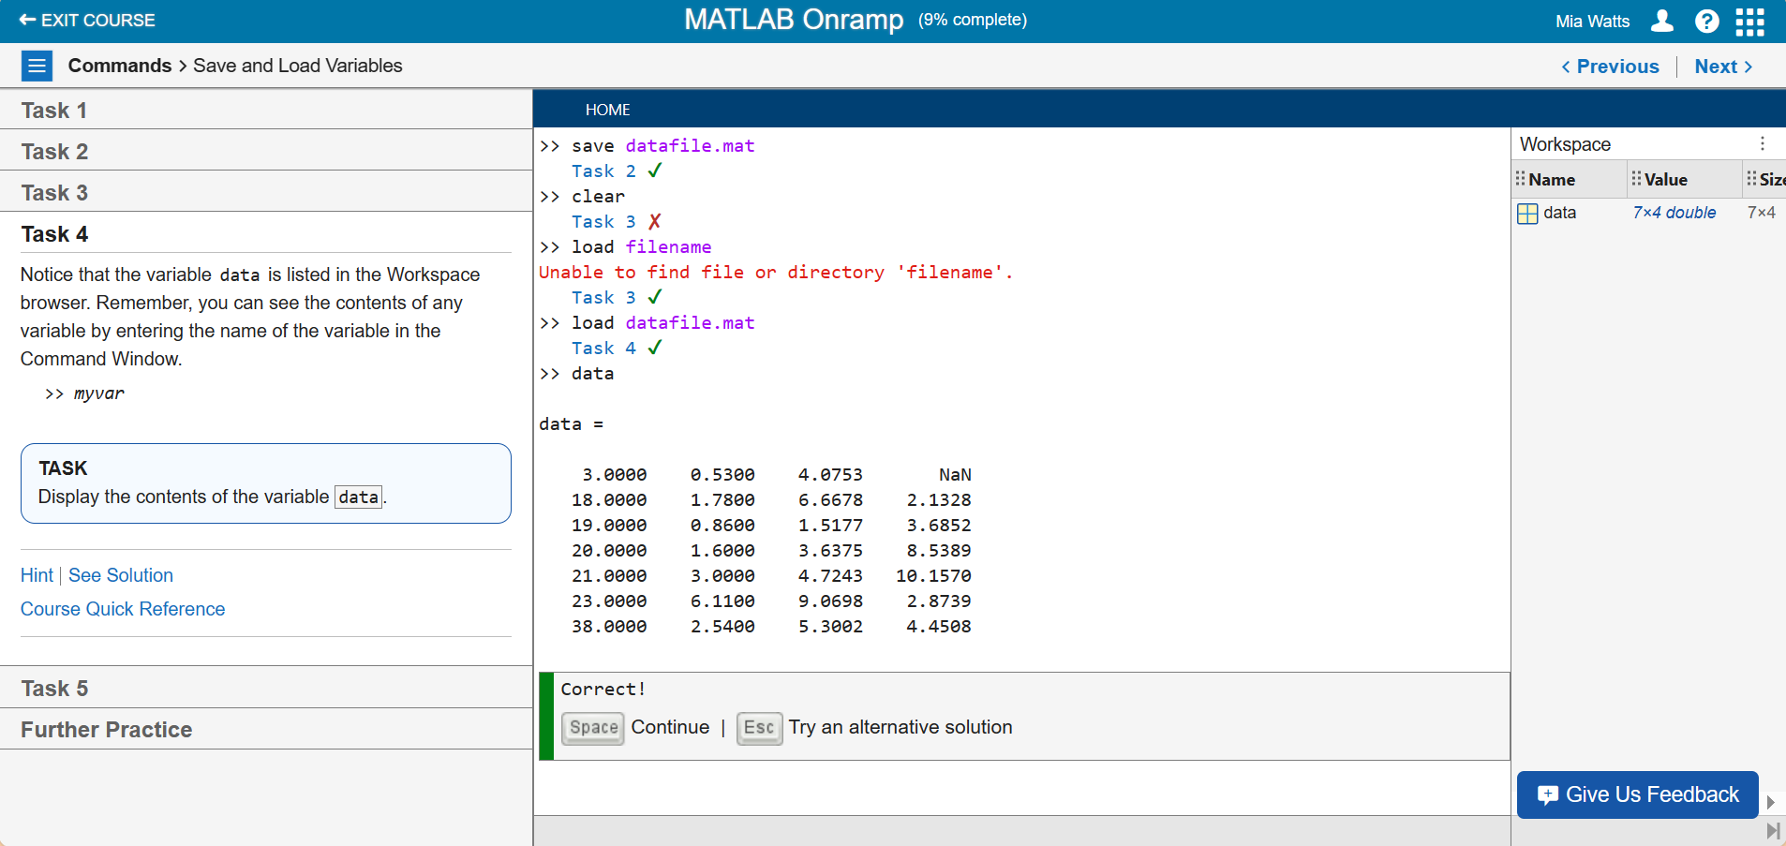

**Task 5 – Clear Window Using “clc”**

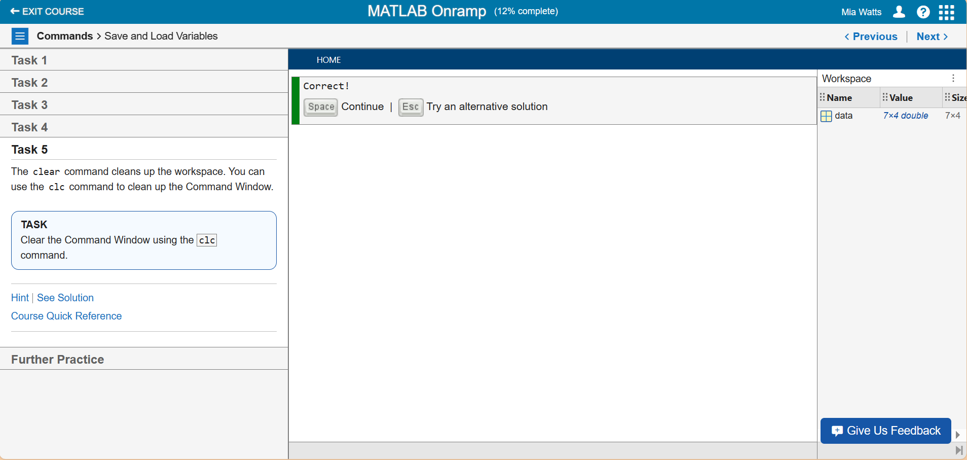

**Further Practice**

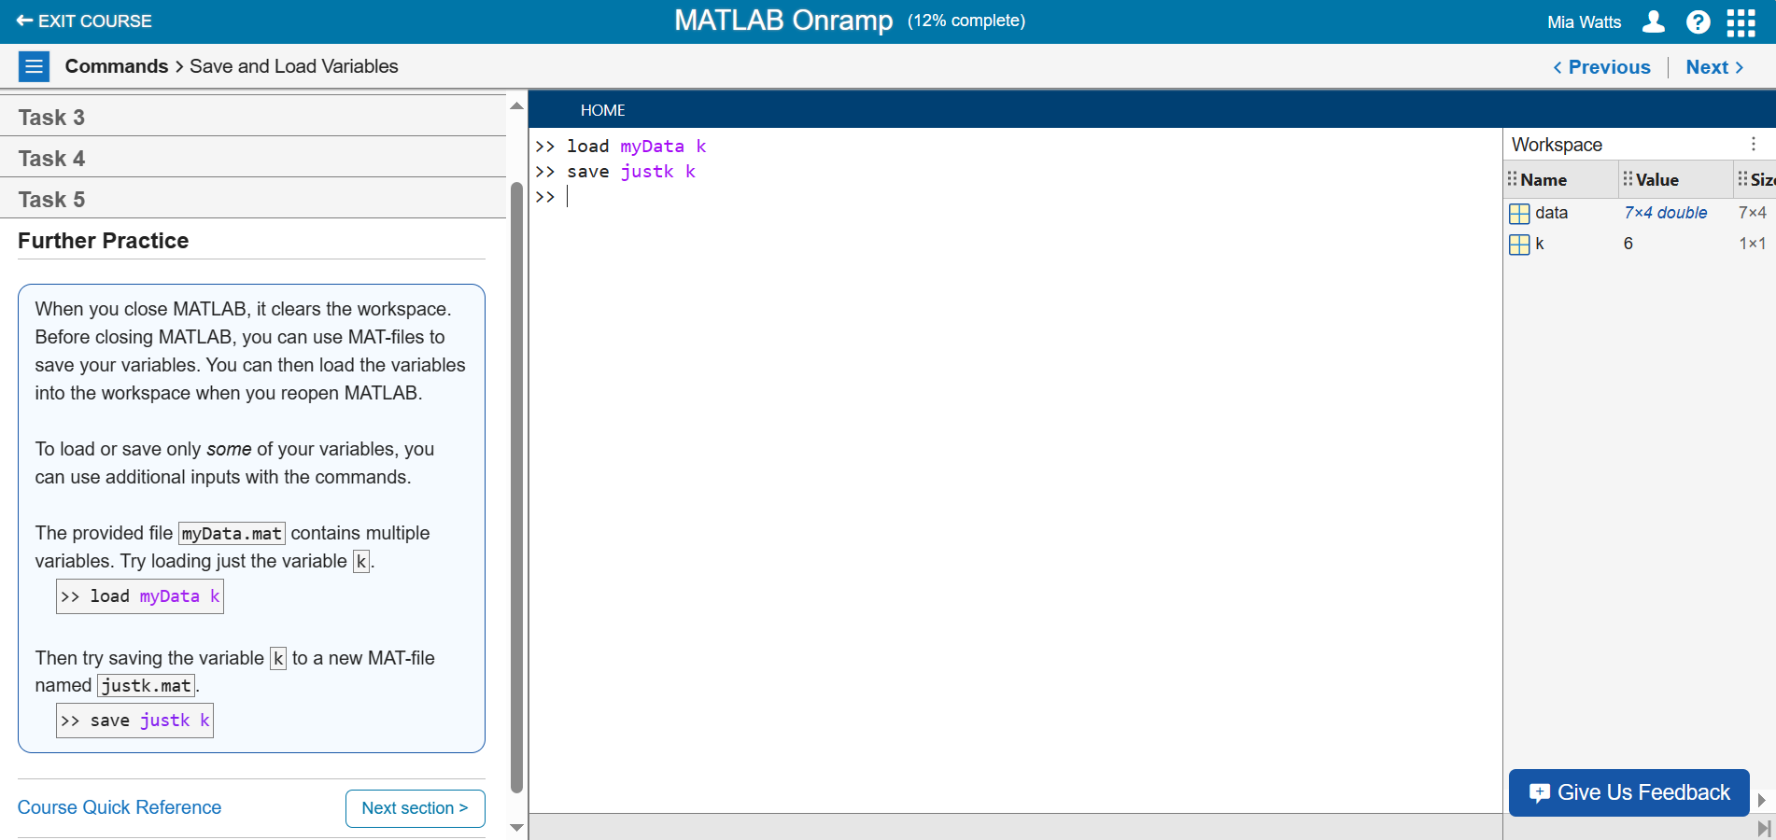

**Section 4**

**Task 1 – Compute pi/2**

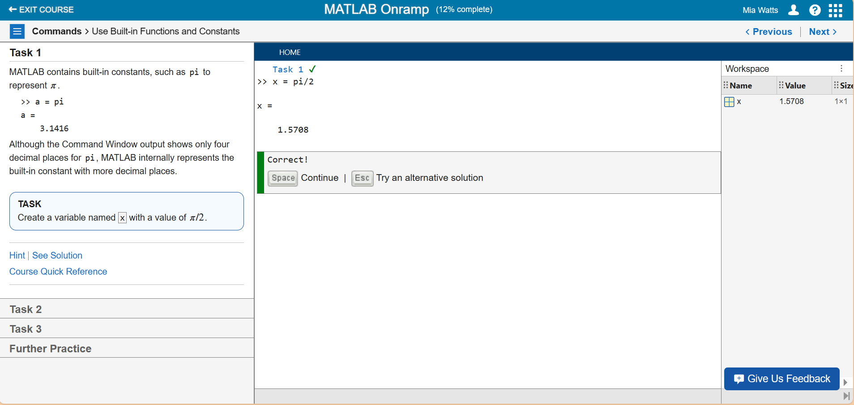

**Task 2 – Using the Sine Function**

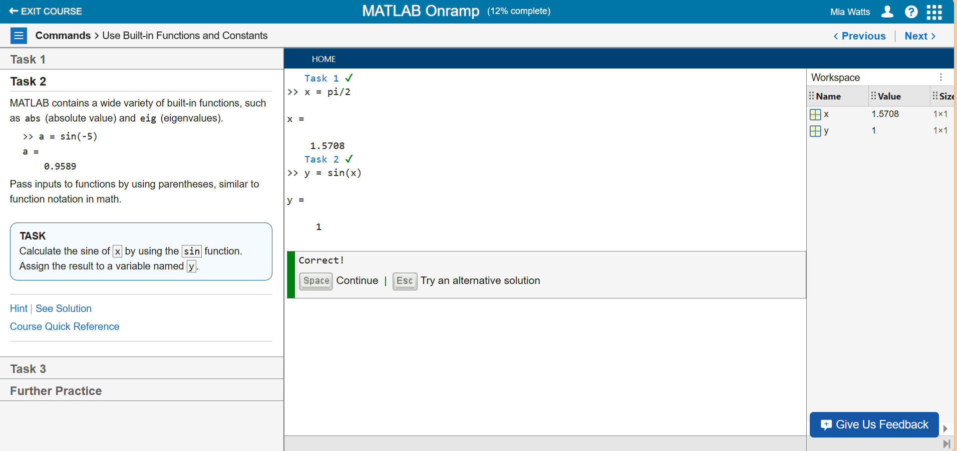

**Task 3 – Using the Square Root Function**

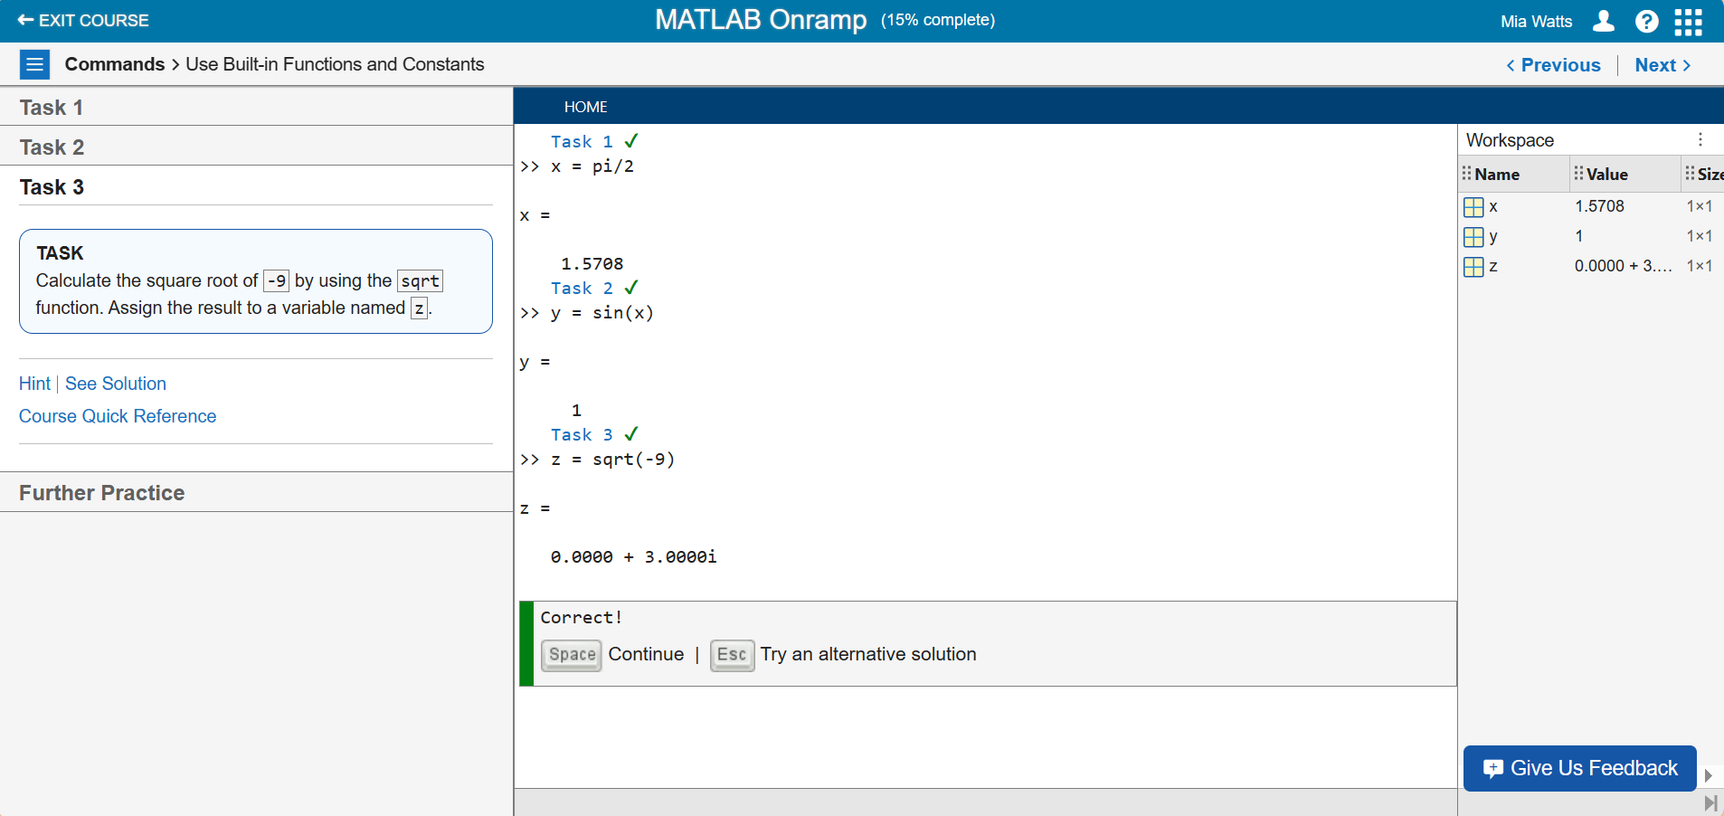

**Further Practice**

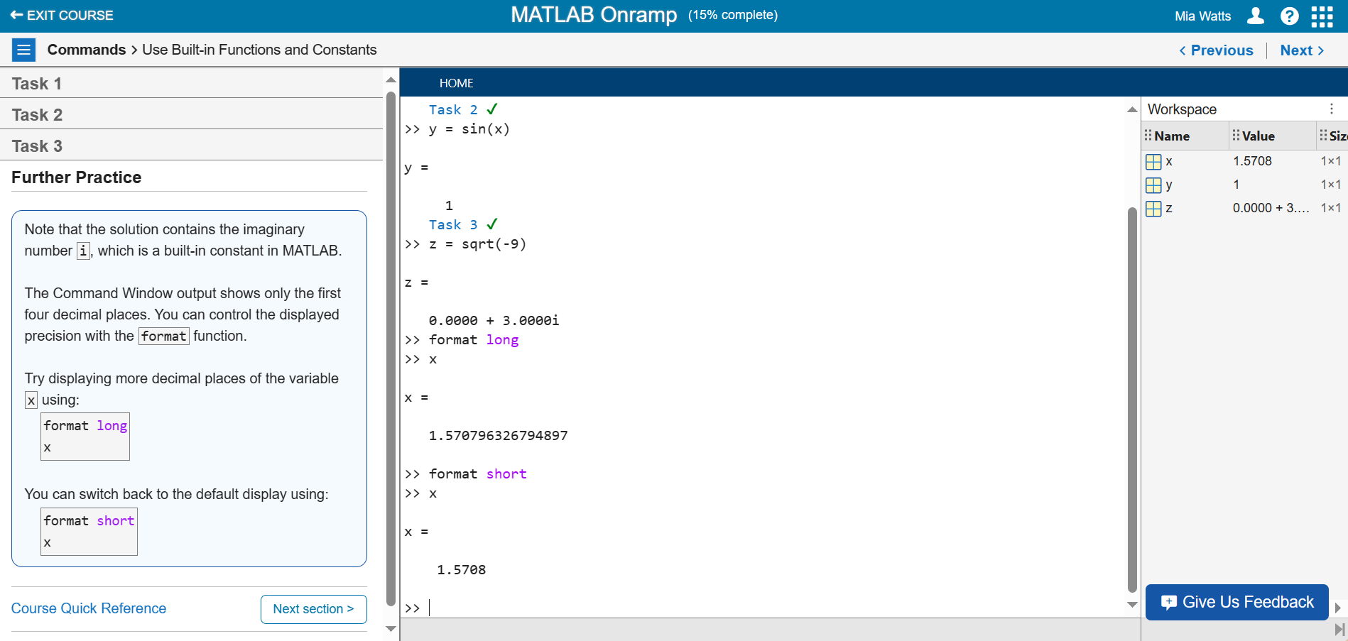

**Section 5**

**Video – Using Desktop Console and Live Editor**

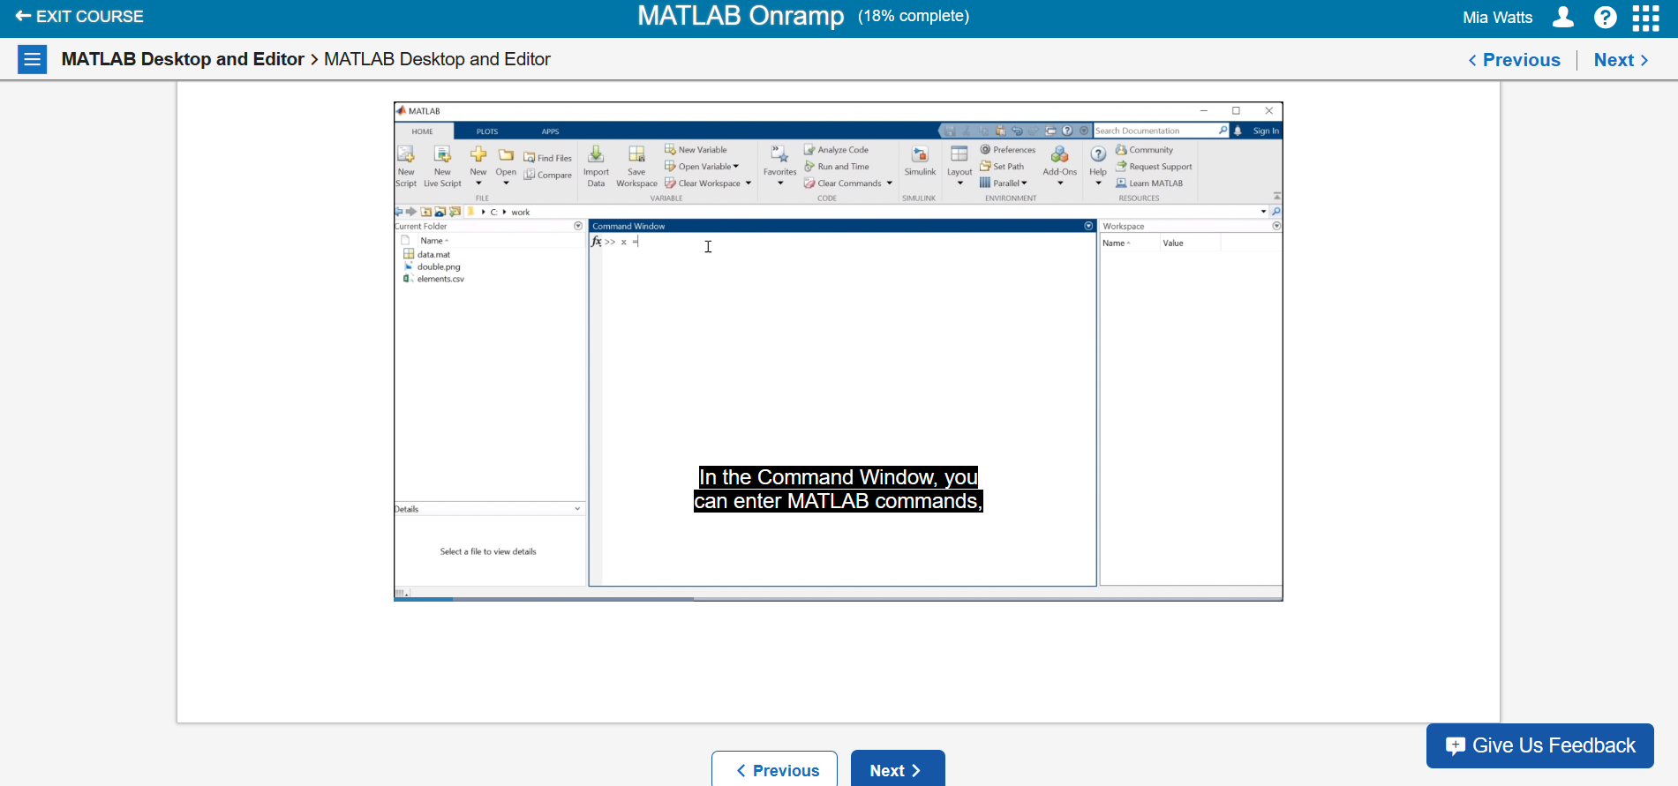

This video discussed using the regular MATLAB console or the MATLAB Live Editor. The editor allows users to enter information into a text-like environment, and everything entered into the terminal can either be executed all at once or can be split into sections. To save data entered into the editor, files can be saved with the .mat, .pdf, or .html file formats. The .mat extension would be useful for those who have MATLAB, and the .pdf and .html extensions would be useful for those who do not have MATLAB.

**Section 6**

**Task 1 – Entering Information in MATLAB’s Live Editor**

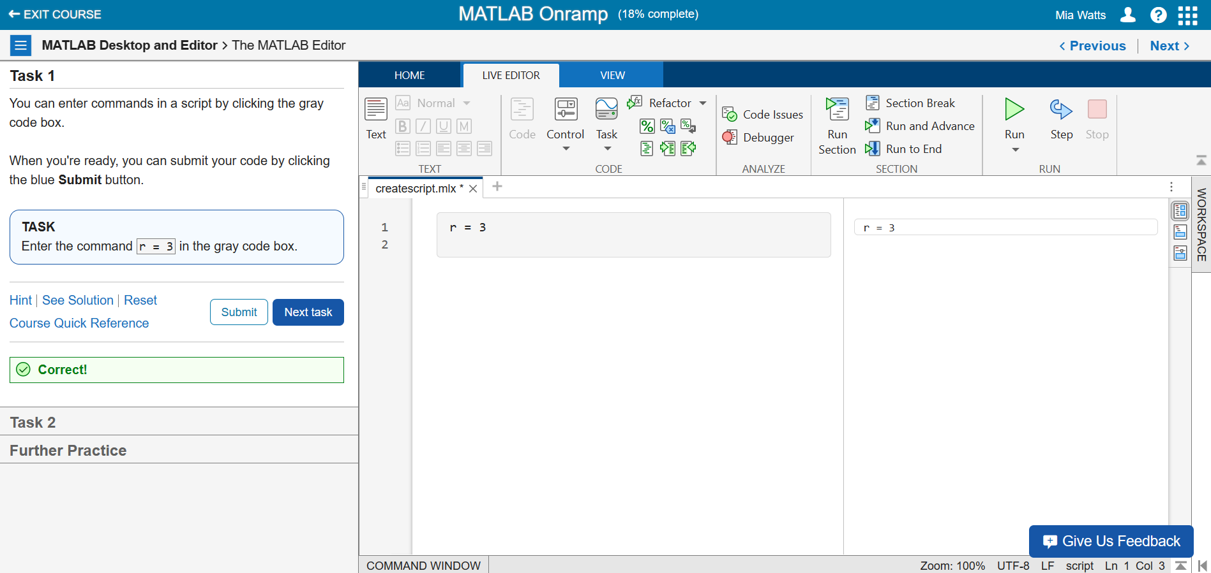

**Task 2 – Entering Another Line into Live Editor**

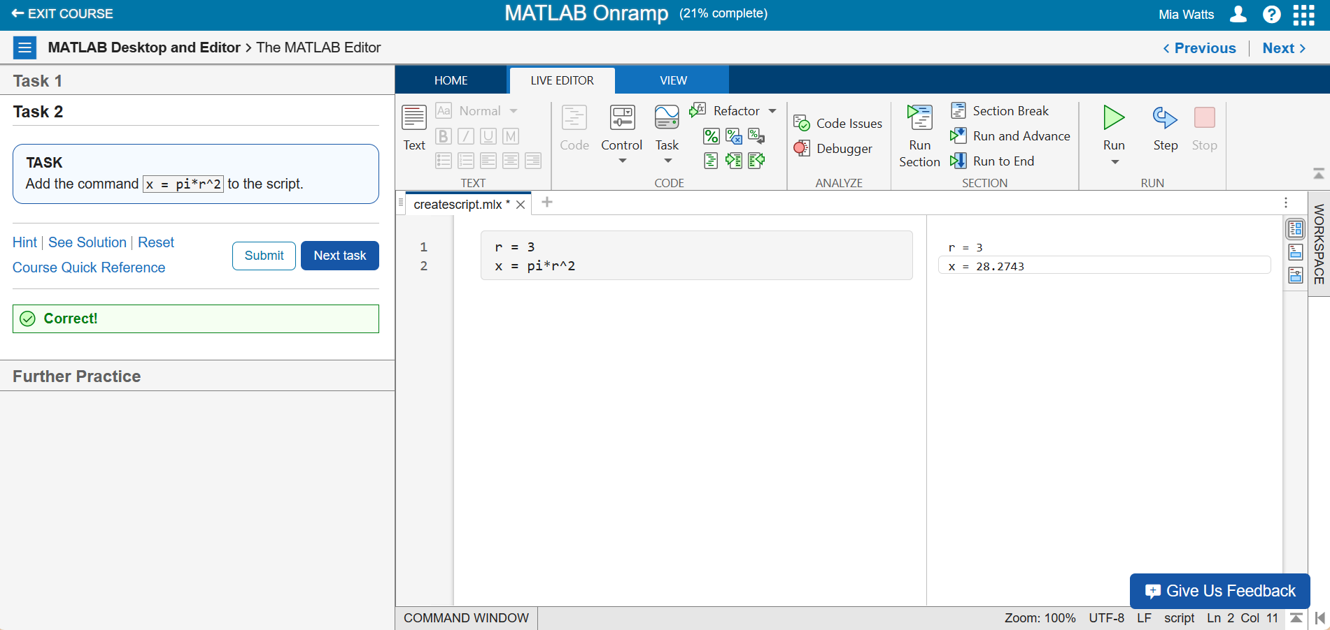

**Further Practice**

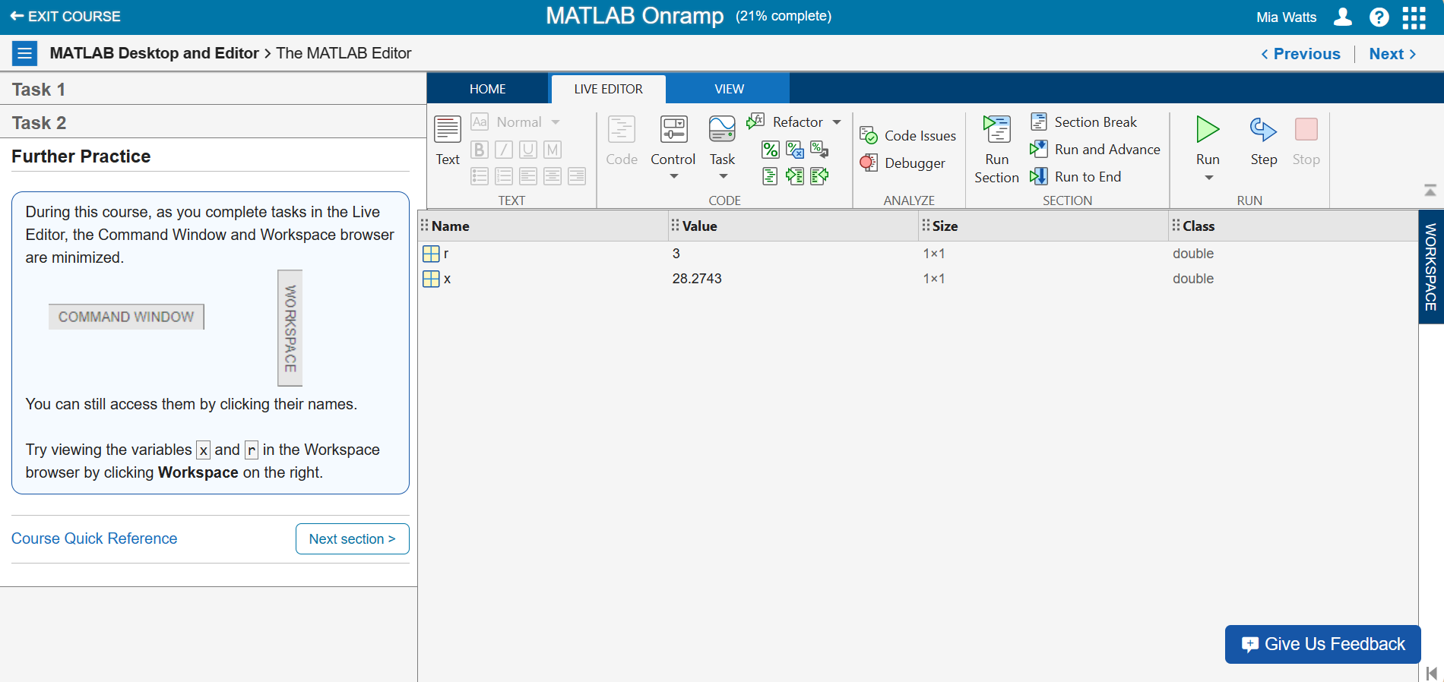

**Section 7**

**Task 1 – Running Scripts and Changing Values**

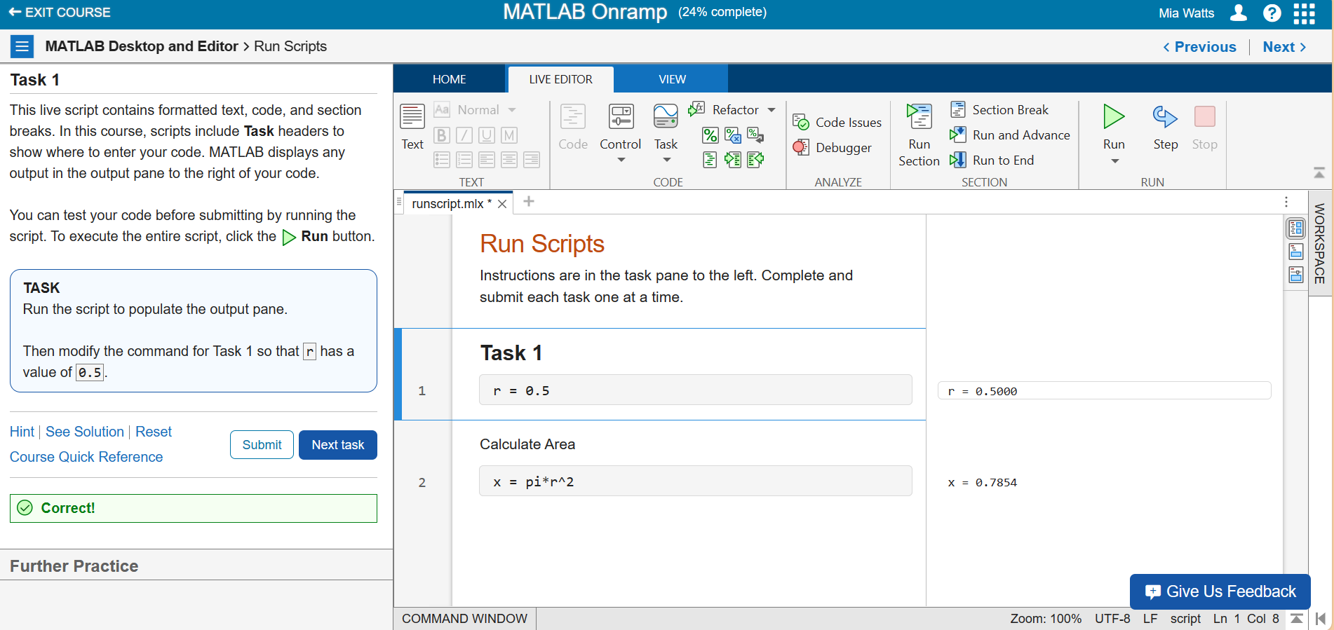

**Further Practice**

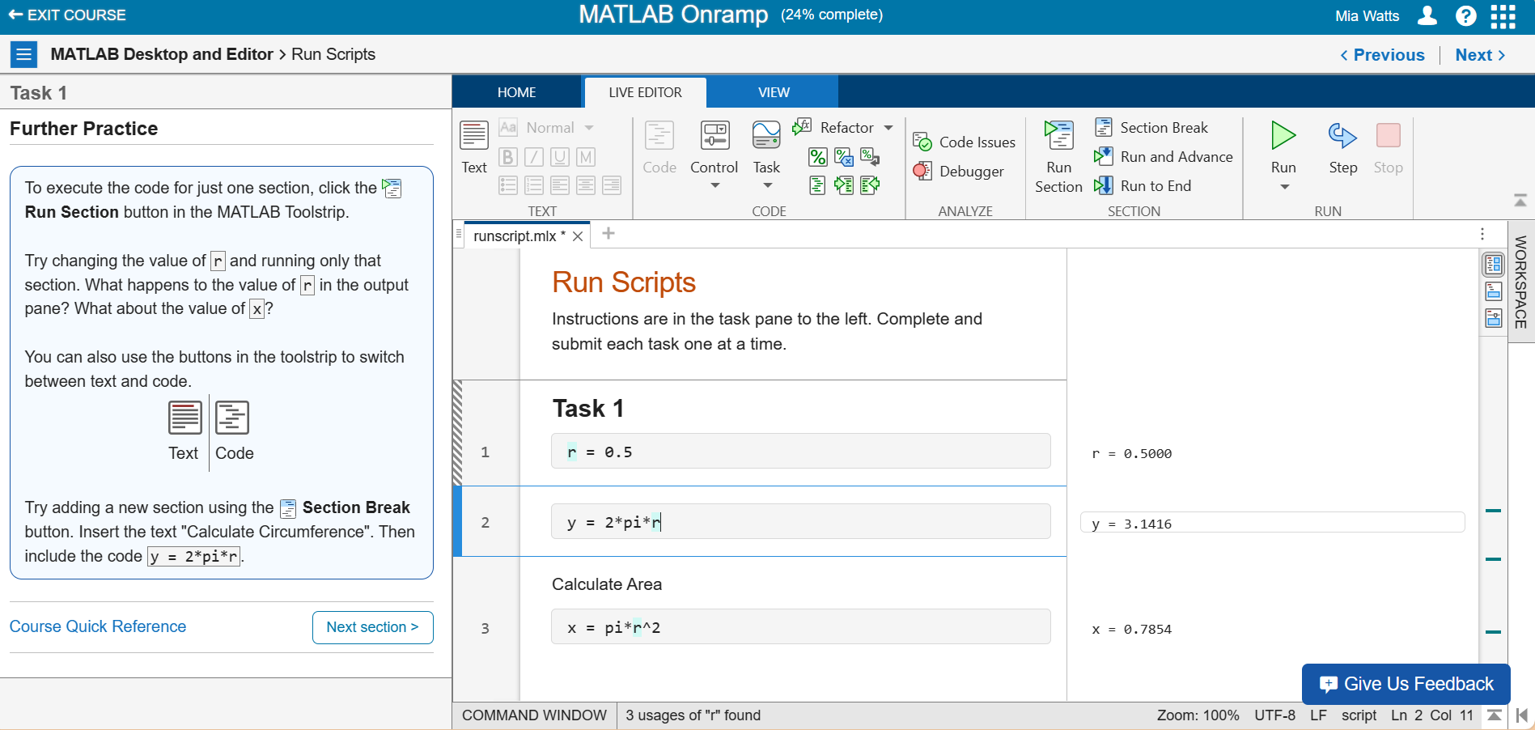

**Section 8**

**Task 1 – Debugging and Fixing an Error**

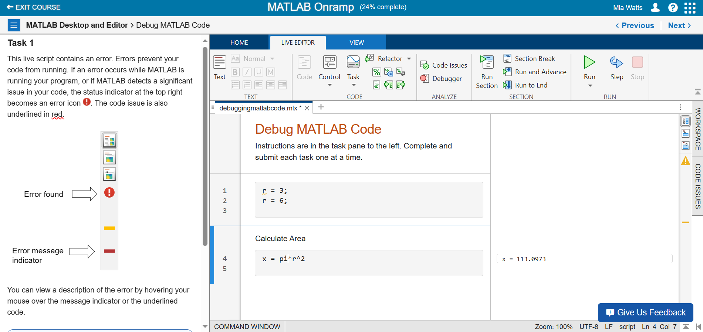

**Further Practice**

**Fixing Warnings**

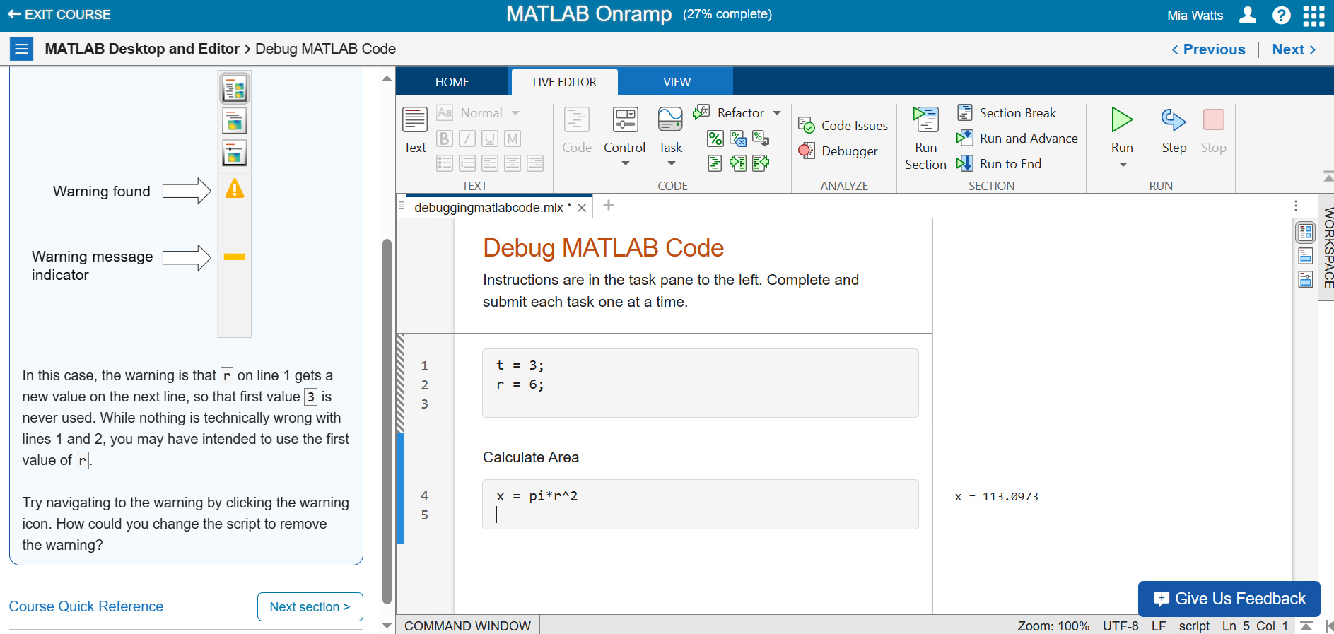

**Section 9**

**Task 1 – Adding First Element to an Array**

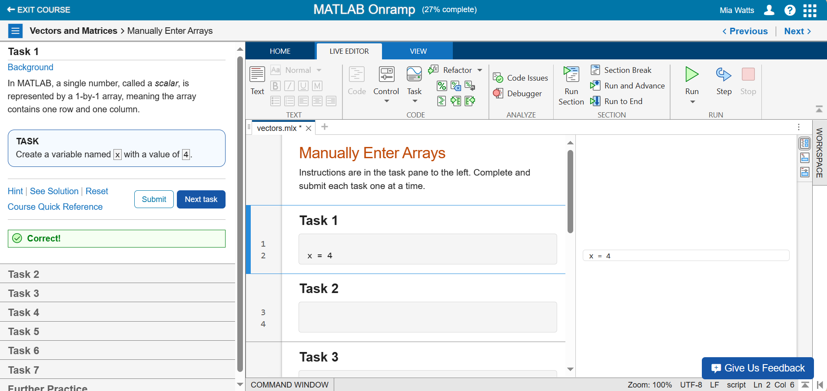

**Task 2 – Creating an Array with Two Values**

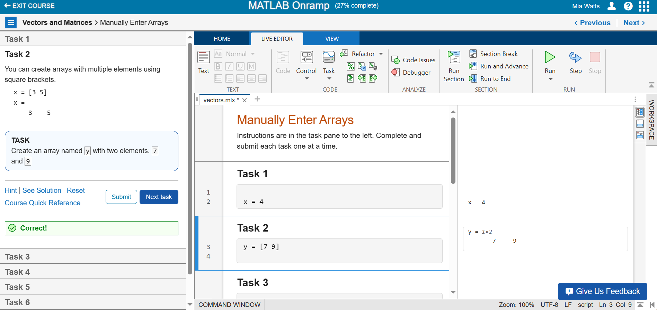

**Task 3 – Creating a Column Vector**

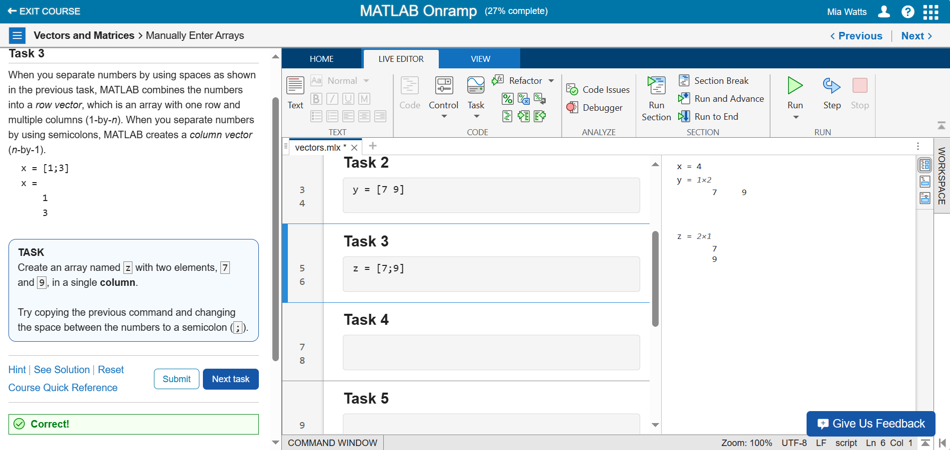

**Task 4 – More Practice with Row Vectors**

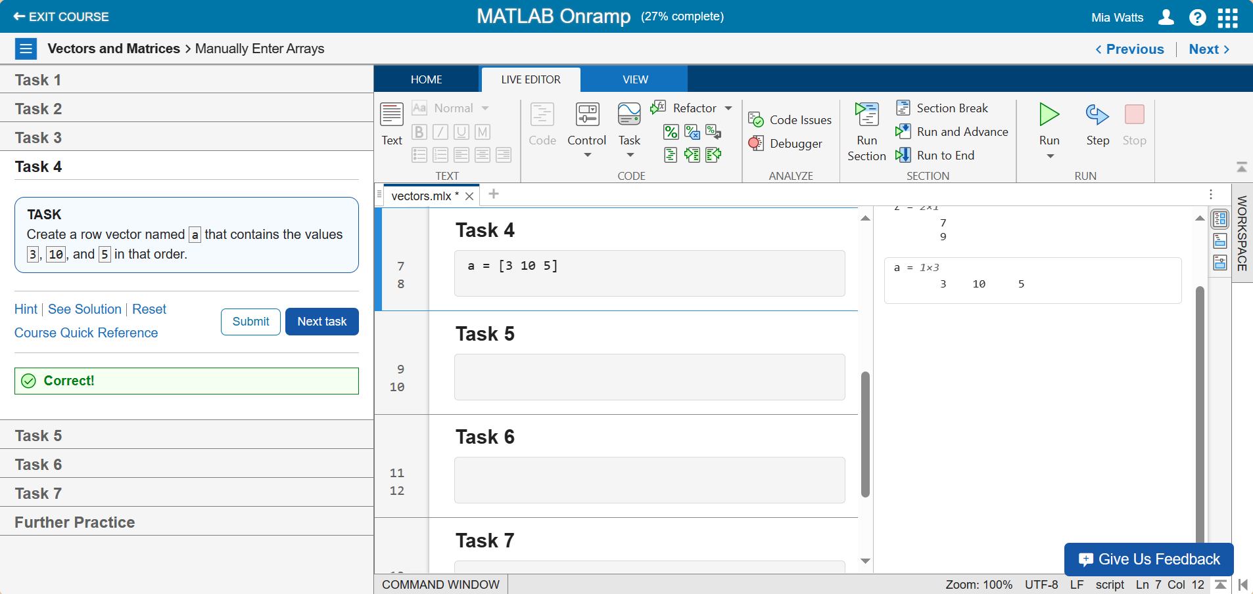

**Task 5 – More Practice with Column Vectors**

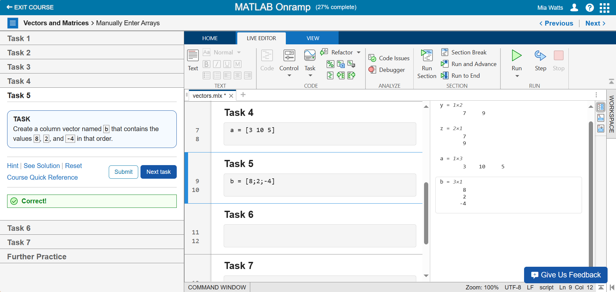

**Task 6 – Creating a Matrix**

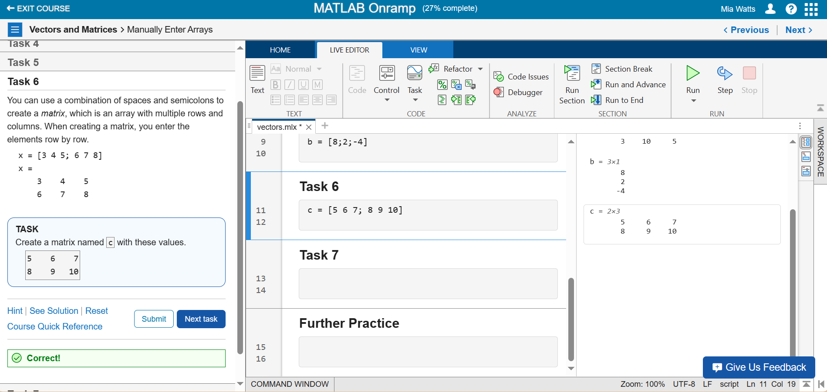

**Task 7 – Creating a Row Vector with Calculations**

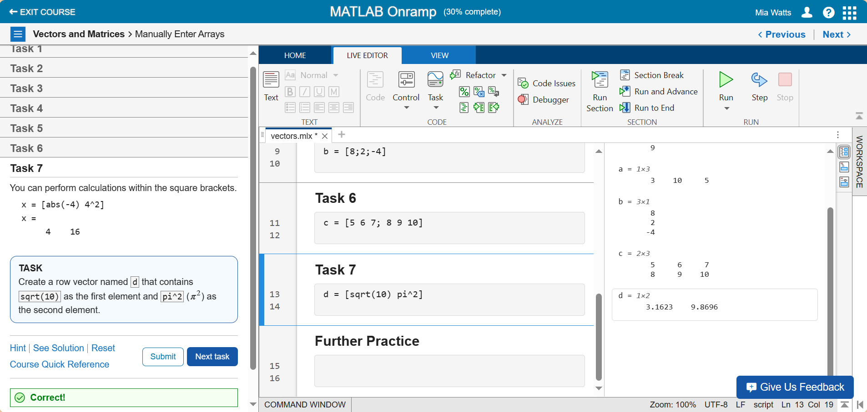

**Further Practice**

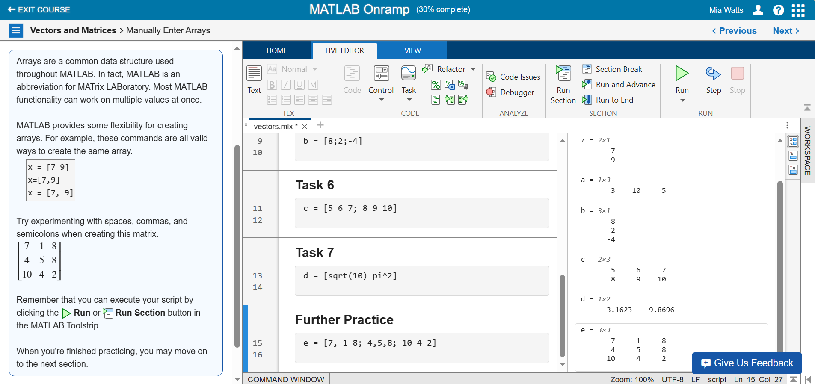

**Section 10**

**Task 1 – Creating Another Row Vector**

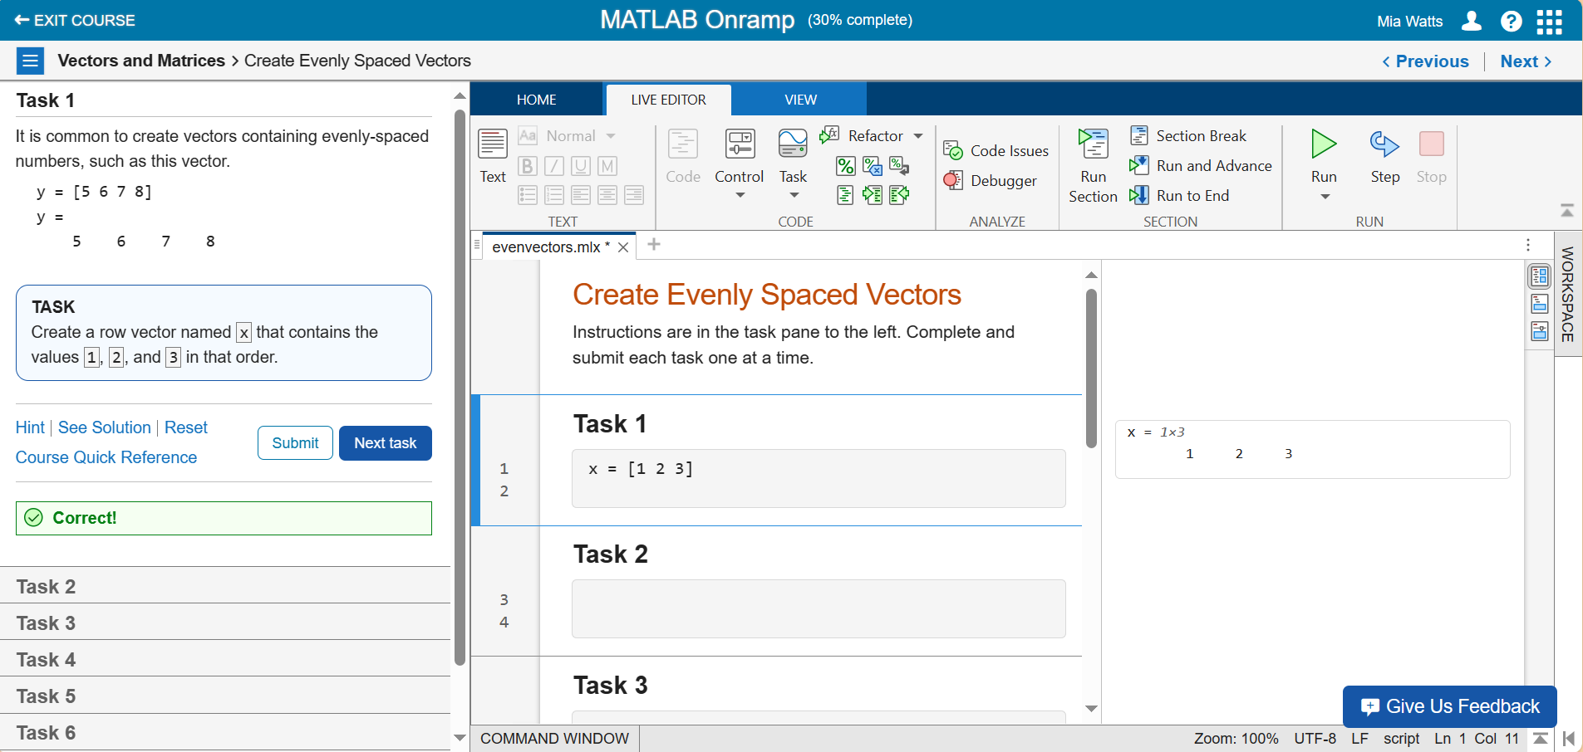

**Task 2 – Using a Colon to Create a Ranged Row Vector**

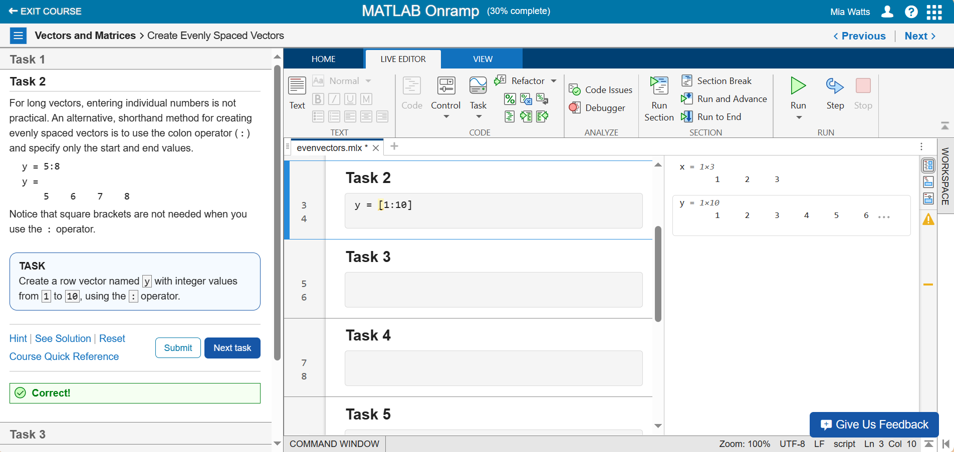

**Task 3 – Specifying Spacing**

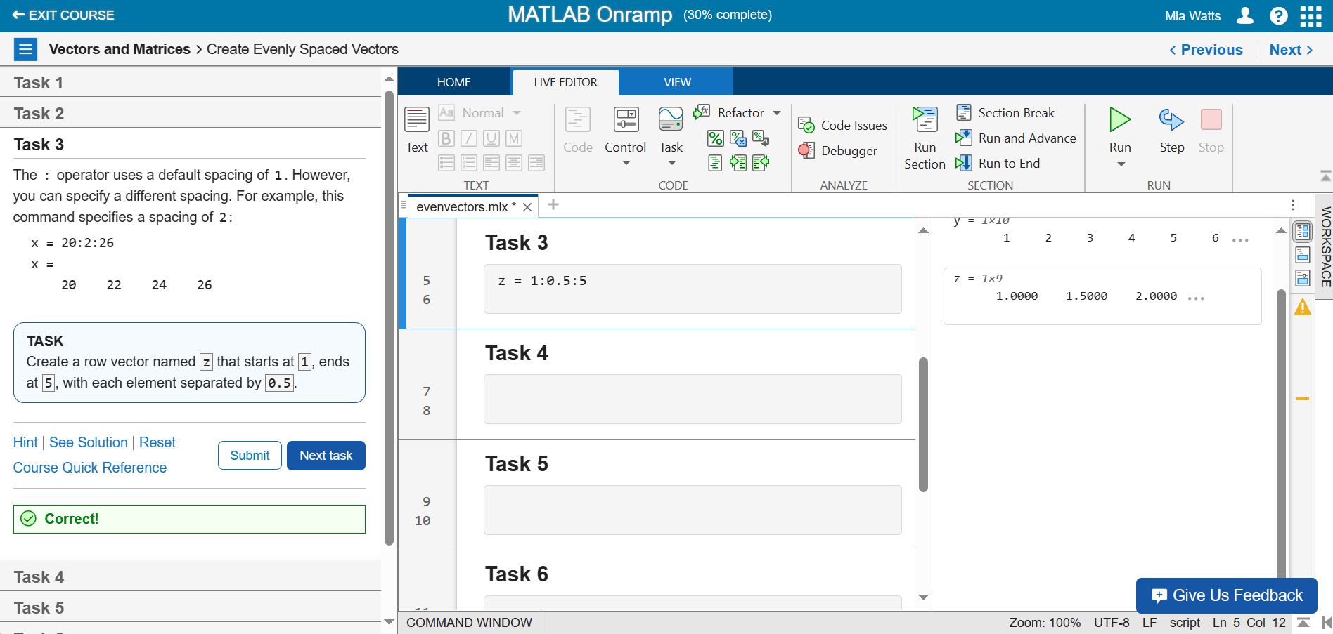

**Task 4 – More Practice with Spacing and Ranges**

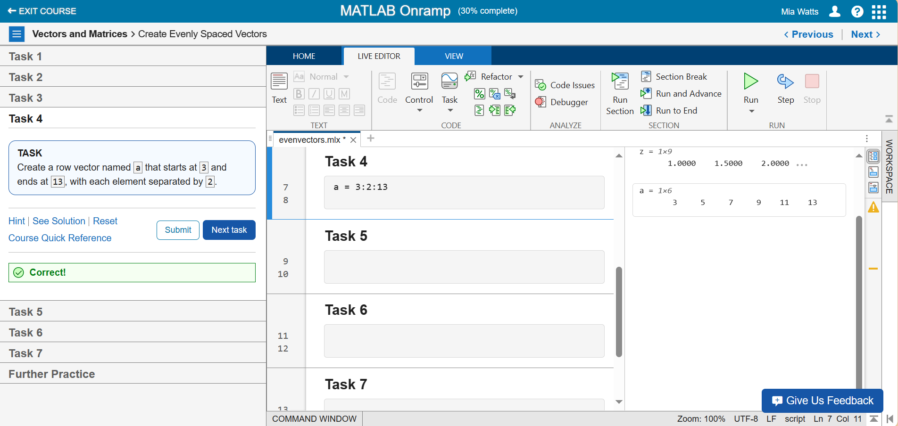

**Task 5 – Using “linspace”**

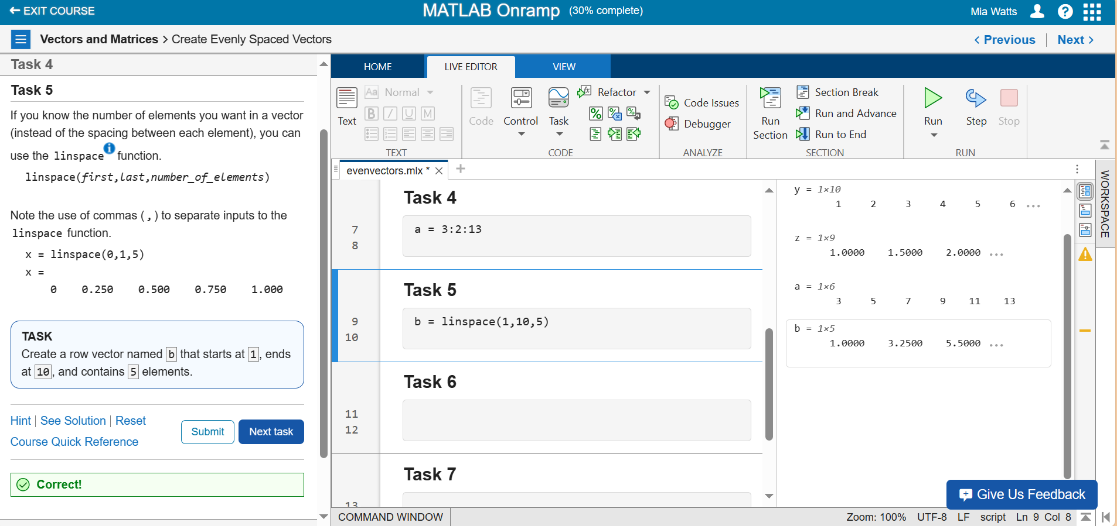

**Task 6 – Using the Transpose Operator**

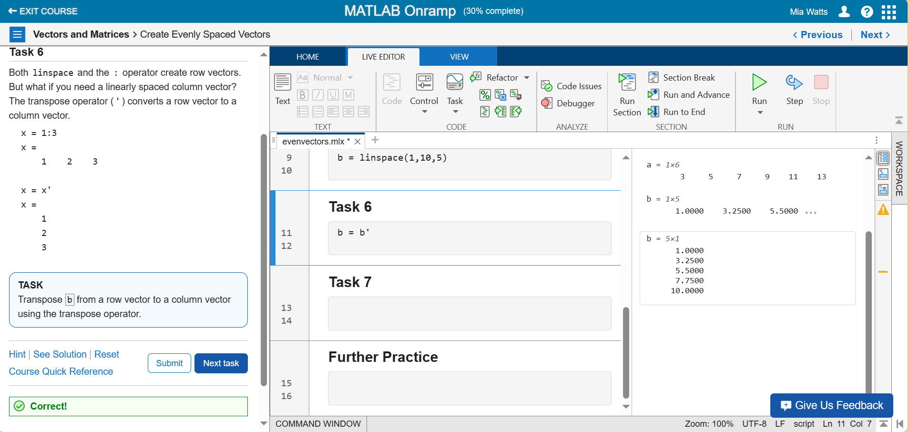

**Task 7 – Transposing a Ranged Row Vector to Create a Column Vector**

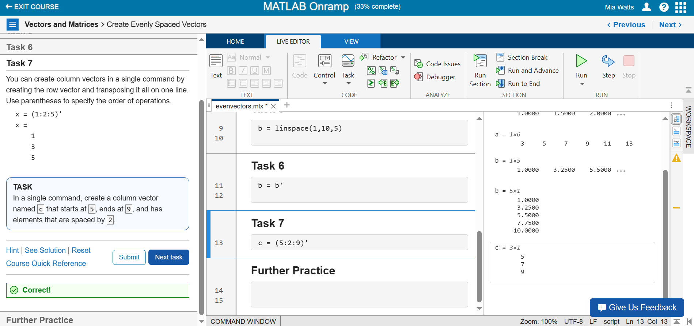

**Further Practice**

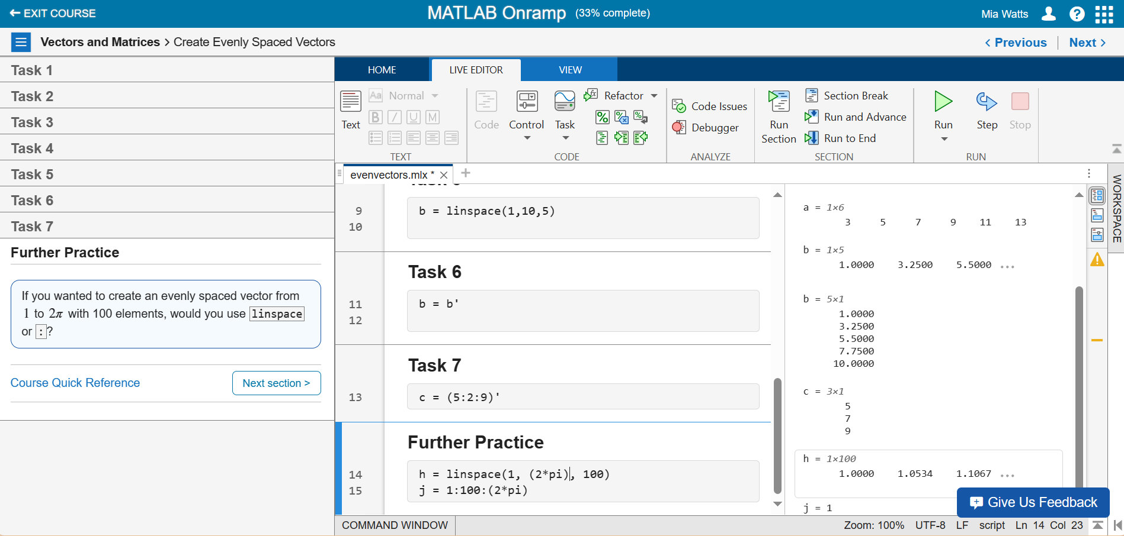

**Section 11**

**Task 1 – 5-by-5 Matrix with Random Numbers**

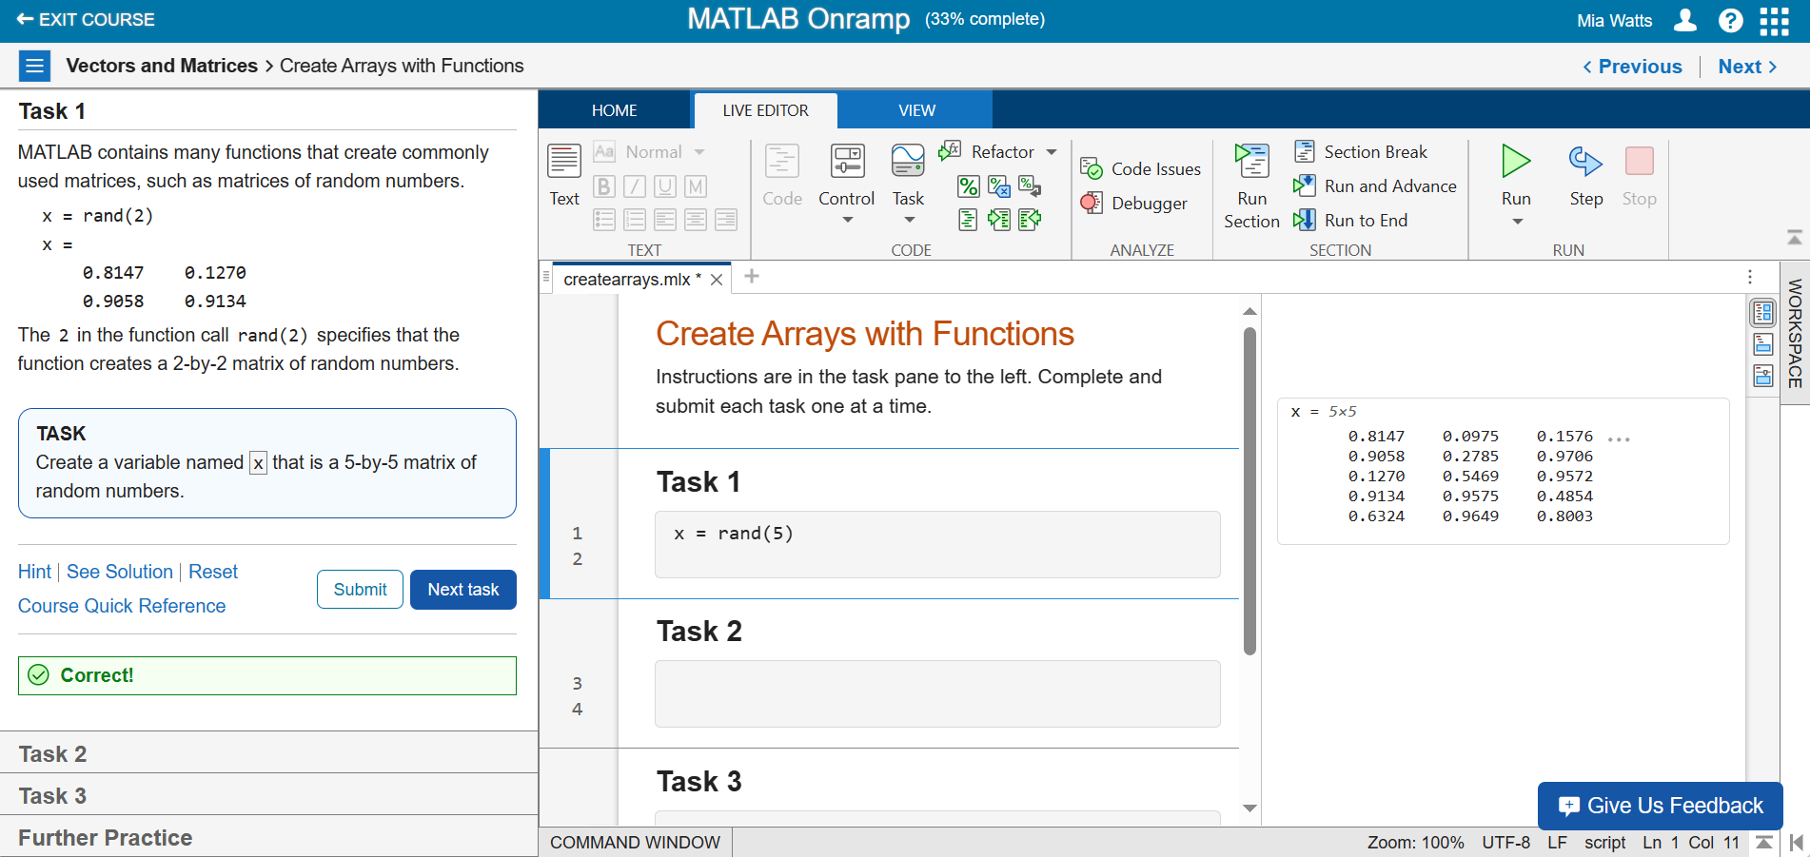

**Task 2 – Random Matrix with 5 Rows and 1 Column**

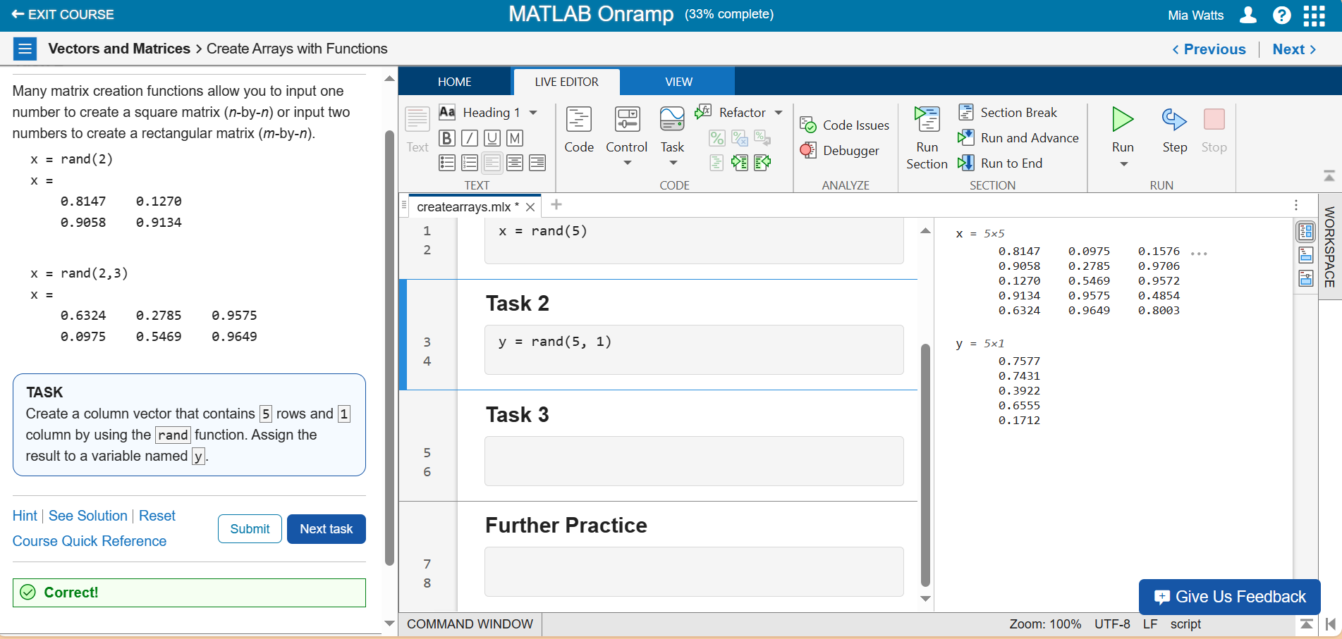

**Task 3 – Zeros Matrix**

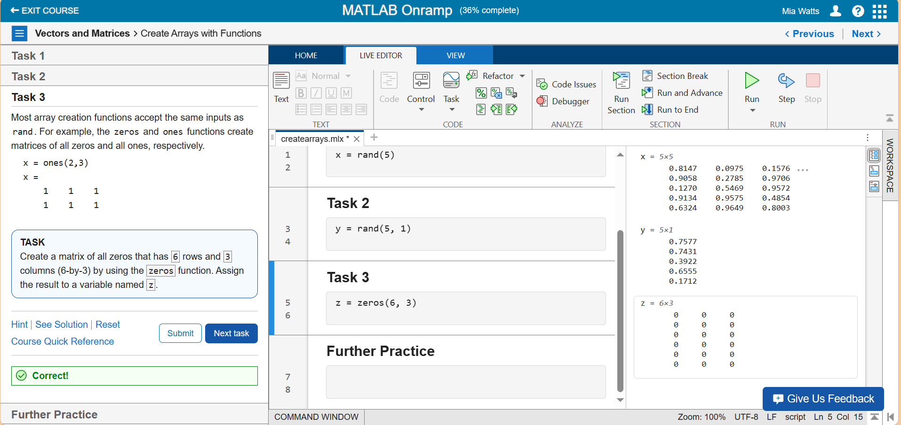

**Further Practice**

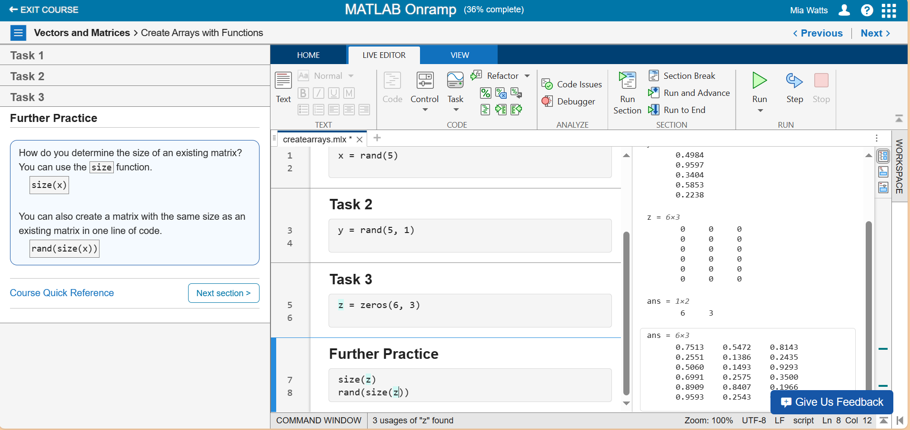

**Section 12**

**Video – Indexing**

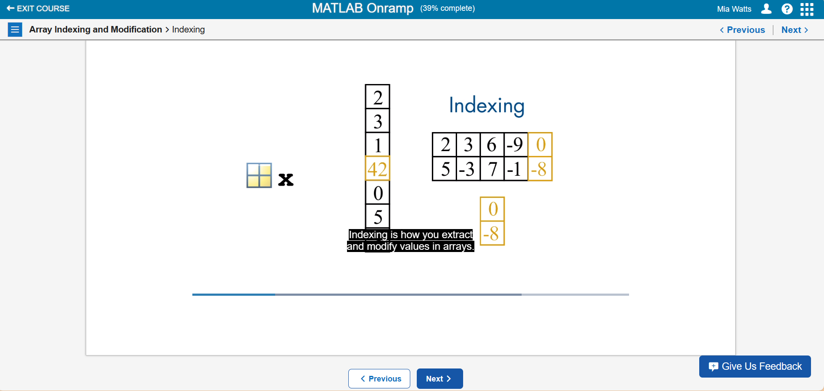

This video consisted of a discussion on how every element in MATLAB is an array. Indexing is important, so the video introduces how to index ranges and single numbers.

**Section 13**

**Task 1 – Index 6th Row and 3rd Column**

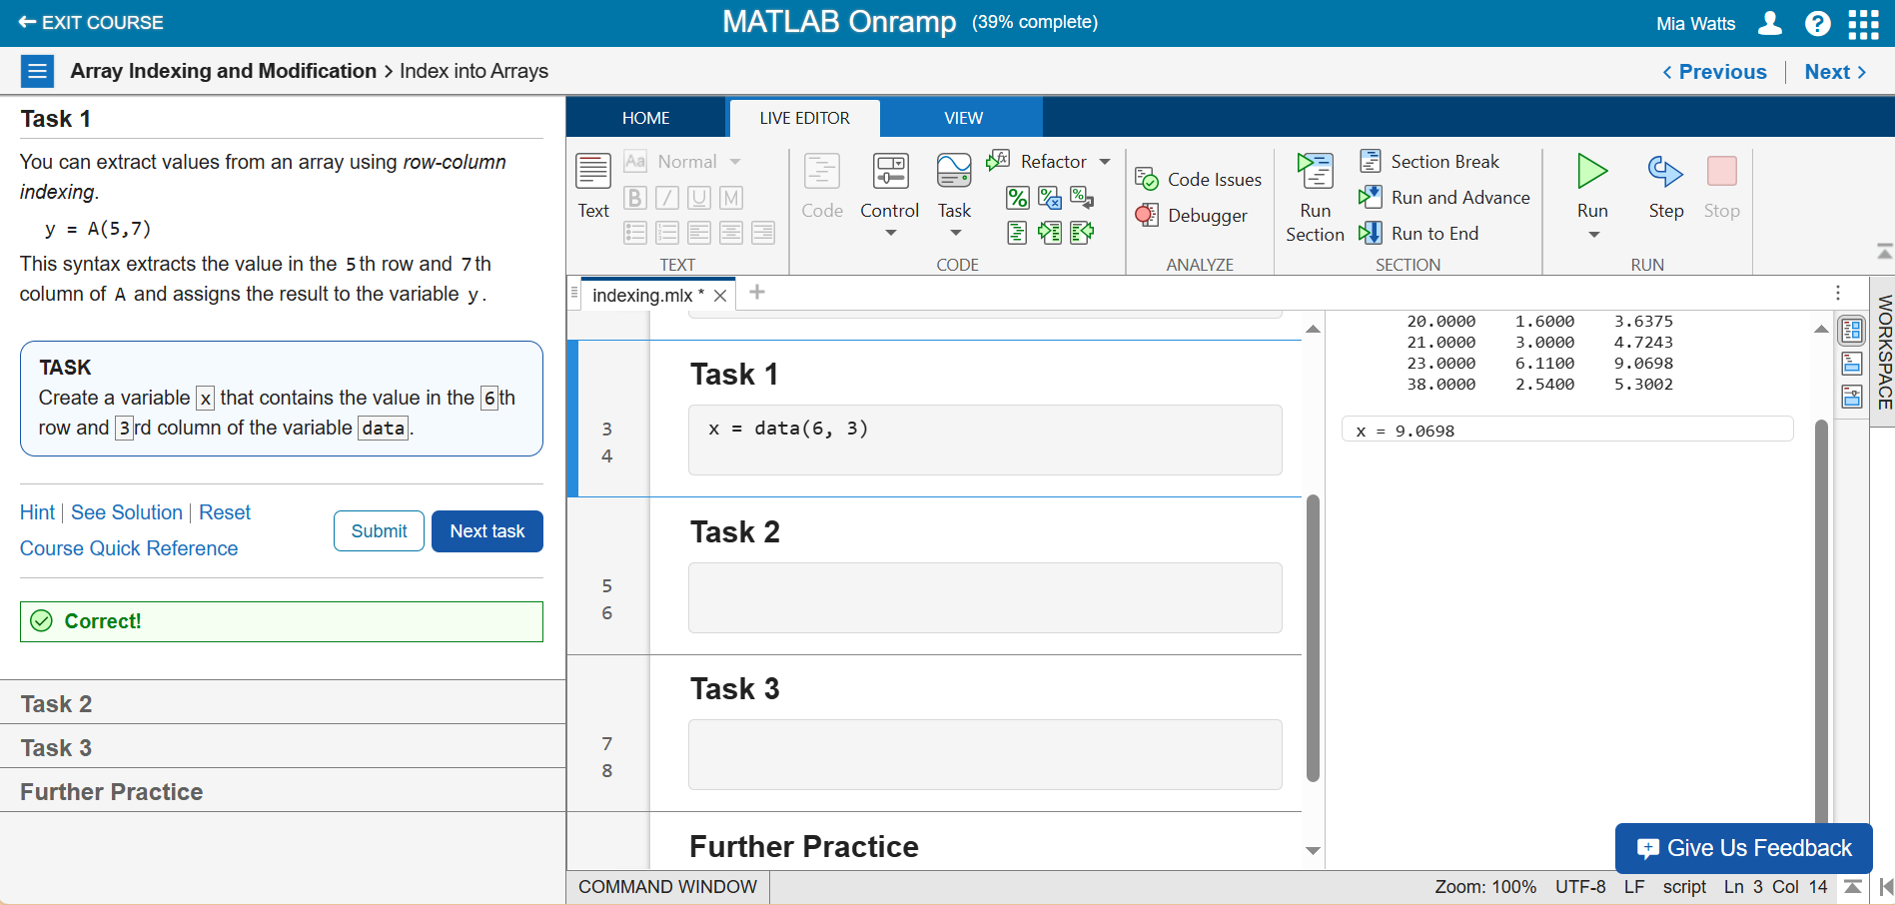

**Task 2 – Using the “end” Command**

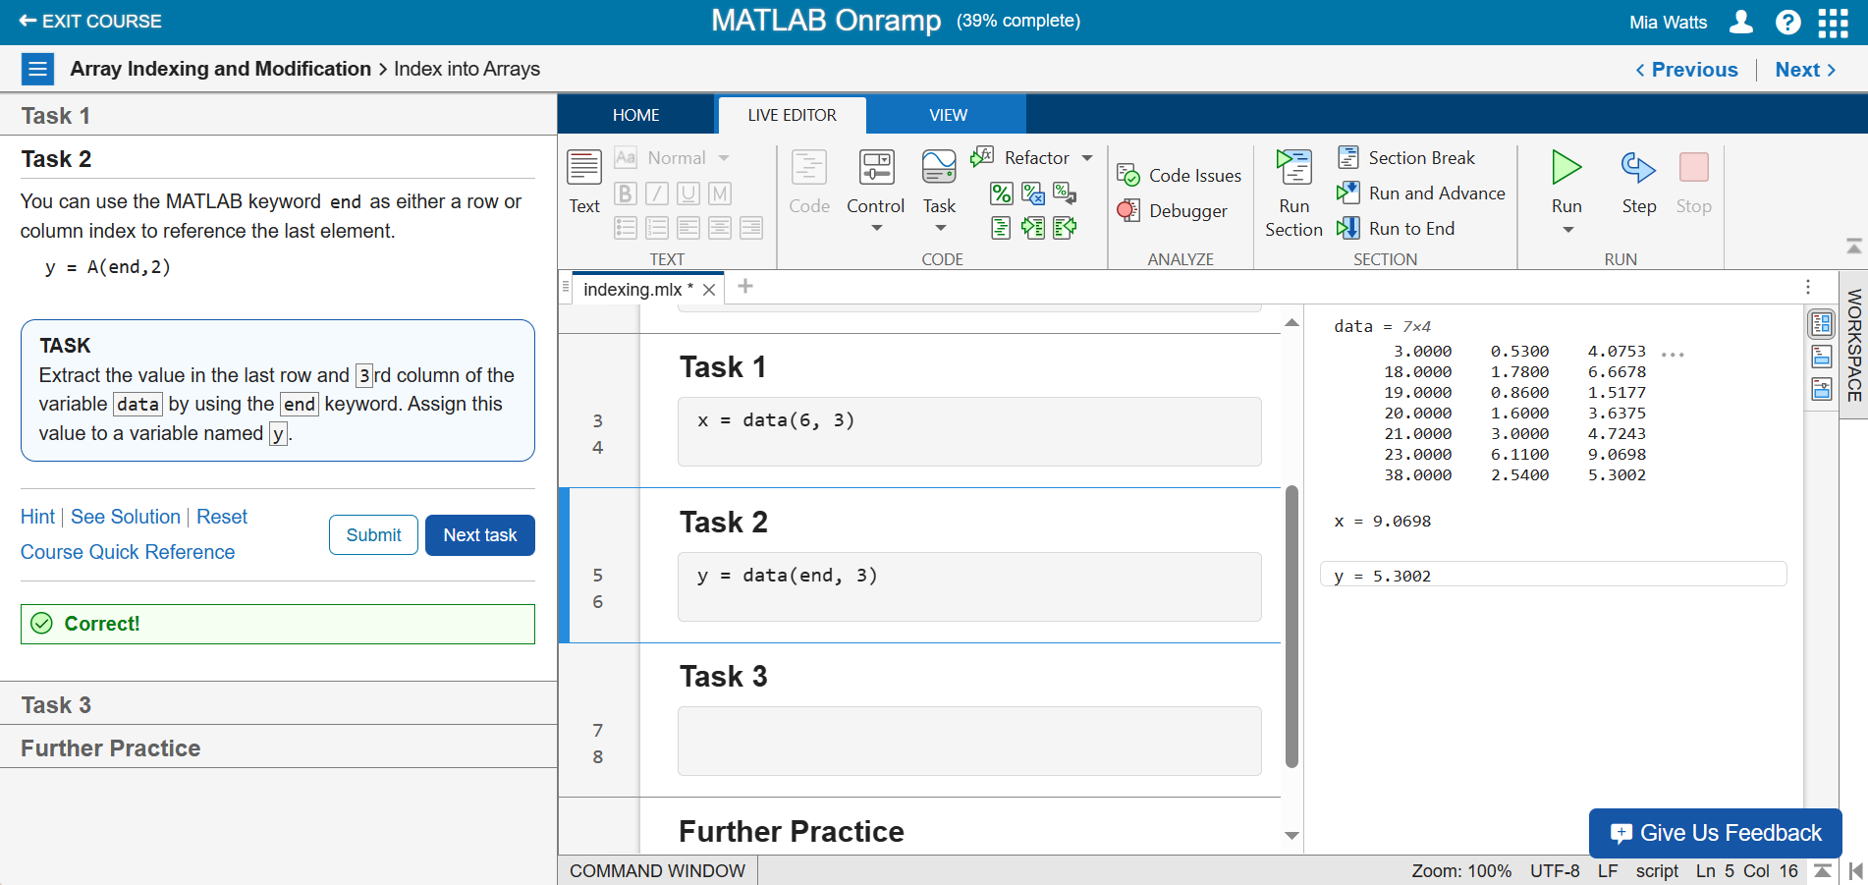

**Task 3 – Finding Second-to-Last Values Using “end”**

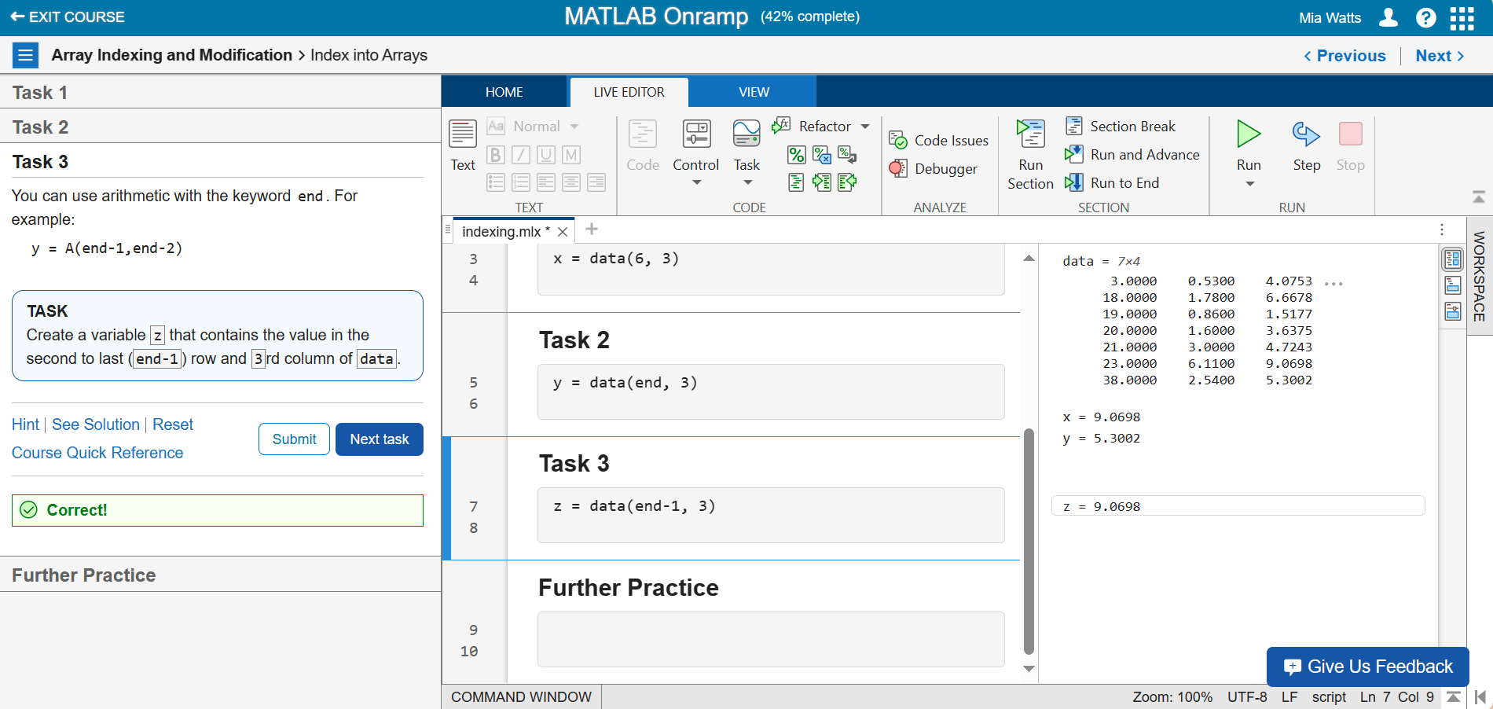

**Further Practice**

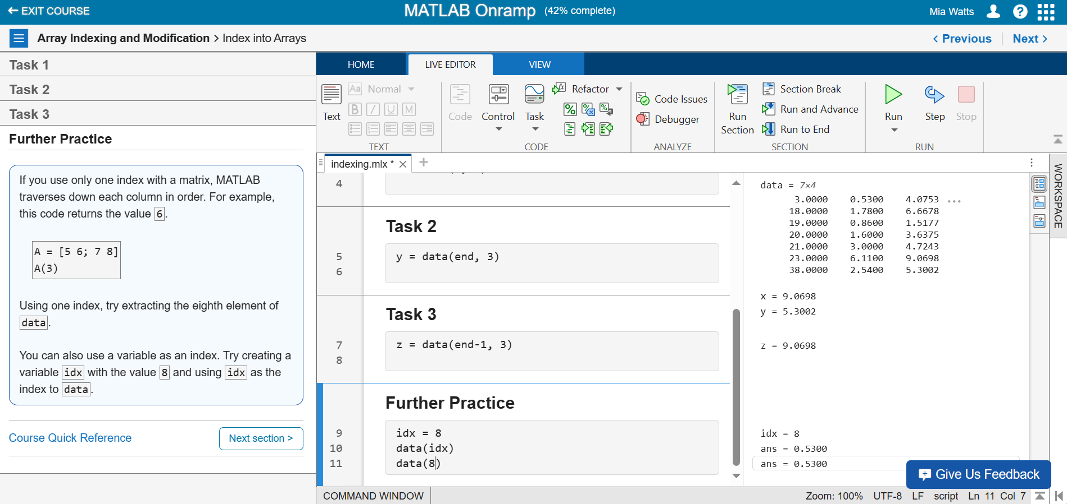

**Section 14**

**Task 1 – Extracting Data with Colon Operators**

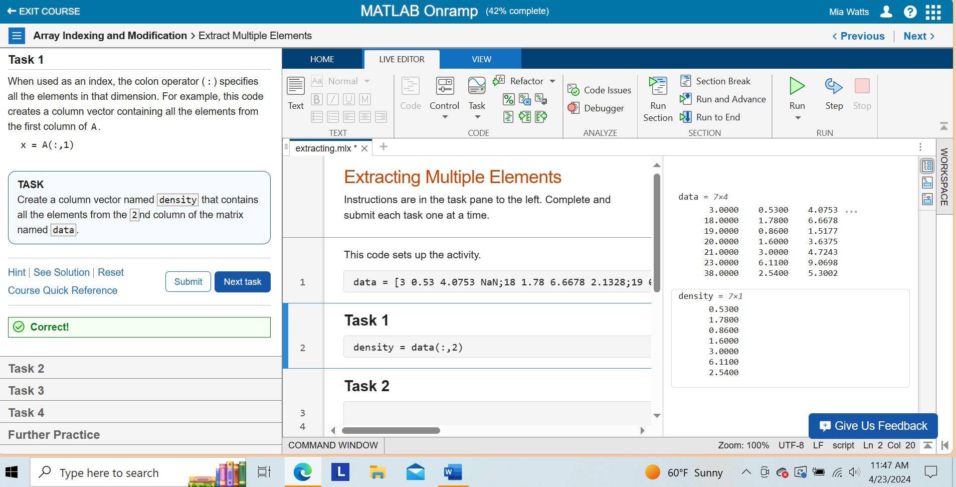

**Task 2 – Obtaining the Last 2 Columns**

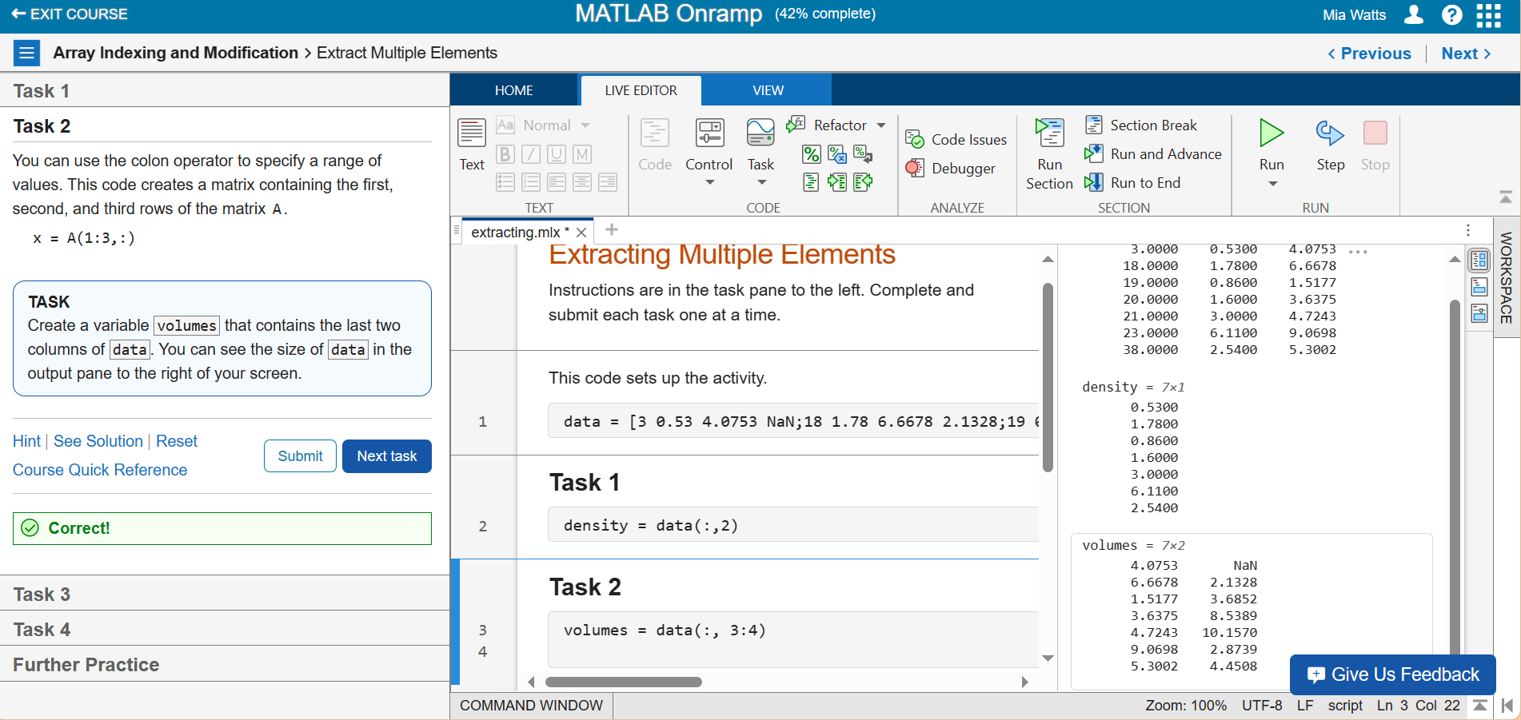

**Task 3 – Single Indexing**

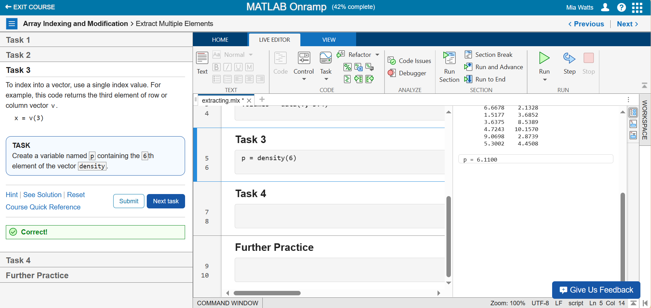

**Task 4 – Referencing Multiple Vector Elements**

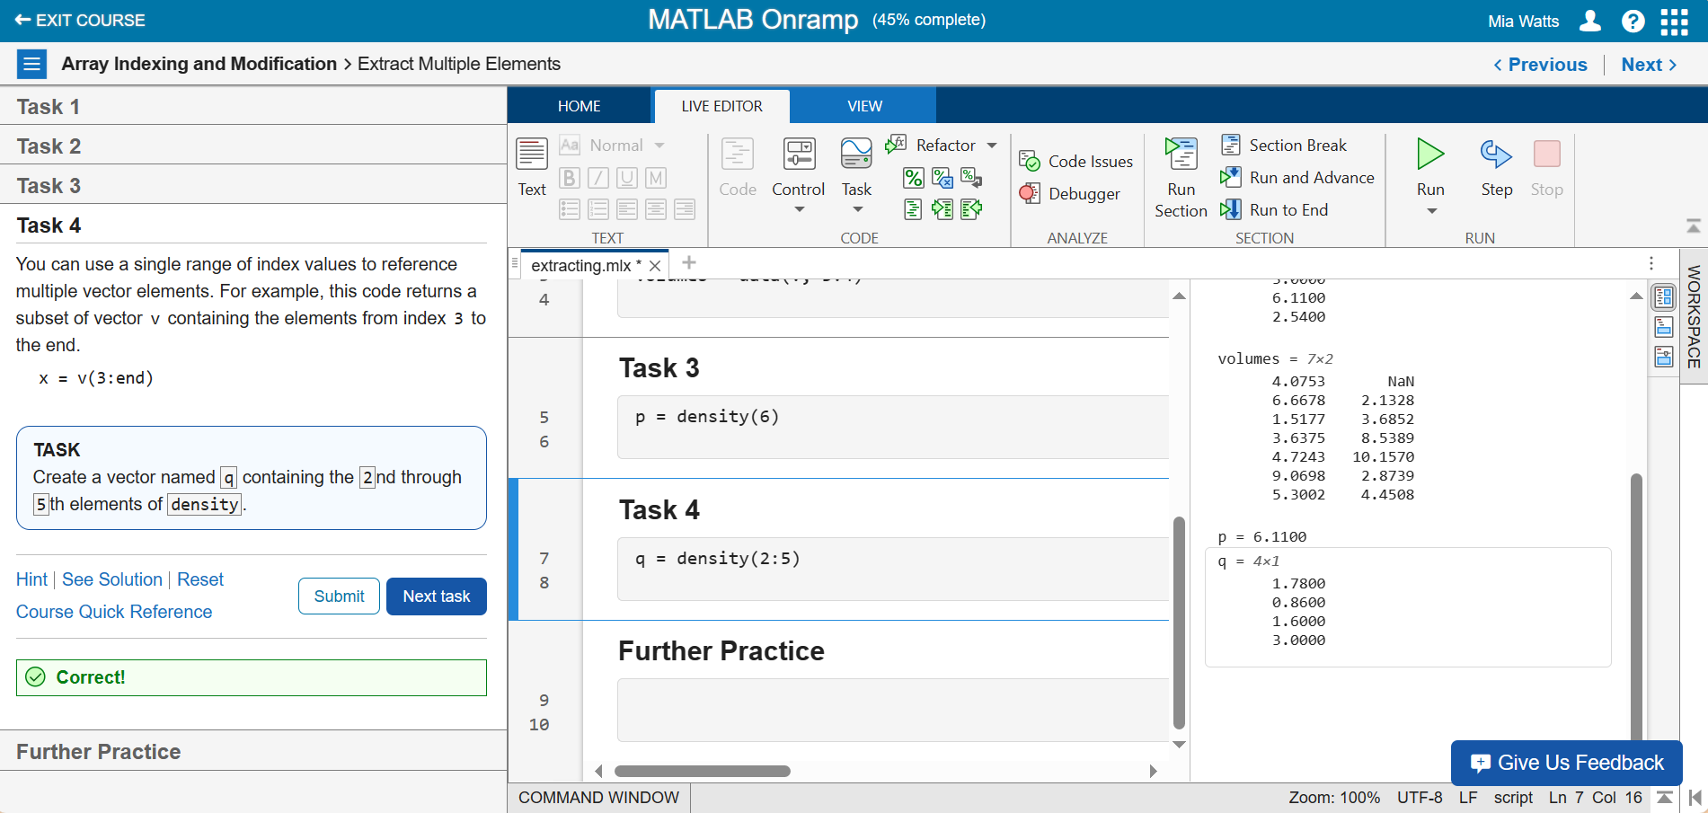

**Further Practice**

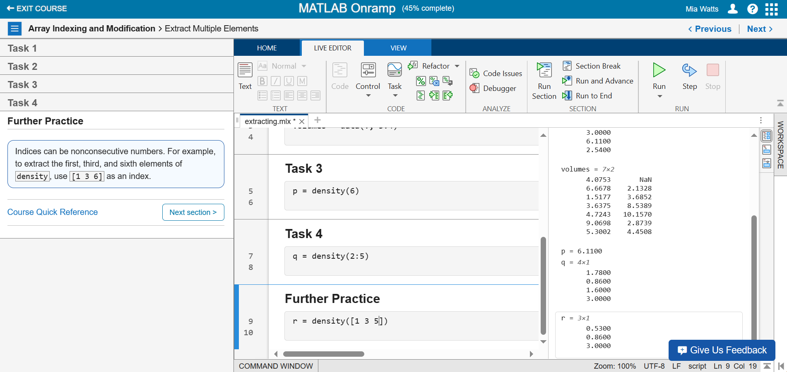

**Section 15**

**Task 1 – Getting Last Column**

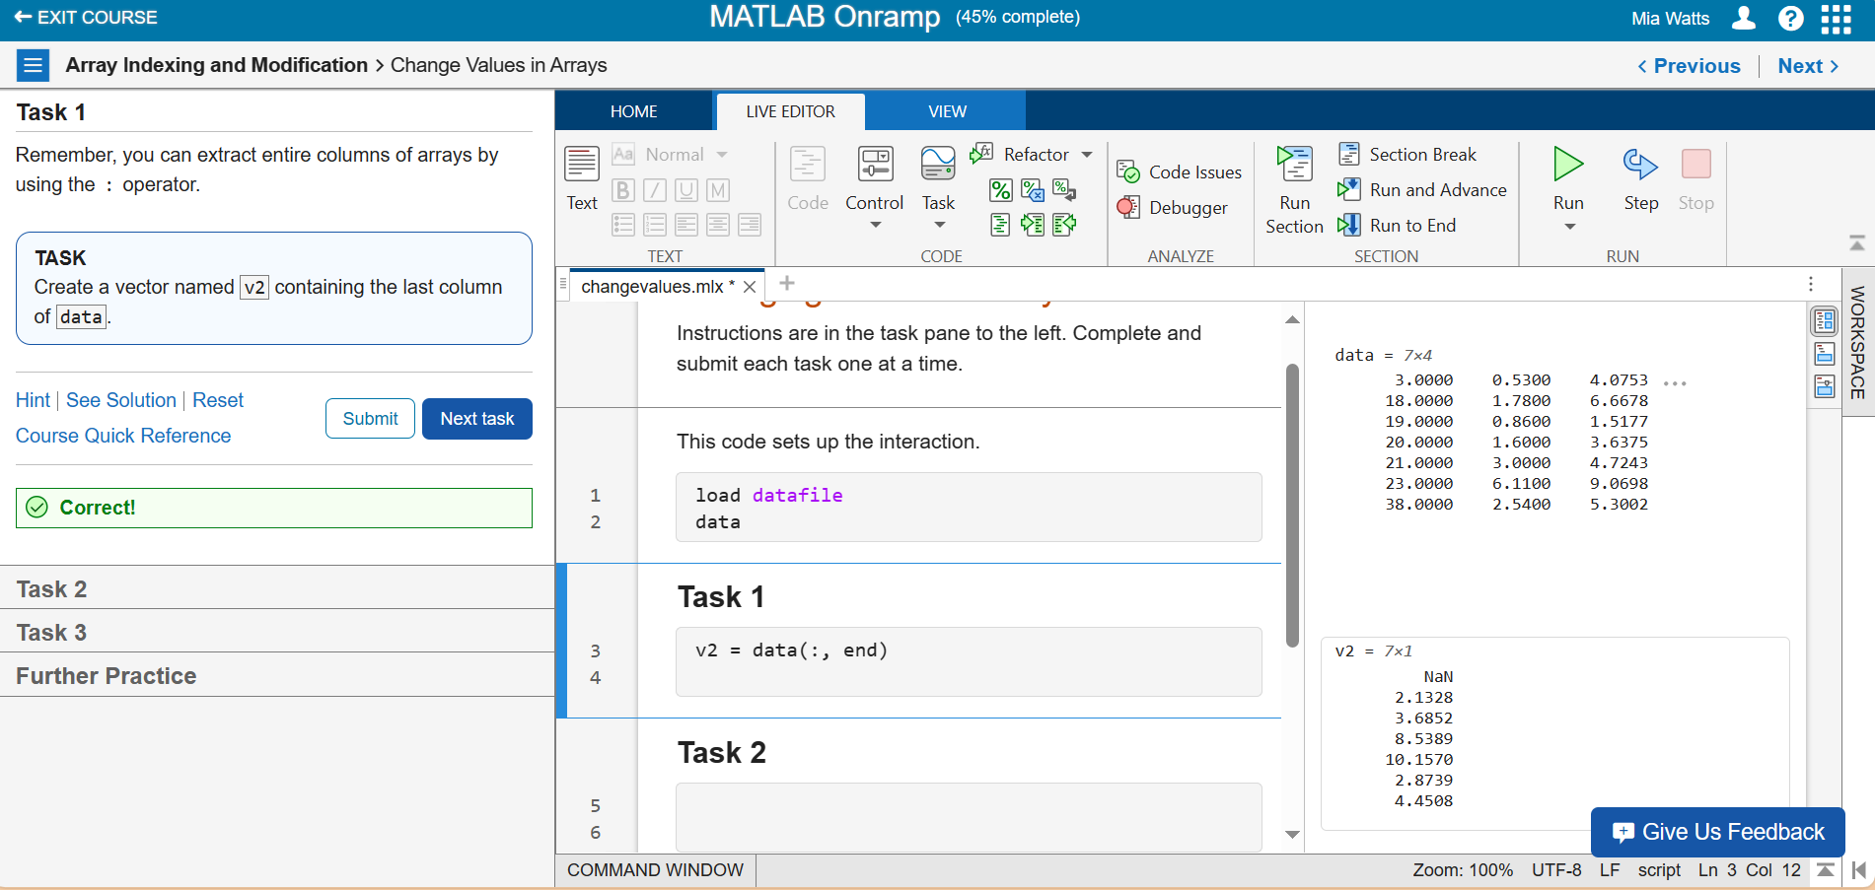

**Task 2 – Changing Elements**

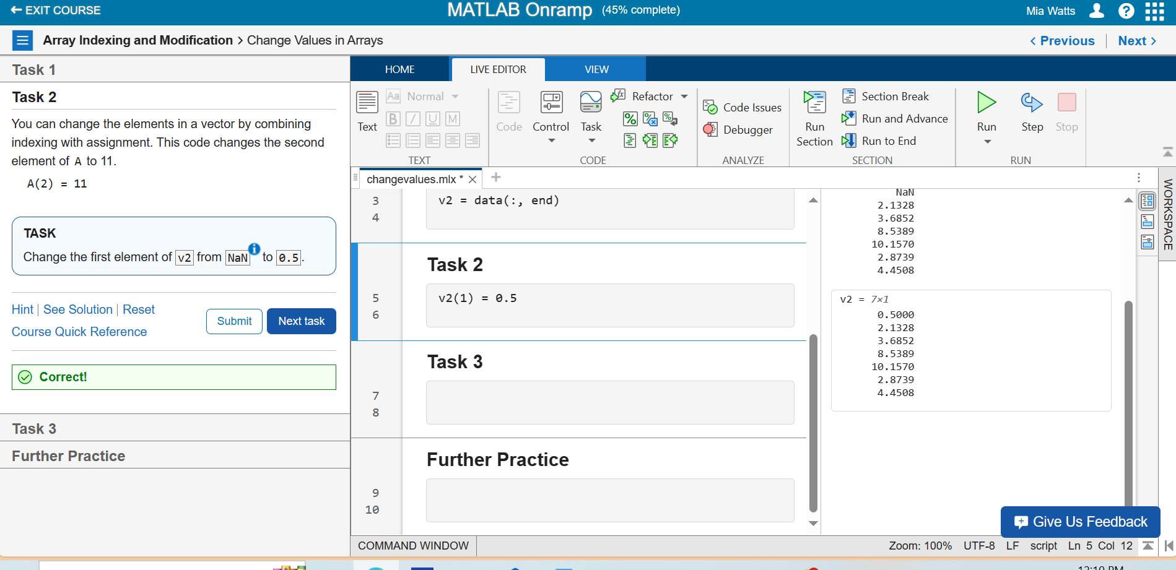

**Task 3 – Changing Elements in a Matrix**

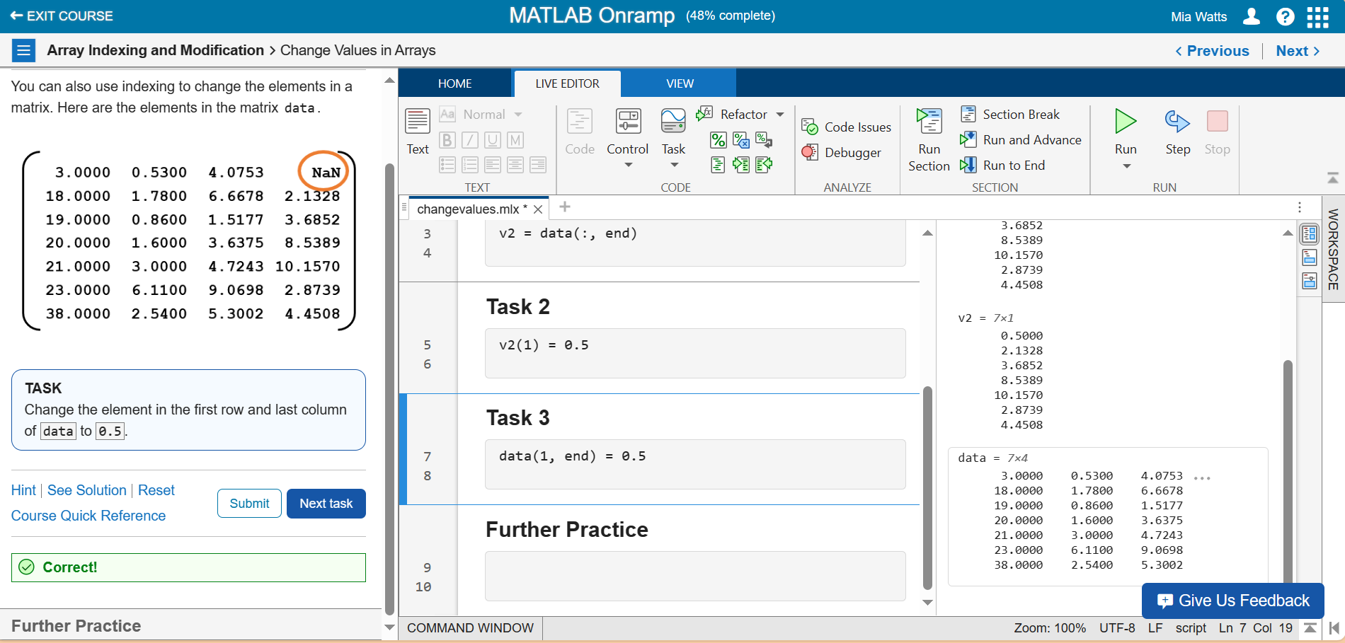

**Further Practice**

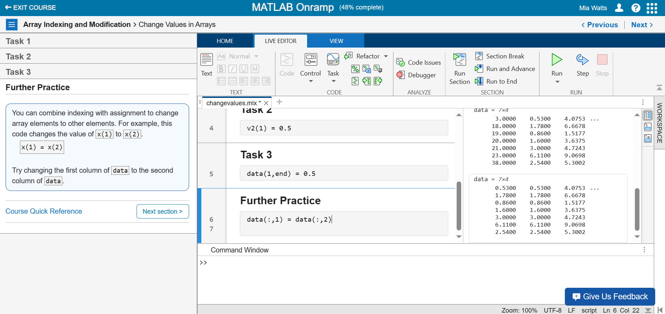

**Section 16**

**Task 1 – Adding 1 to Every Value**

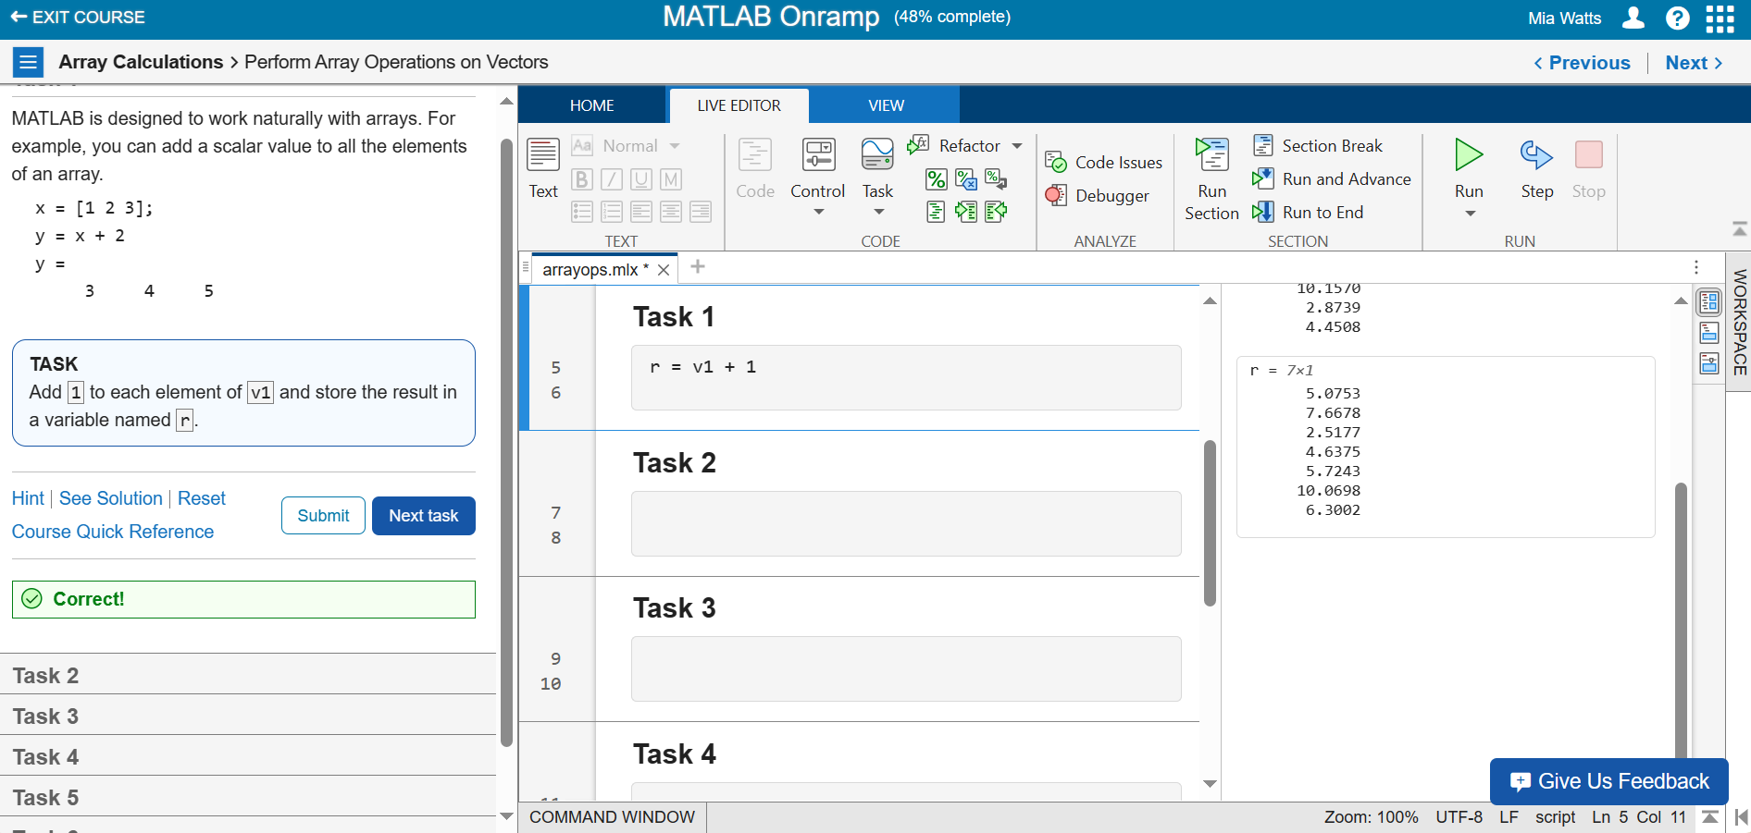

**Task 2 – Adding Arrays**

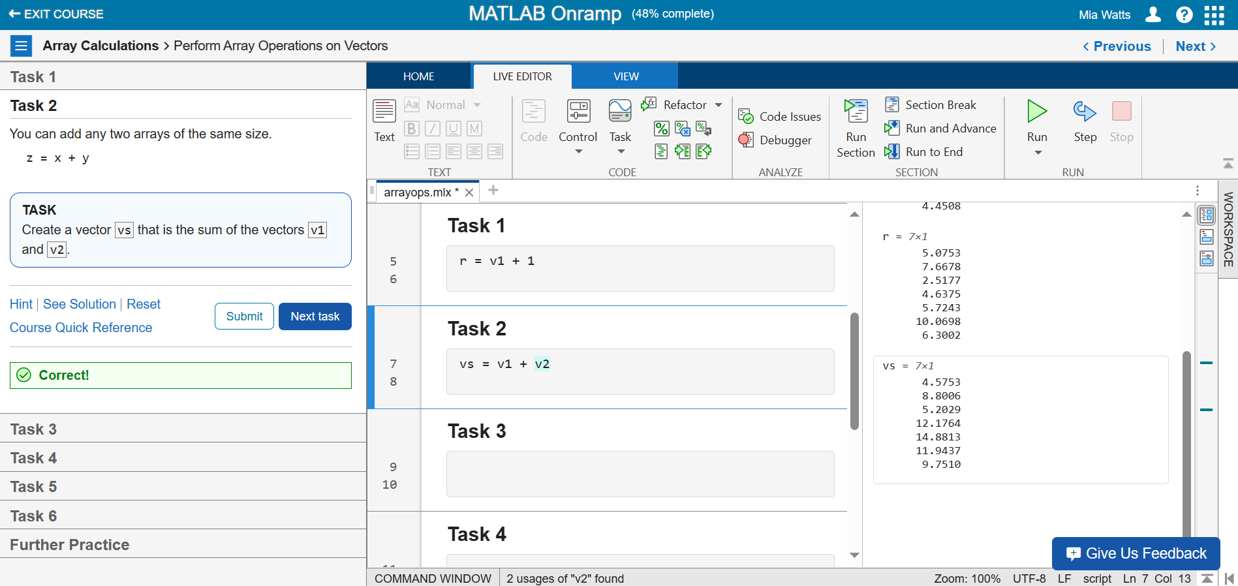

**Task 3 – Dividing Array Values**

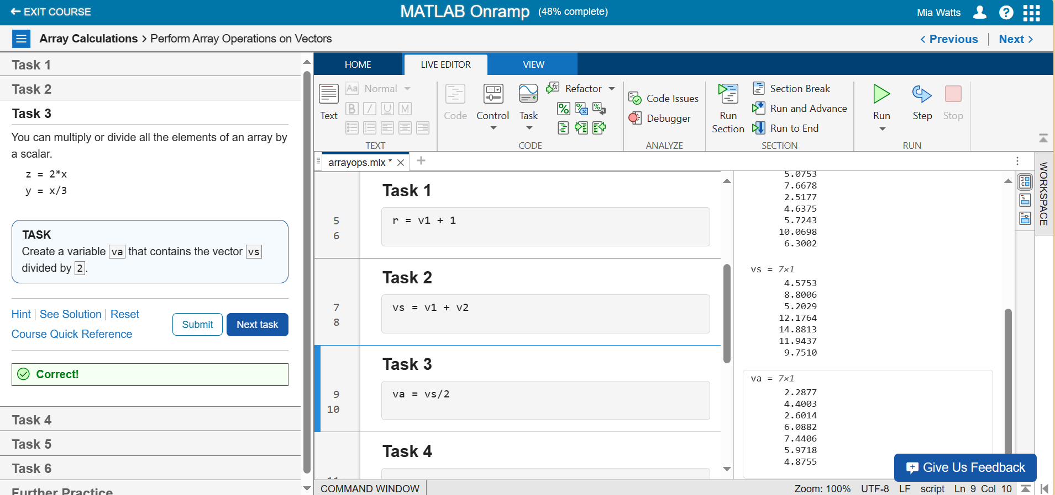

**Task 4 – Finding Maximum Values**

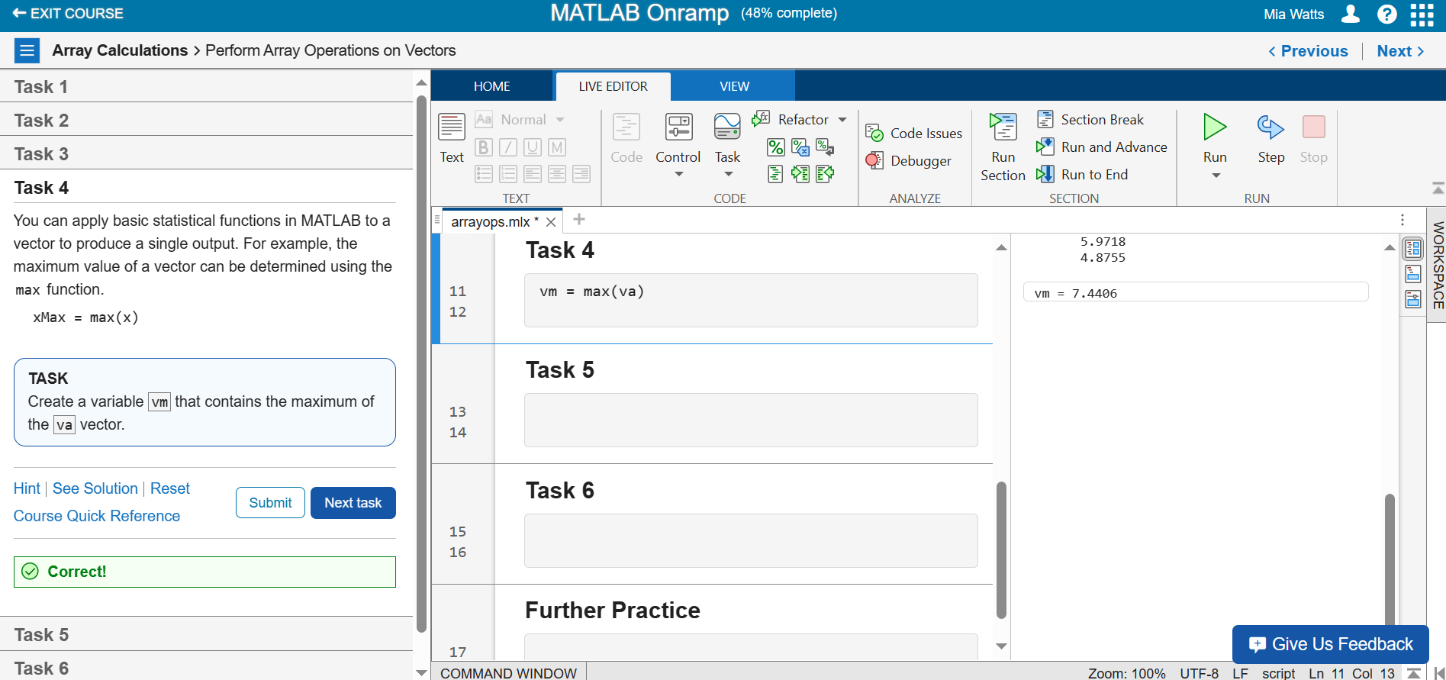

**Task 5 – Using the Round Function**

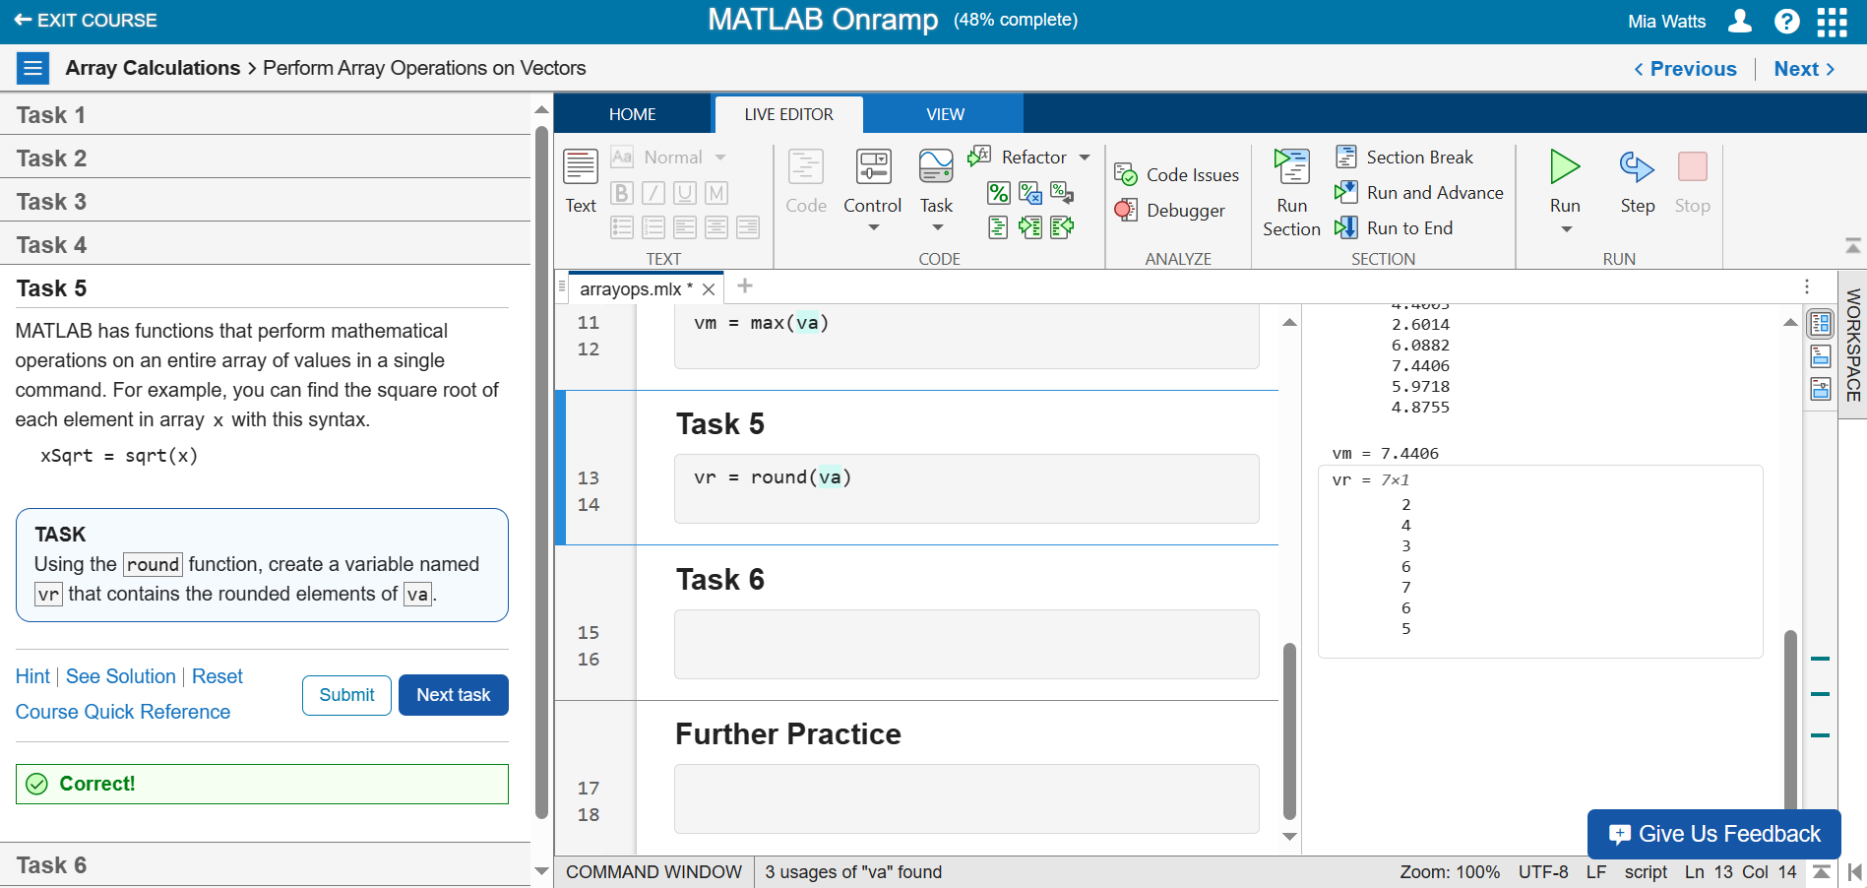

**Task 6 – Multiplying Arrays with Element-Wise Product**

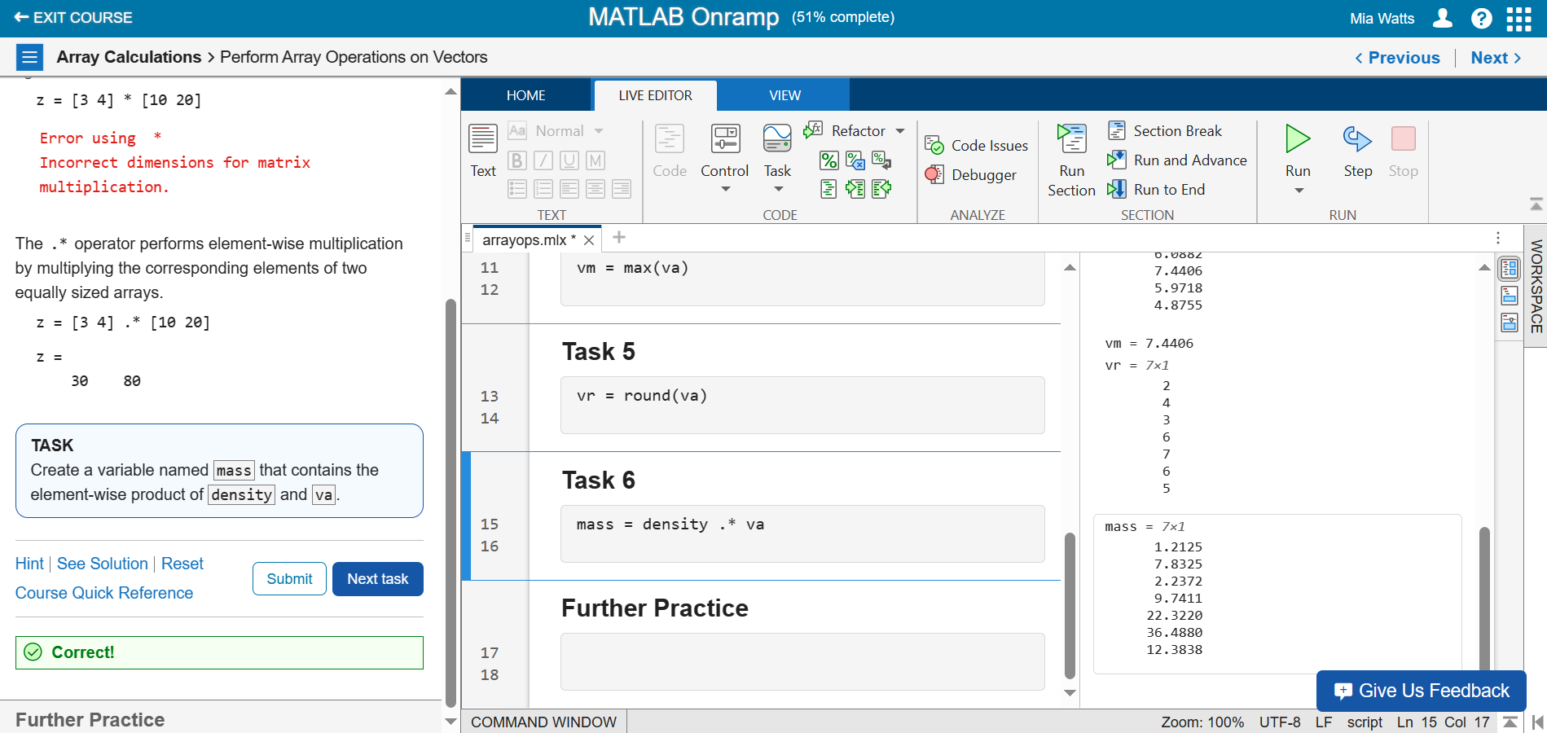

**Further Practice**

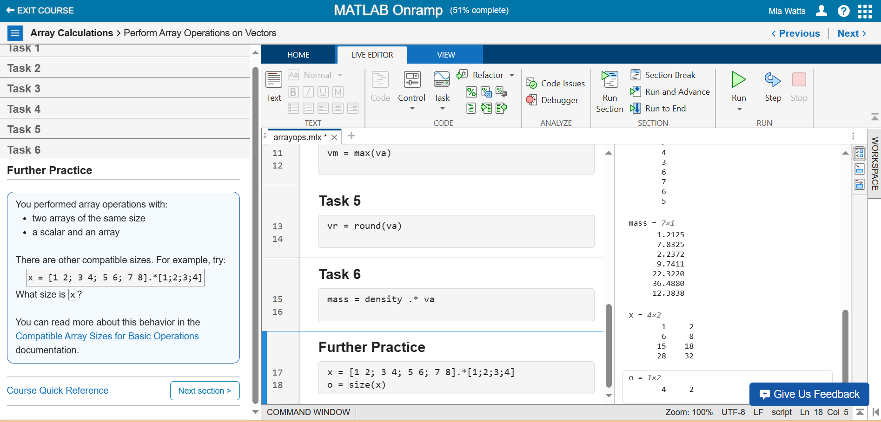

**Section 17**

**Task 1 –**

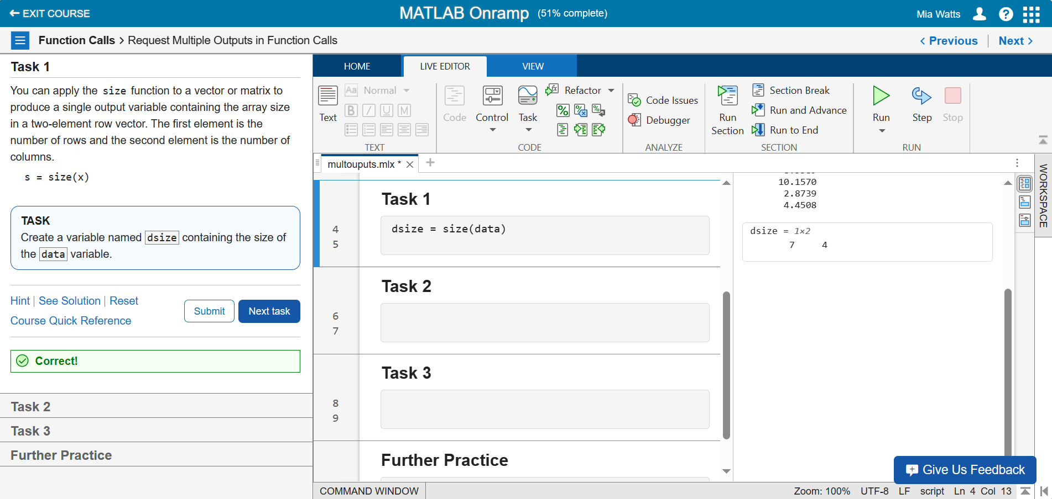

**Task 2 – Variables with Columns and Rows as Values**

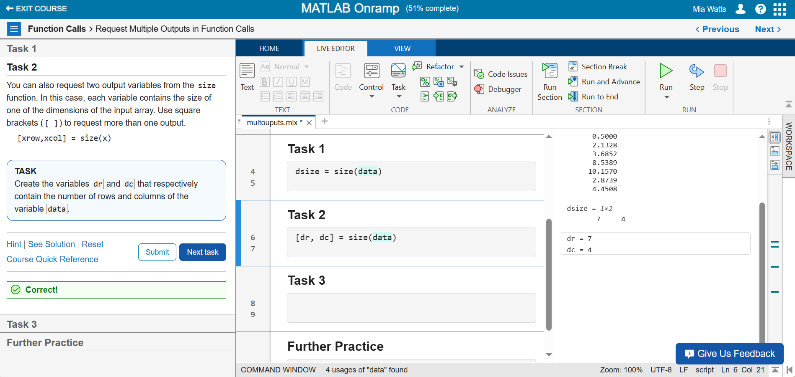

**Task 3 – Storing Max Values and Index Values**

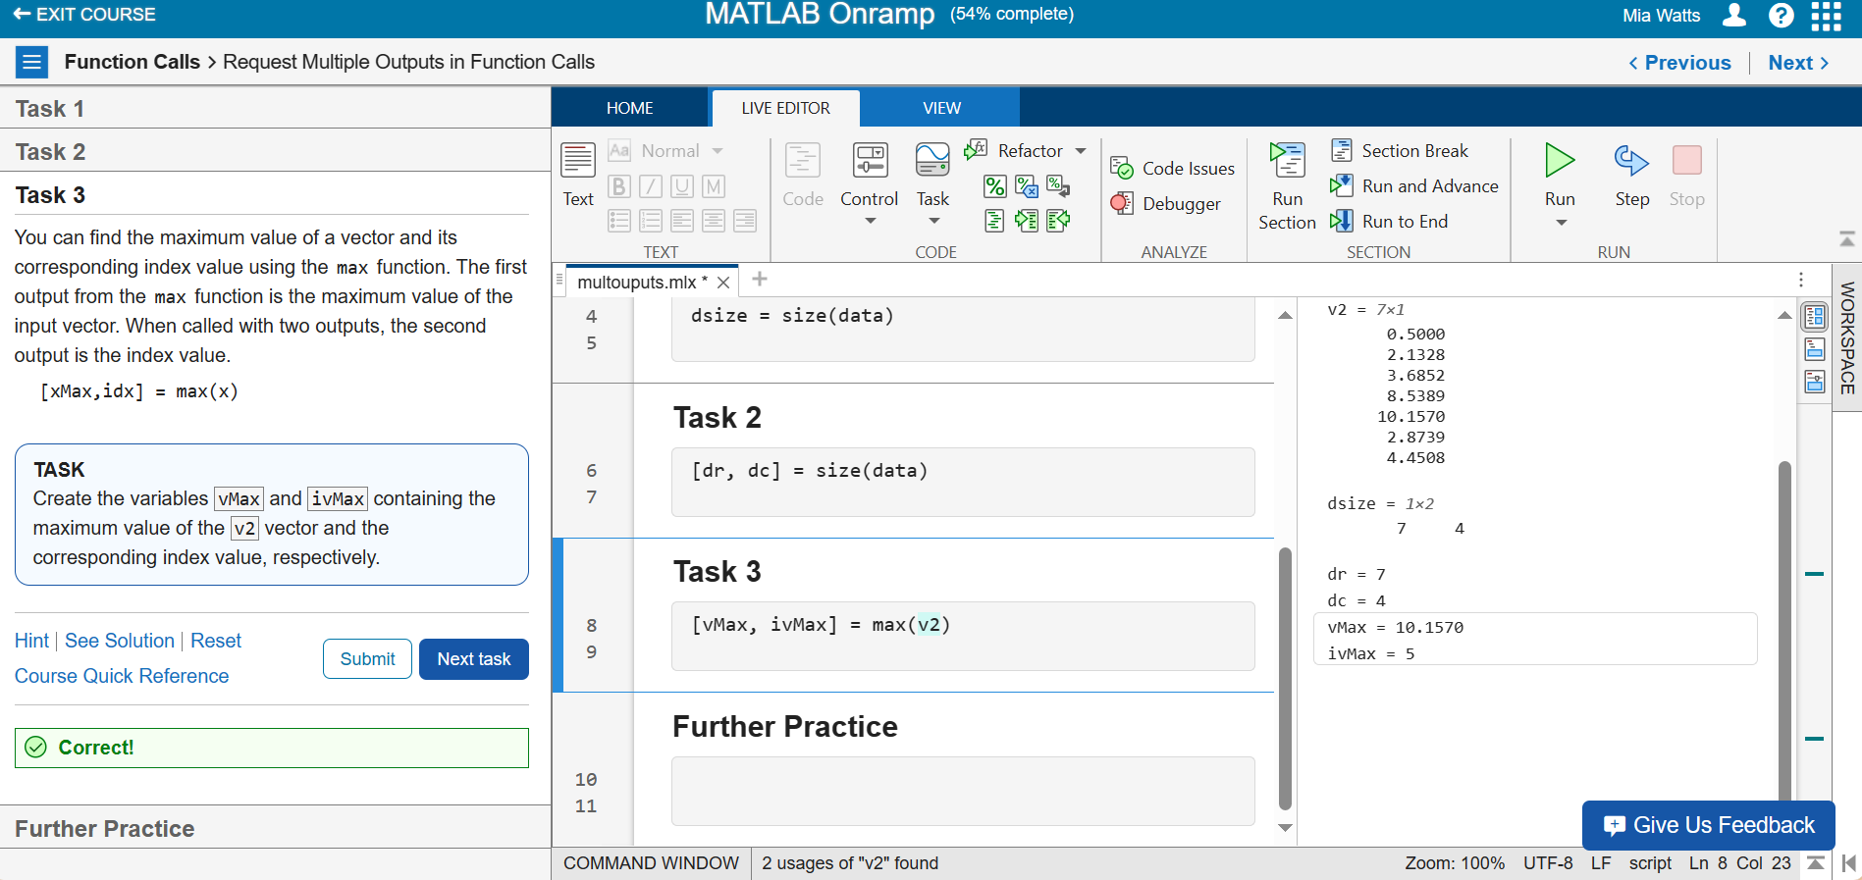

**Further Practice**

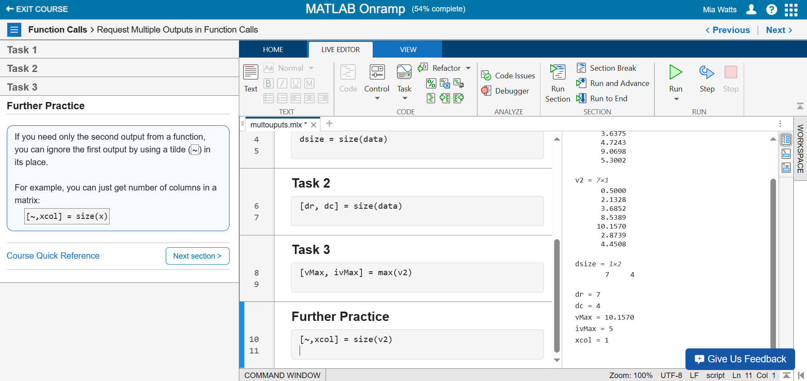

**Section 18**

**Video – MATLAB’s Help Feature**

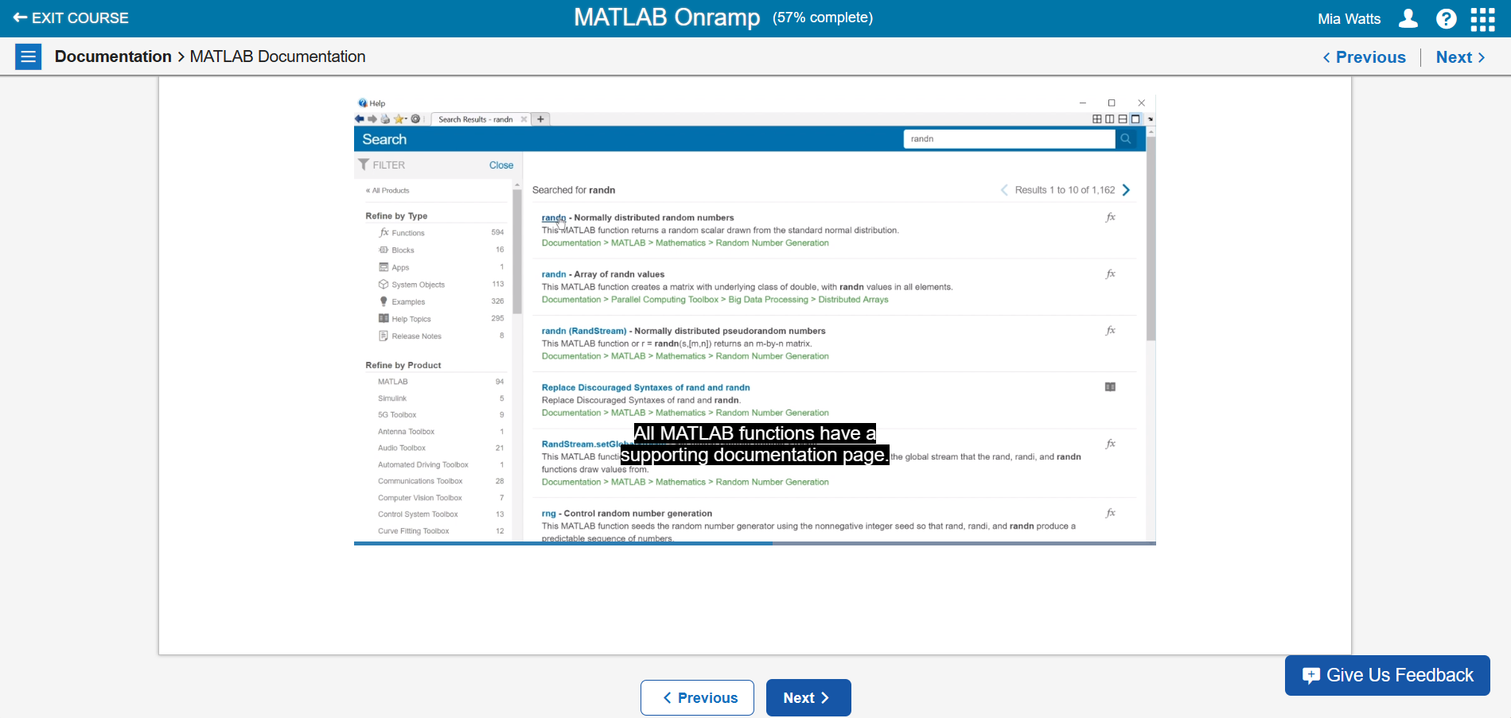

This video discussed MATLAB’s Help feature which shows complete documentation on functions that someone may not understand, especially if they are new to MATLAB.

**Section 19**

**Task 1 – Using Documentation to Solve a Task**

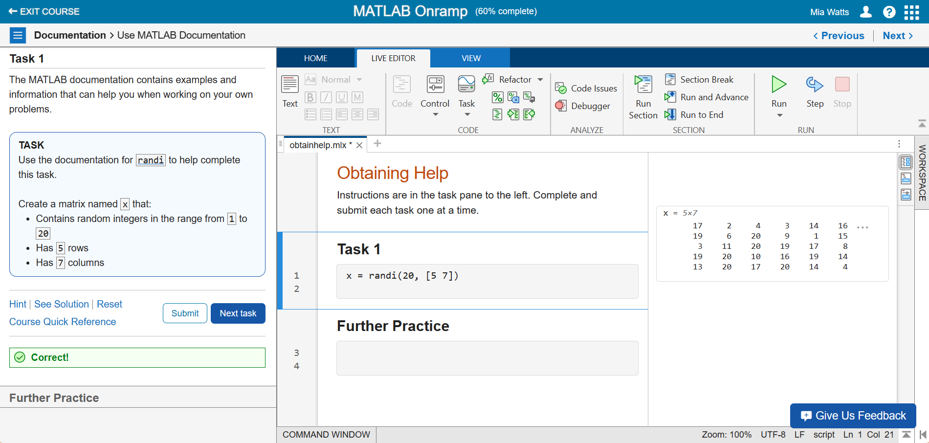

**Further Practice**

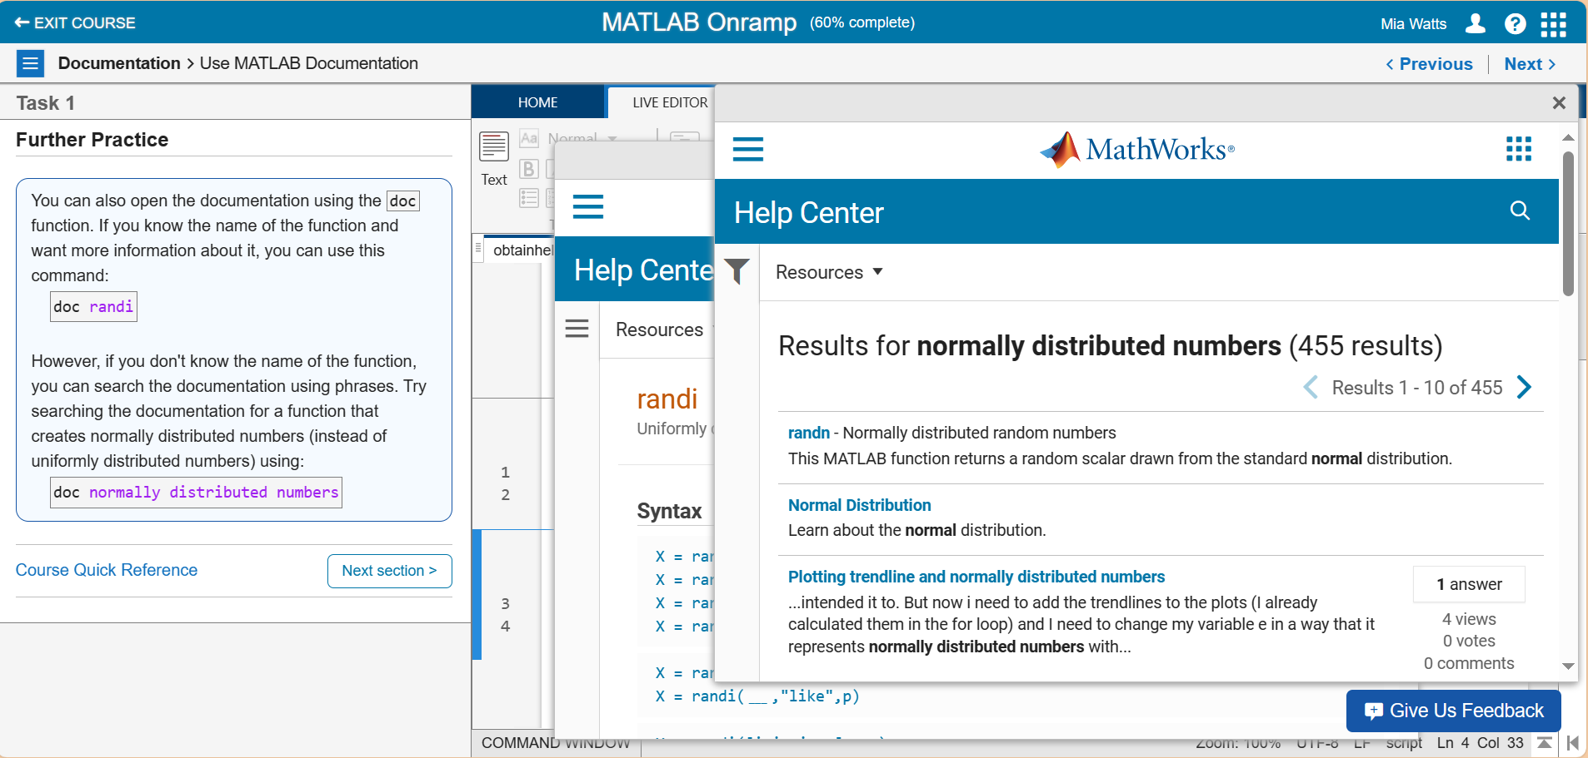

**Section 20**

**Task 1 – Plotting**

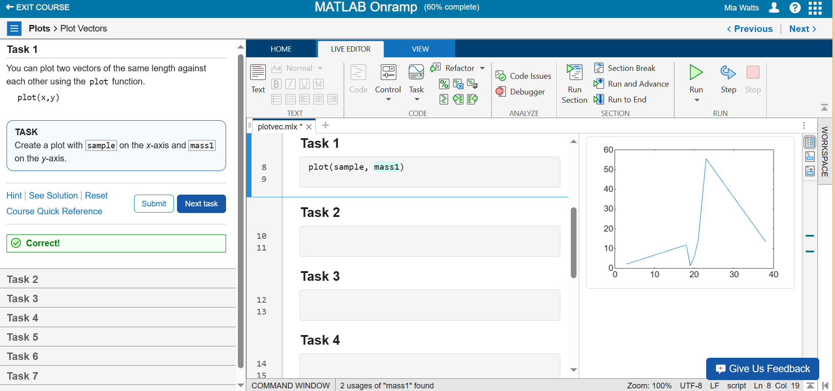

**Task 2 – Changing Plot Lines**

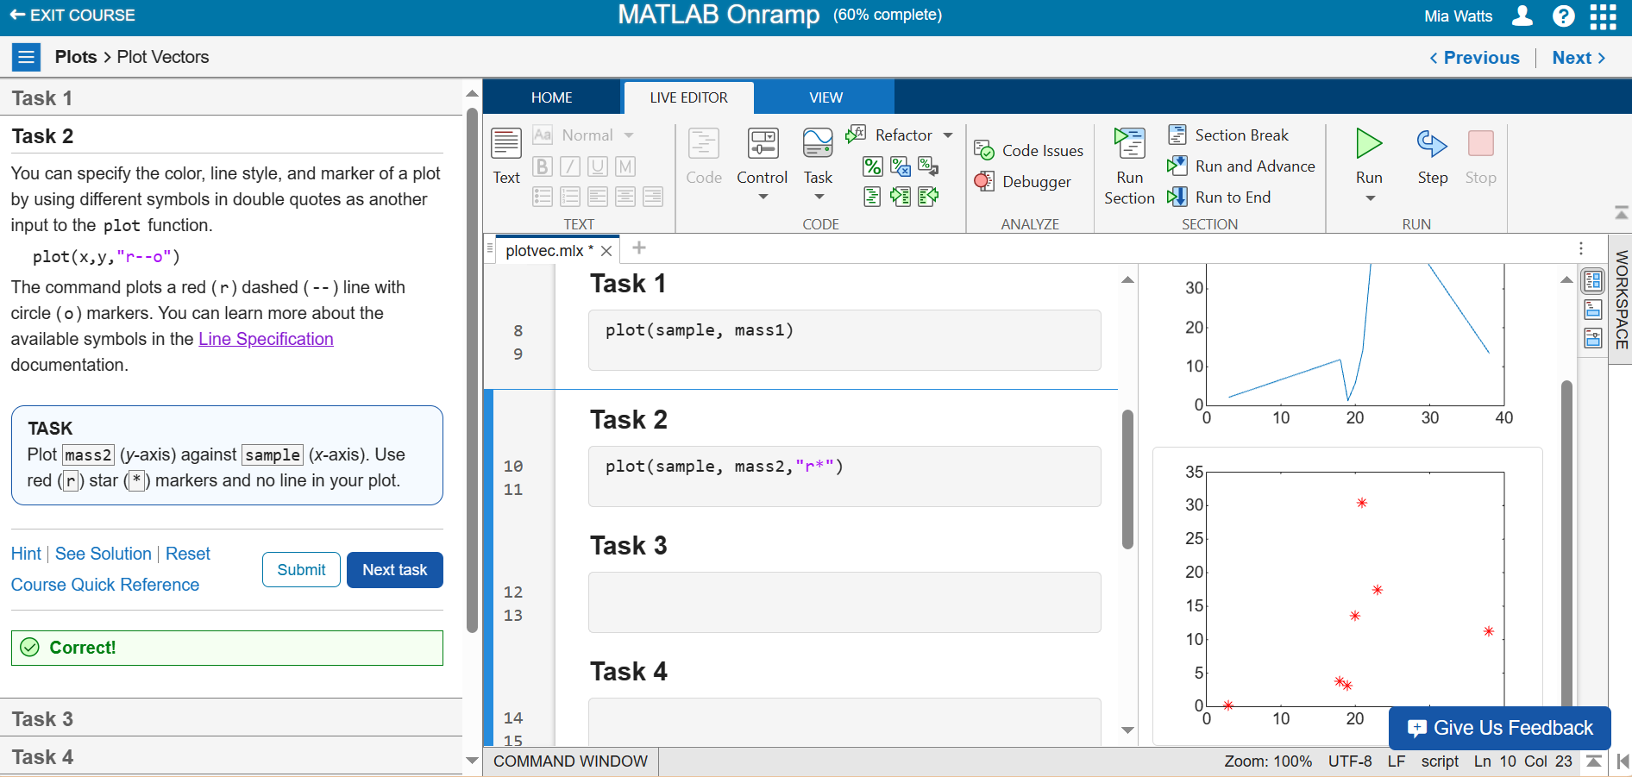

**Task 3 – More Plotting**

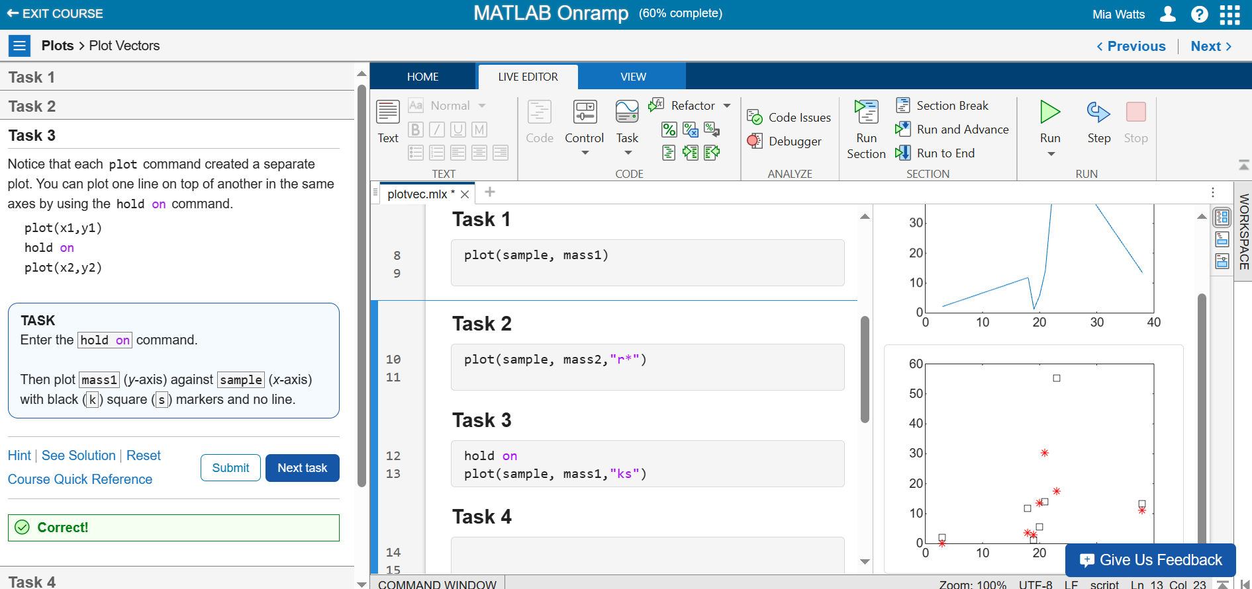

**Task 4 – Using “hold off” Commands**

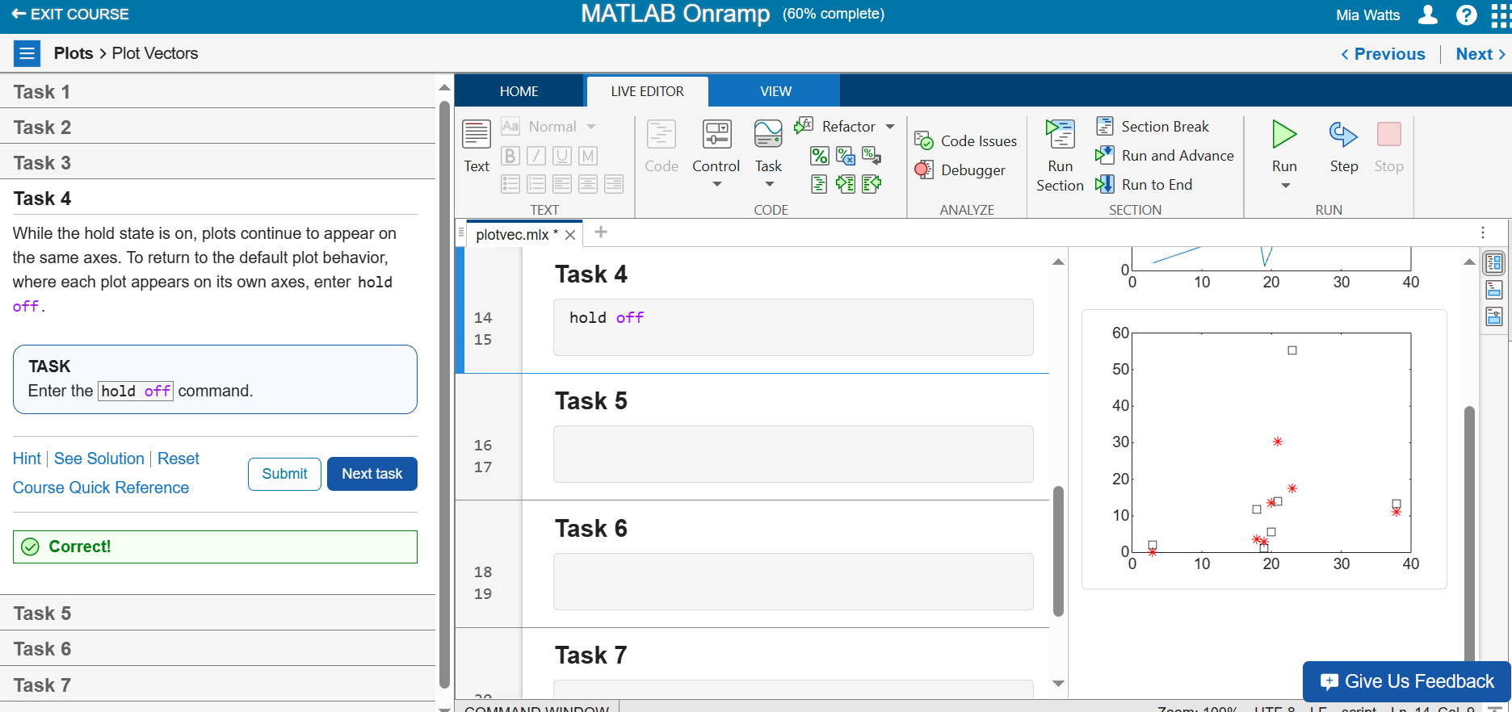

**Task 5 – Plotting a Vector**

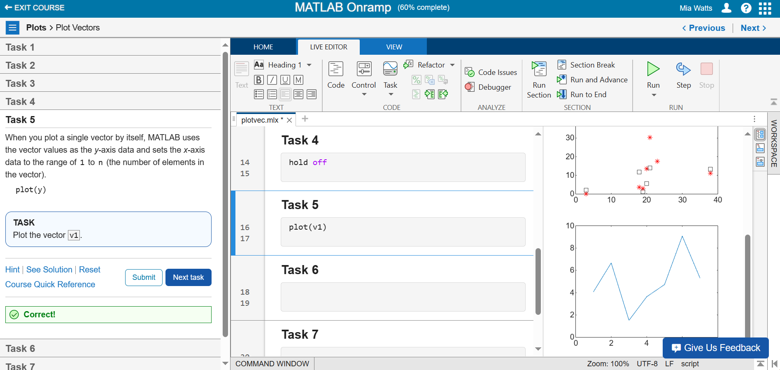

**Task 6 – Plotting Vectors with Different Line Widths**

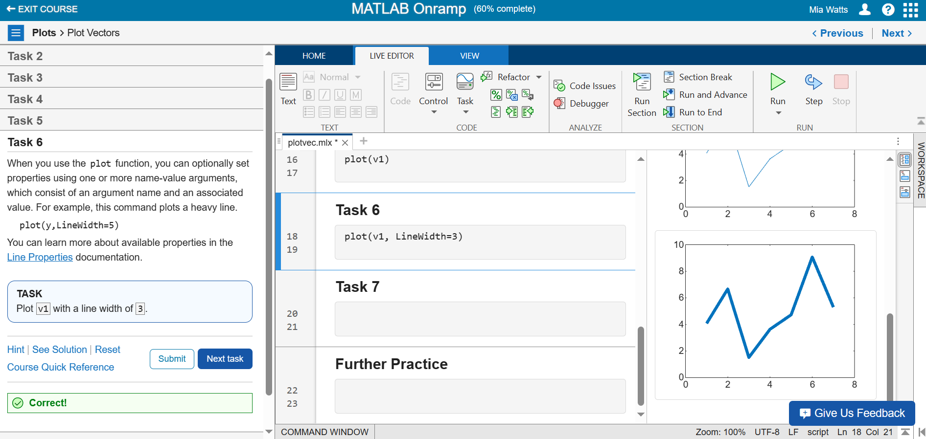

**Task 7 – Plotting Graphs with More Parameters**

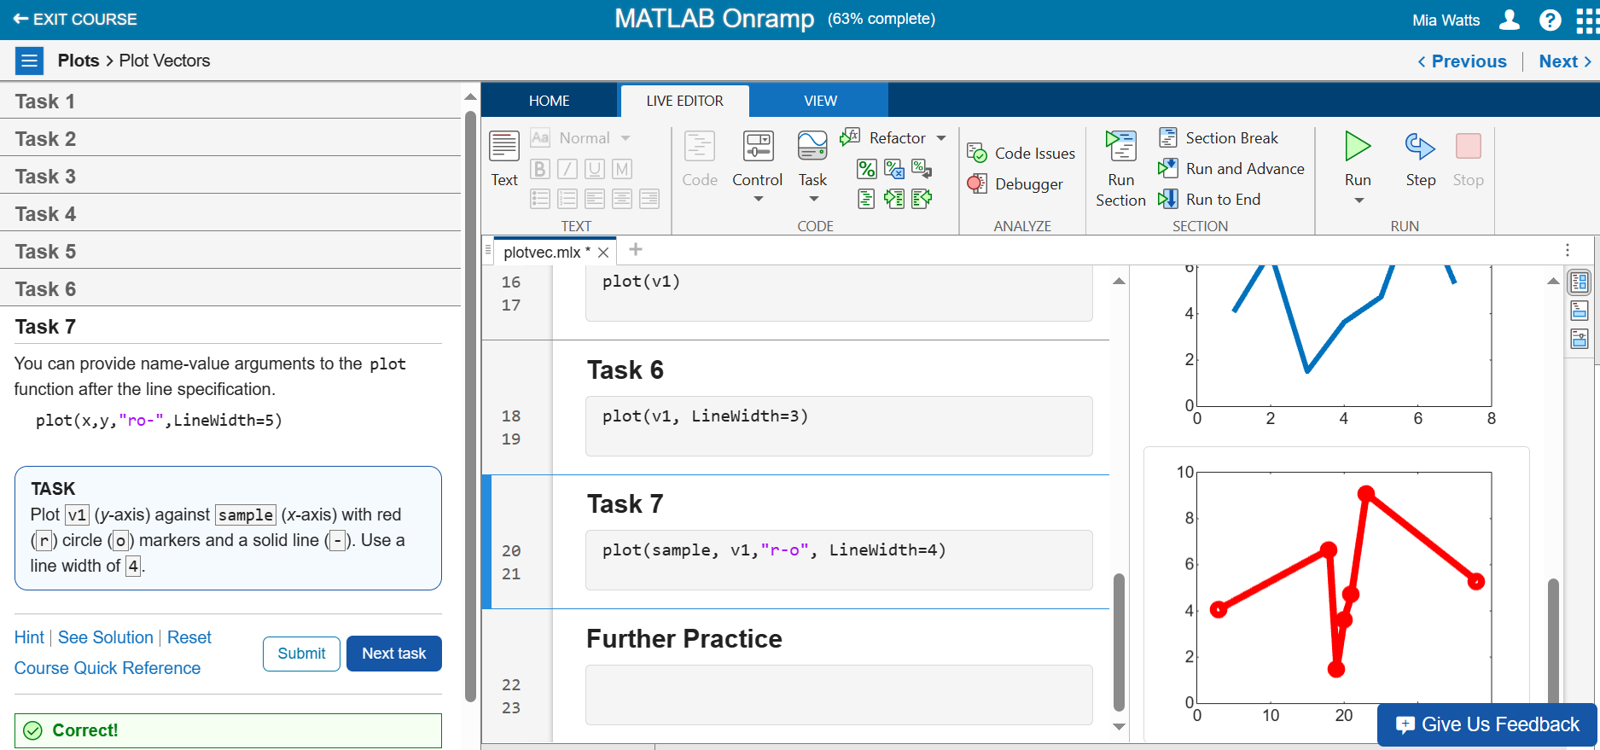

**Further Practice**

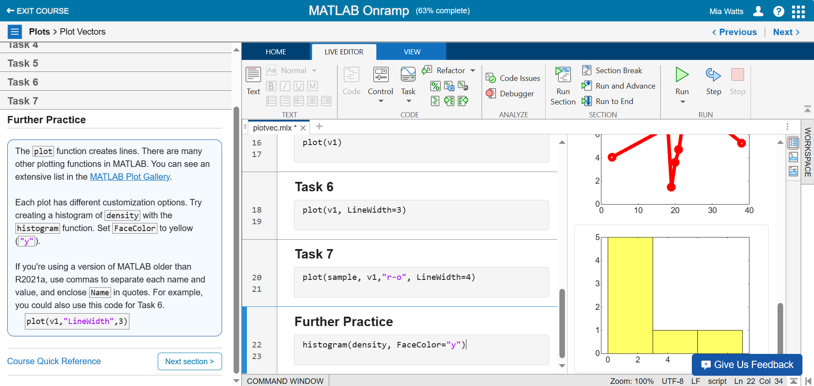

**Section 21**

**Task 1 – Creating a Title**

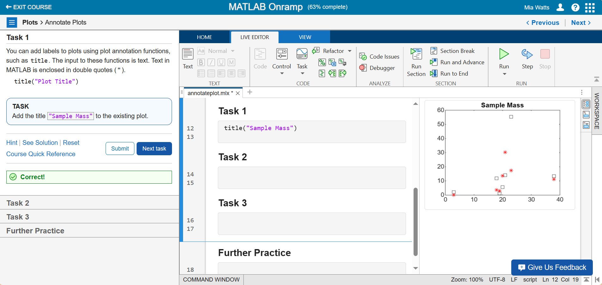

**Task 2 – Adding a y-axis Title**

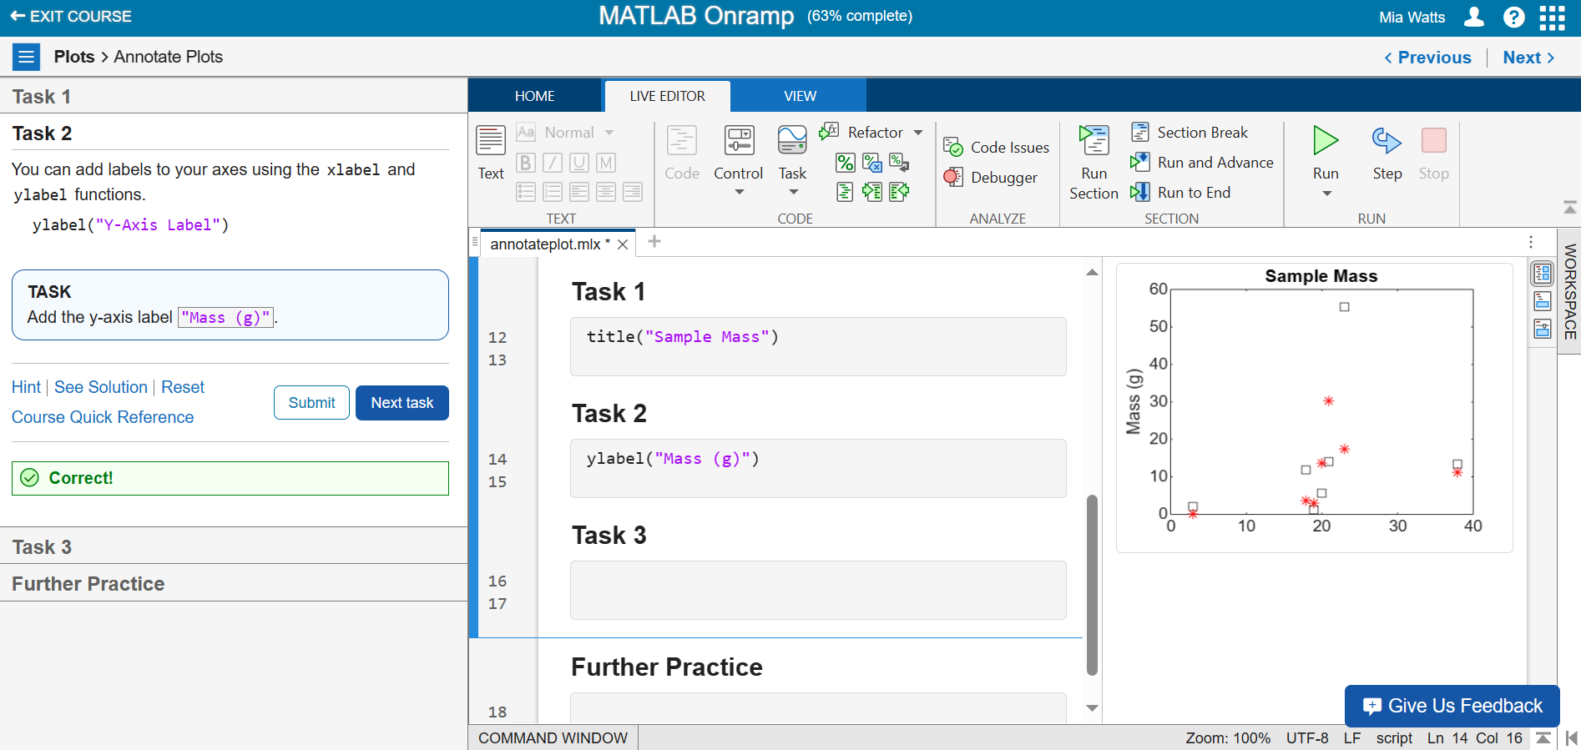

**Task 3 – Added a Legend**

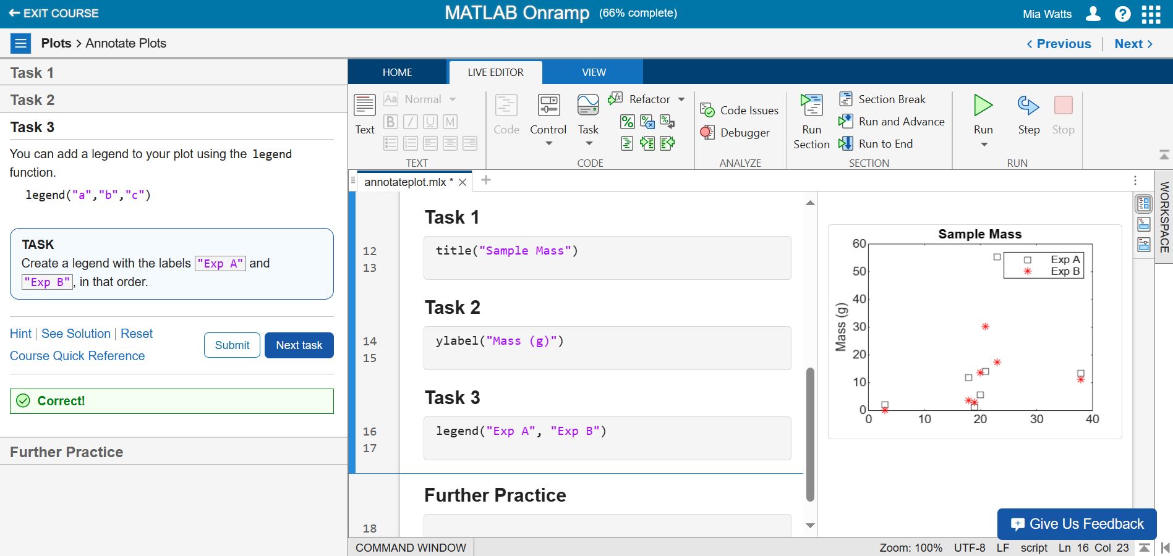

**Further Practice**

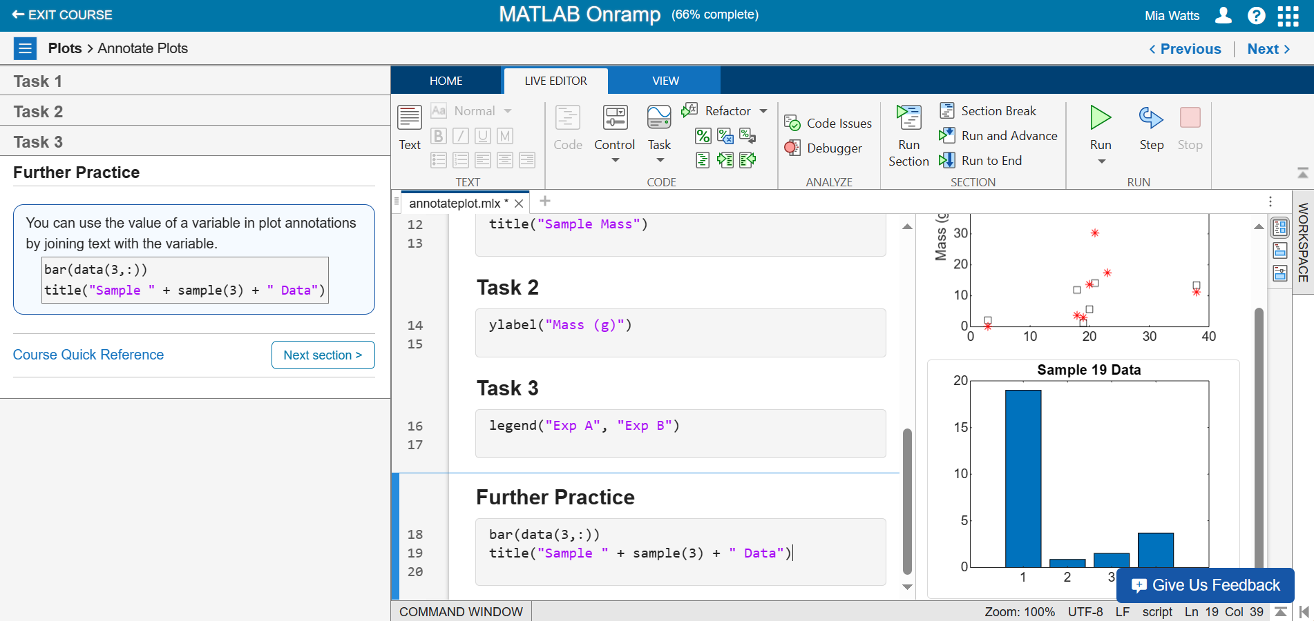

**Section 22**

**Video – Using the Import Tool**

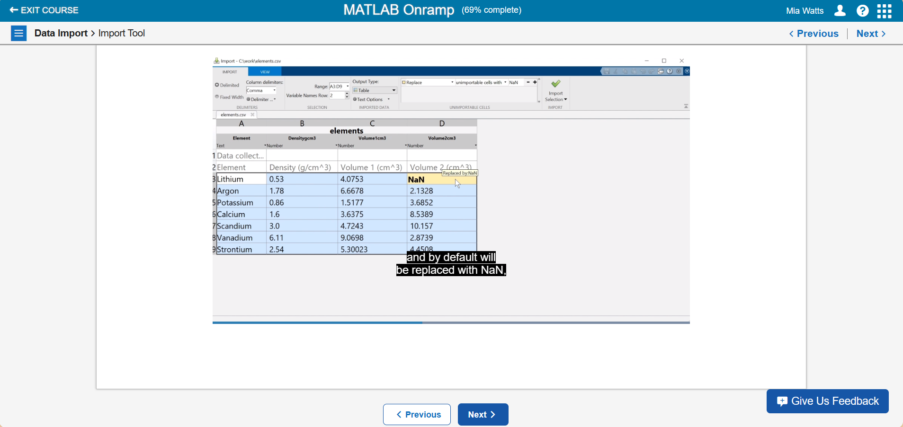

The above video introduced the import tool which can be used to import information into MATLAB, like a table as shown above. Photos can be imported along with .mat files which can load data or information into the console.

**Section 23**

**Task 1 – Assigns an Imported Table to a Variable**

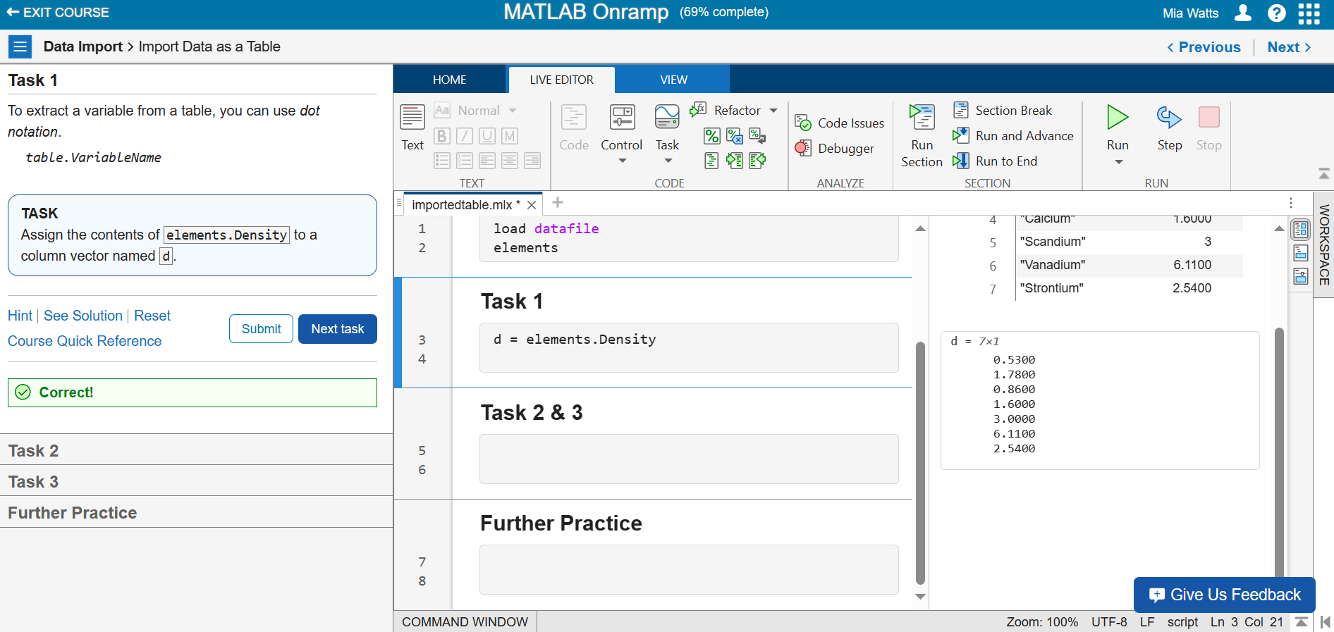

**Task 2 – Multiplying Elements Together**

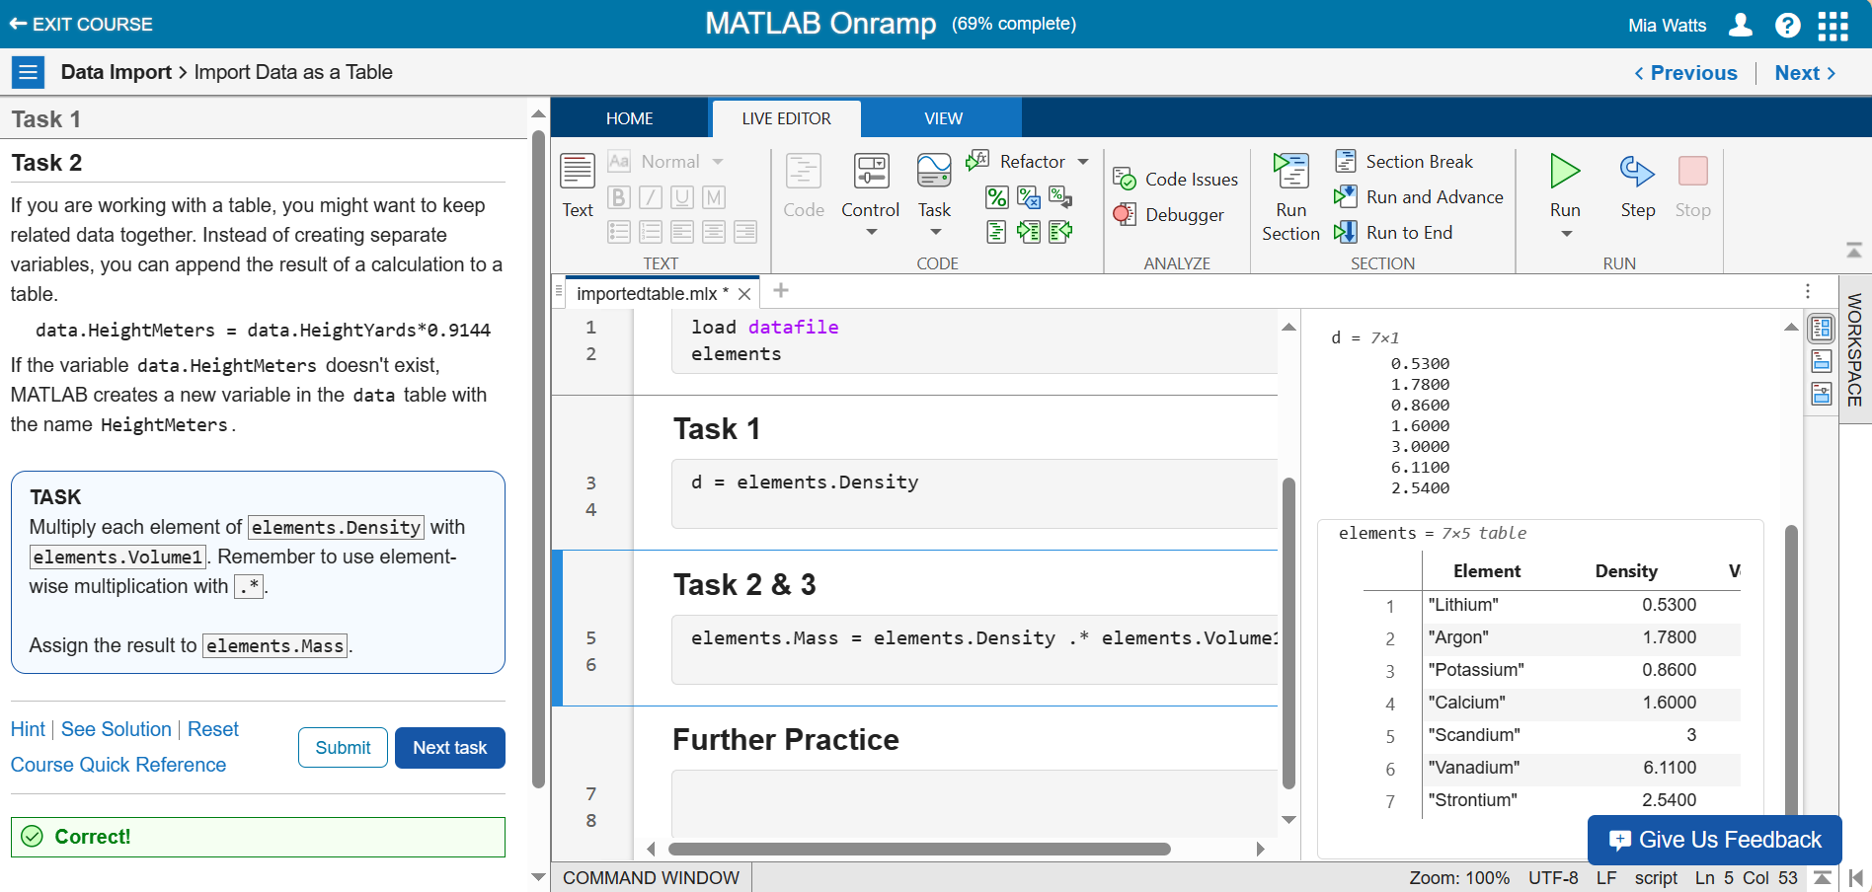

**Task 3 –**

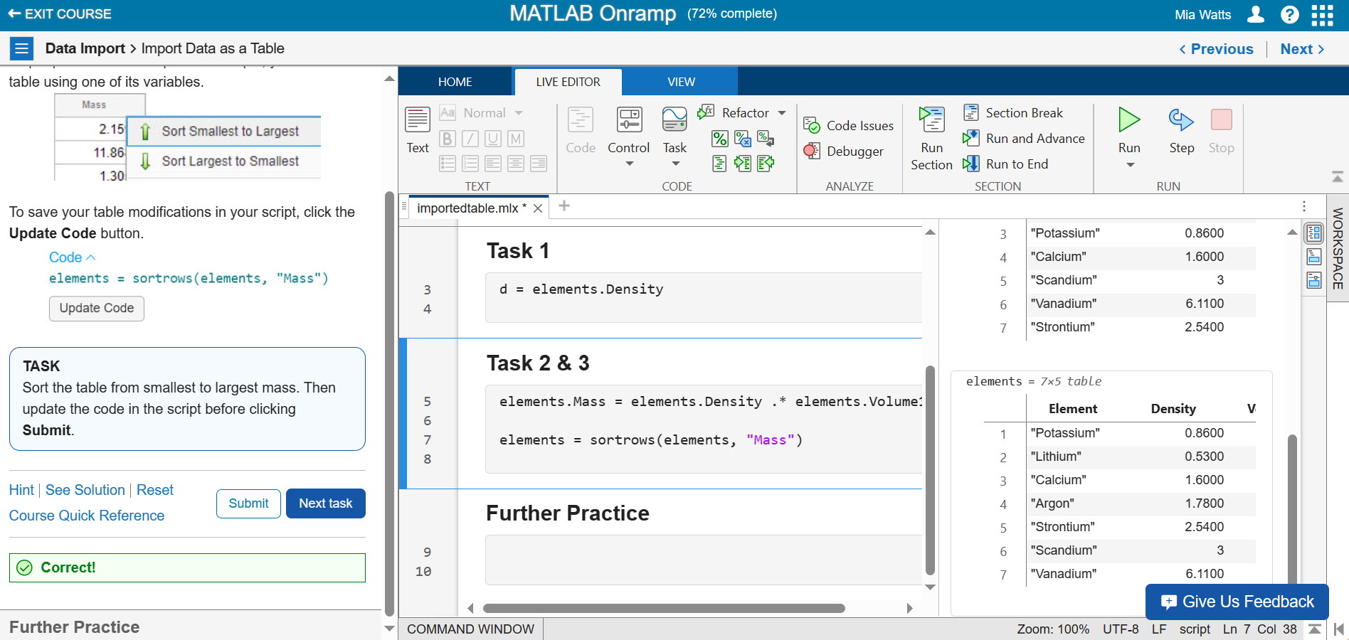

**Further Practice**

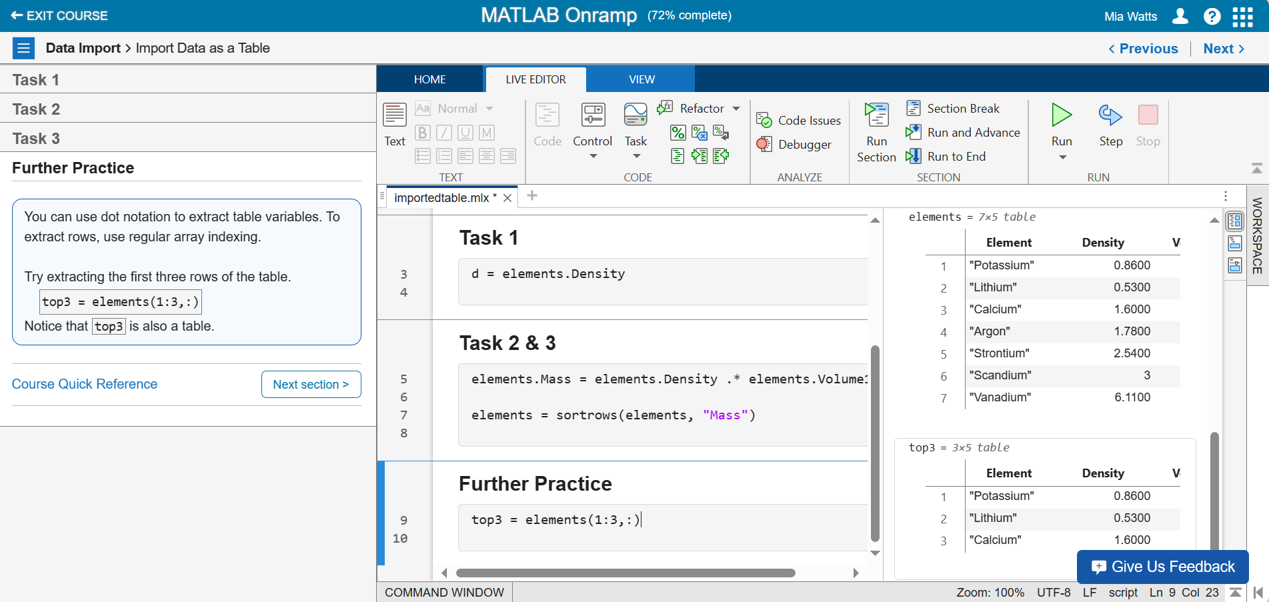

**Section 24**

**Task 1 – Using the Less Than Operator**

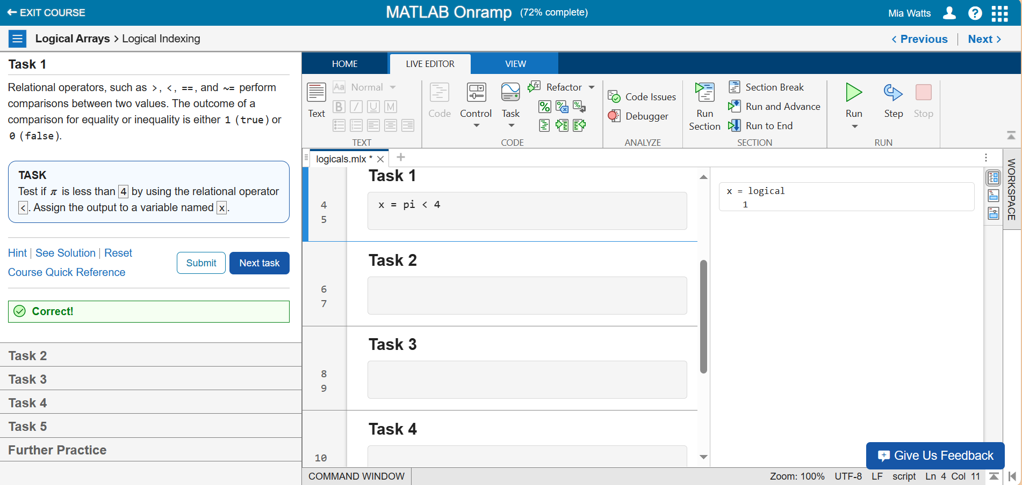

**Task 2 – Checked to Find Values in a Vector Less Than 4**

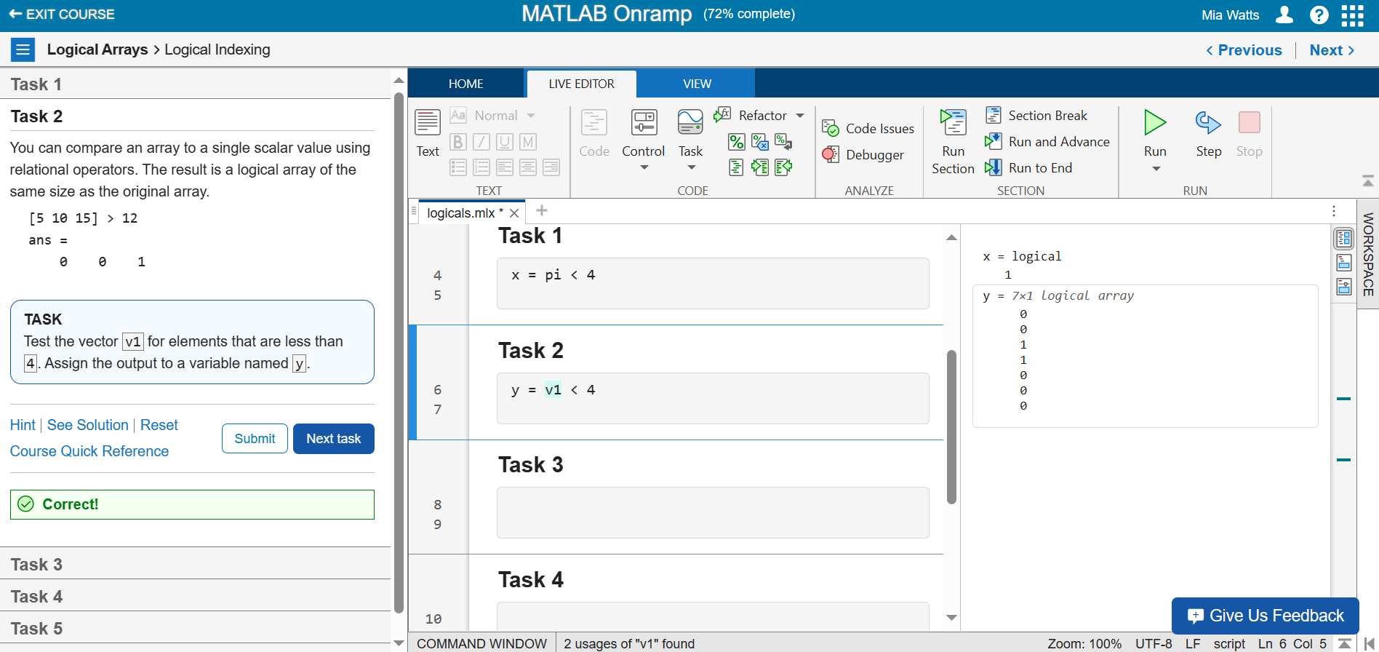

**Task 3 – Creating a Variable with Elements Less Than 4**

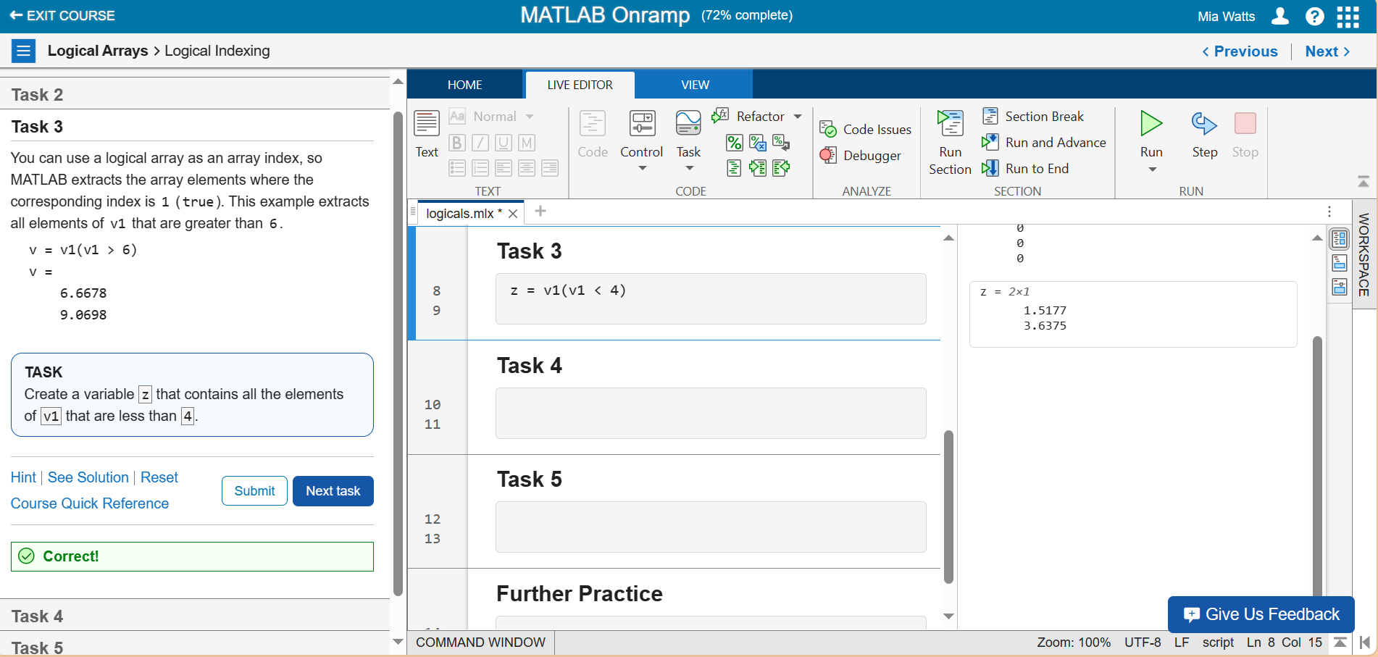

**Task 4 – Using Logical Indexing with Two Different Arrays**

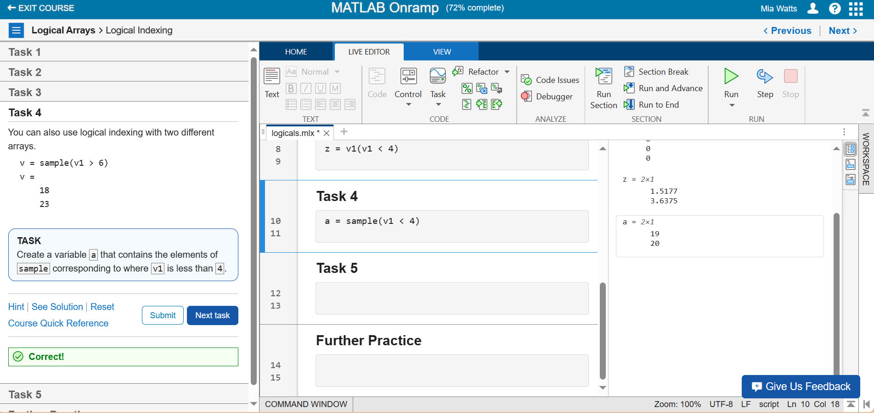

**Task 5 – Reassigning Values Less Than 4 to 0**

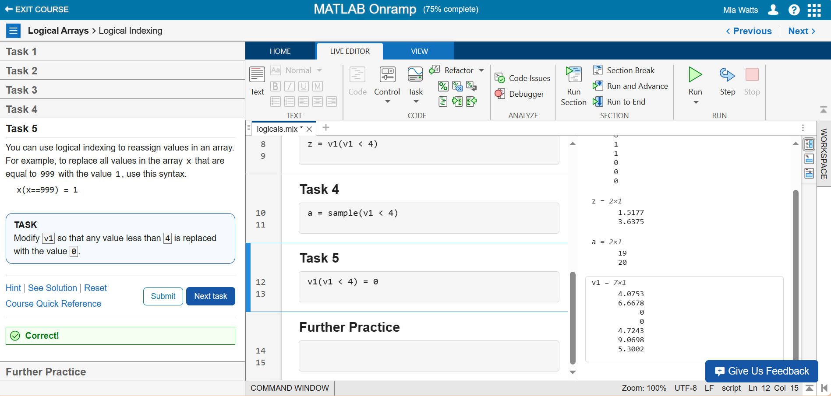

**Further Practice**

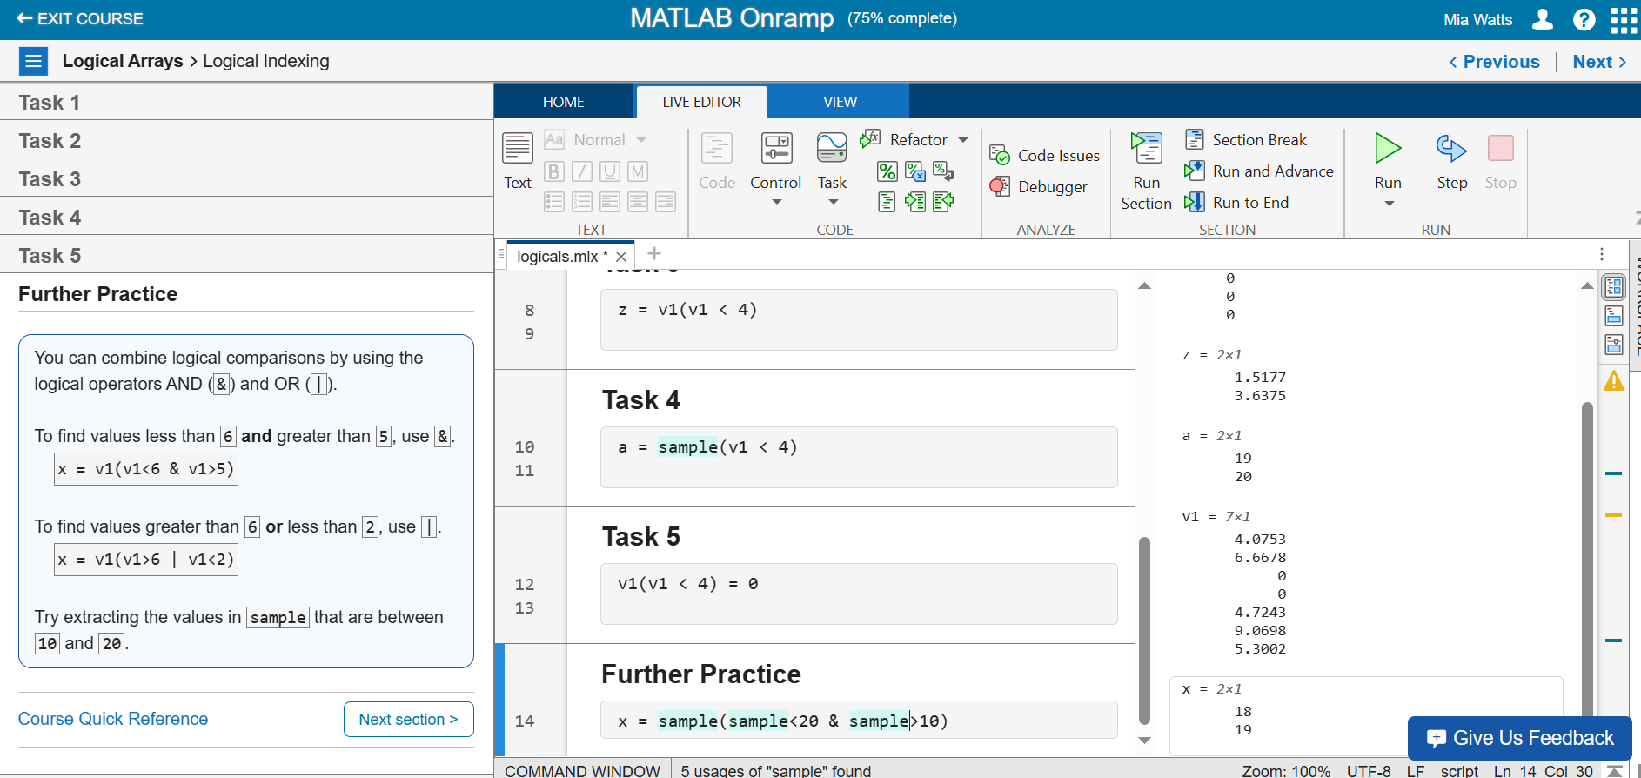

**Section 24**

**Video – Programming Constructs**

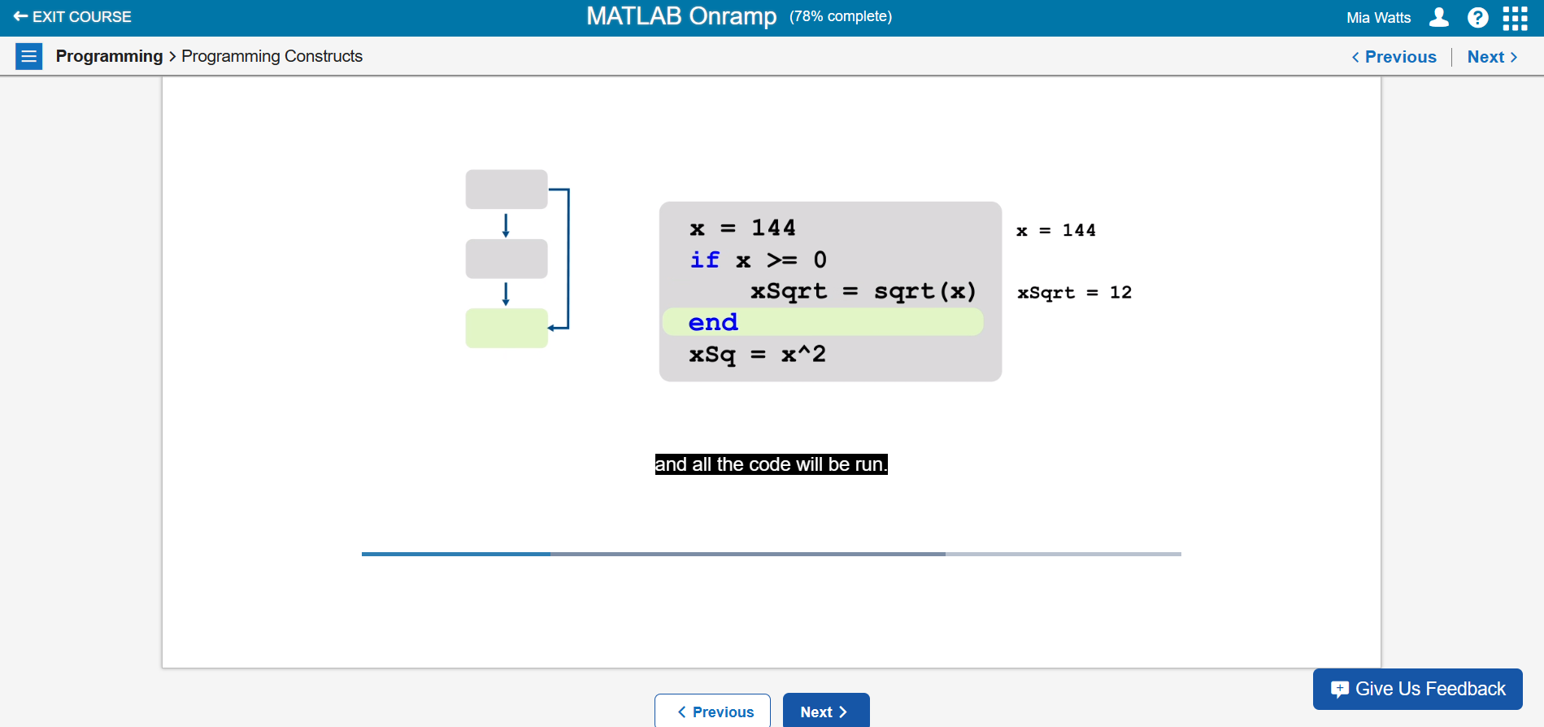

Using for loops along with if-else statements are mentioned in this video. Each of these are important along with printing results, so the video describes how to use the statements that correspond with the given loop or structure.

**Section 25**

**Task 1 – Practice with If Statements**

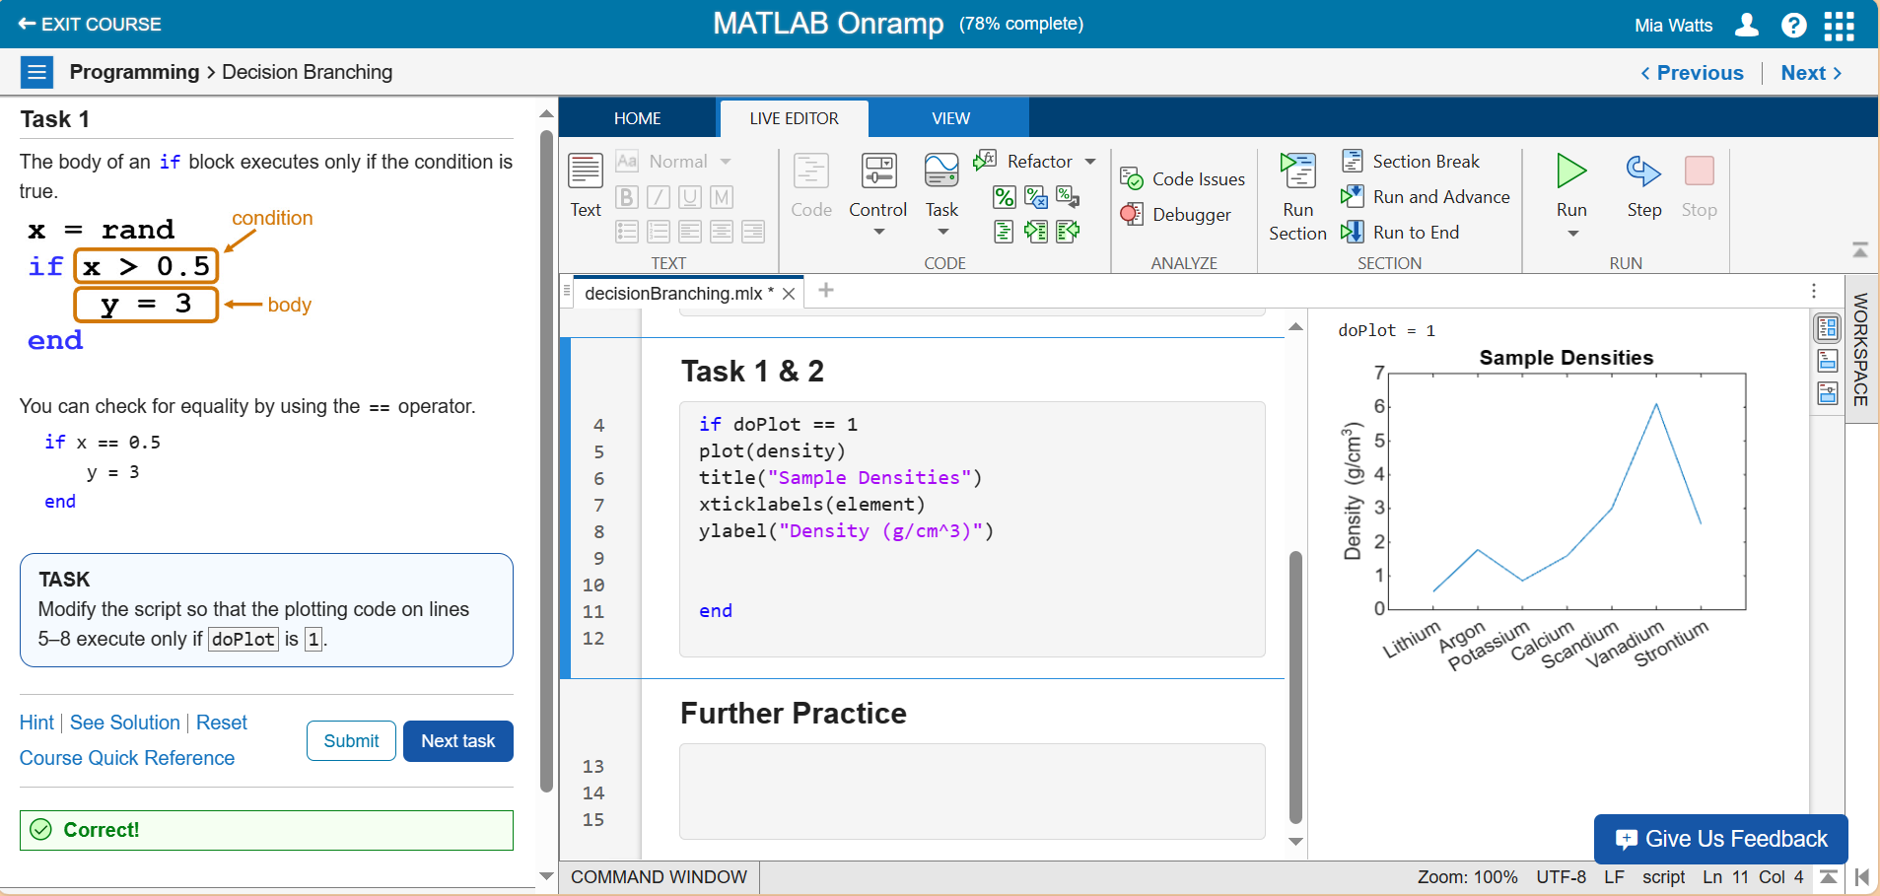

**Task 2 – Practice with Else Statements**

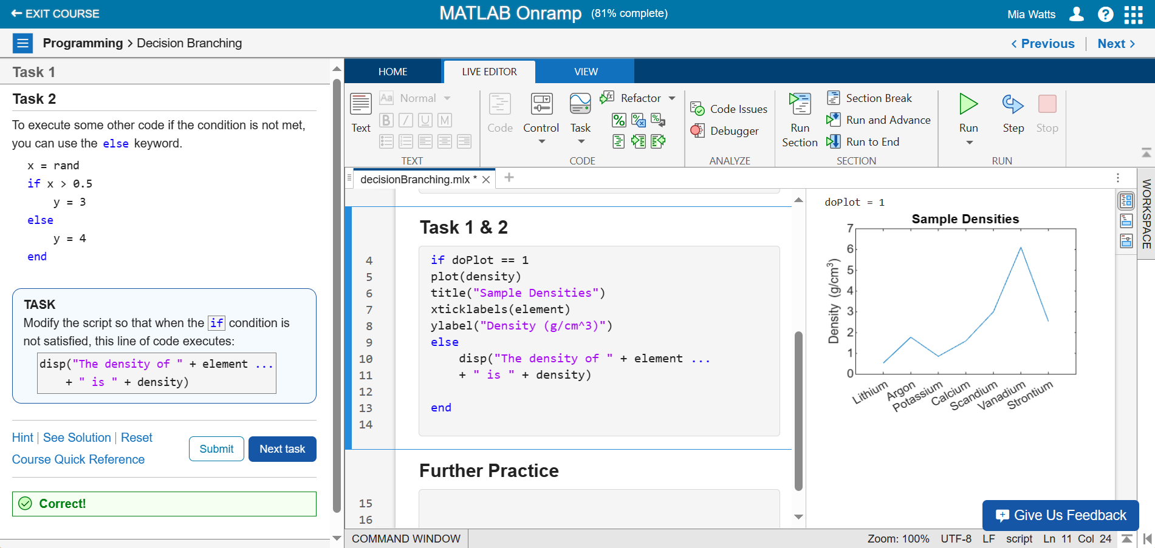

**Further Practice**

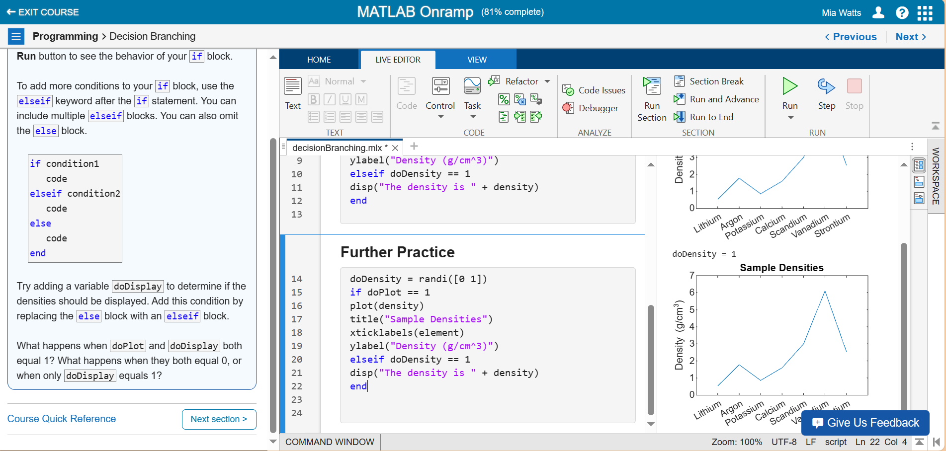

**Section 26**

**Task 1 –**

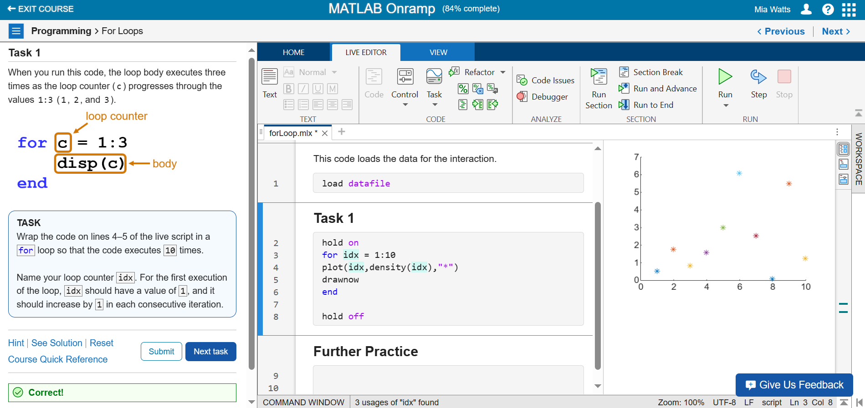

**Further Practice**

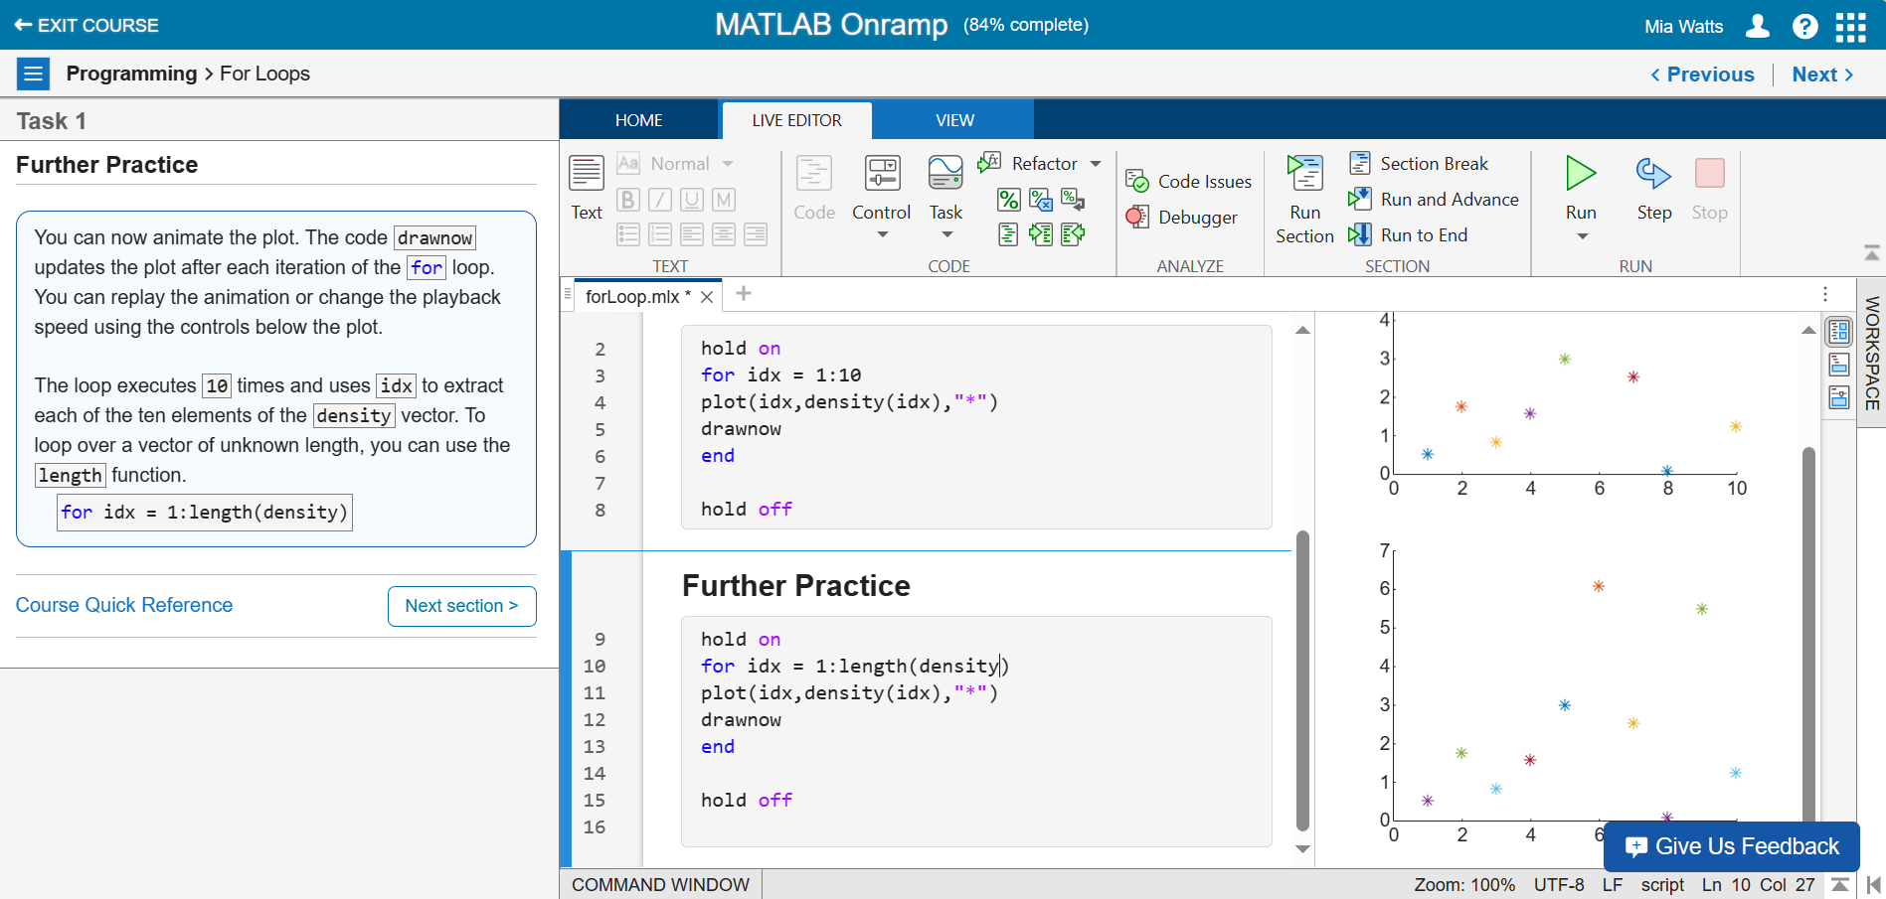

**Section 27**

**Final Project – Stellar Motion**

**Task 1 – Storing a Vector and Calculating Lambda End**

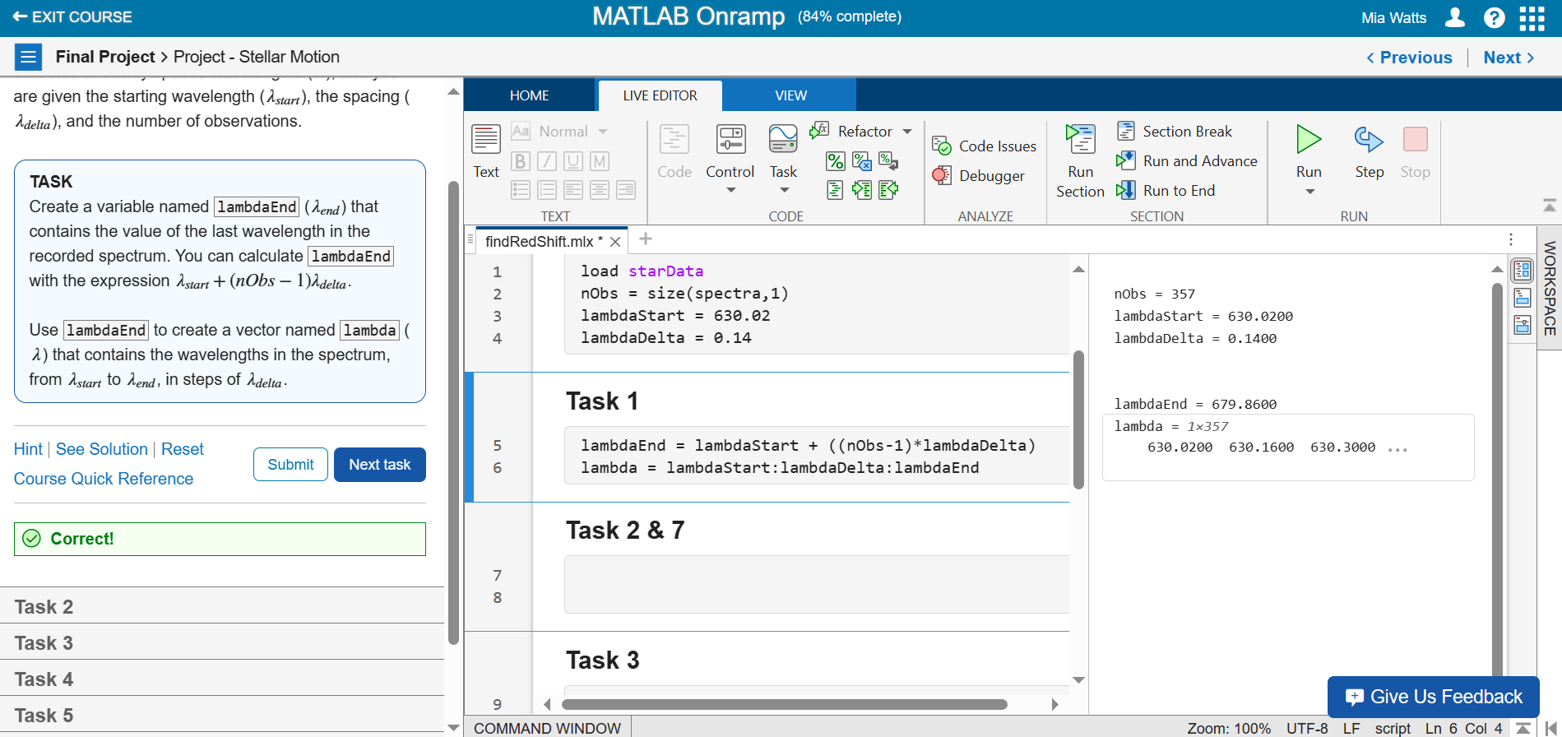

**Task 2 – Extracting the 6th Column**

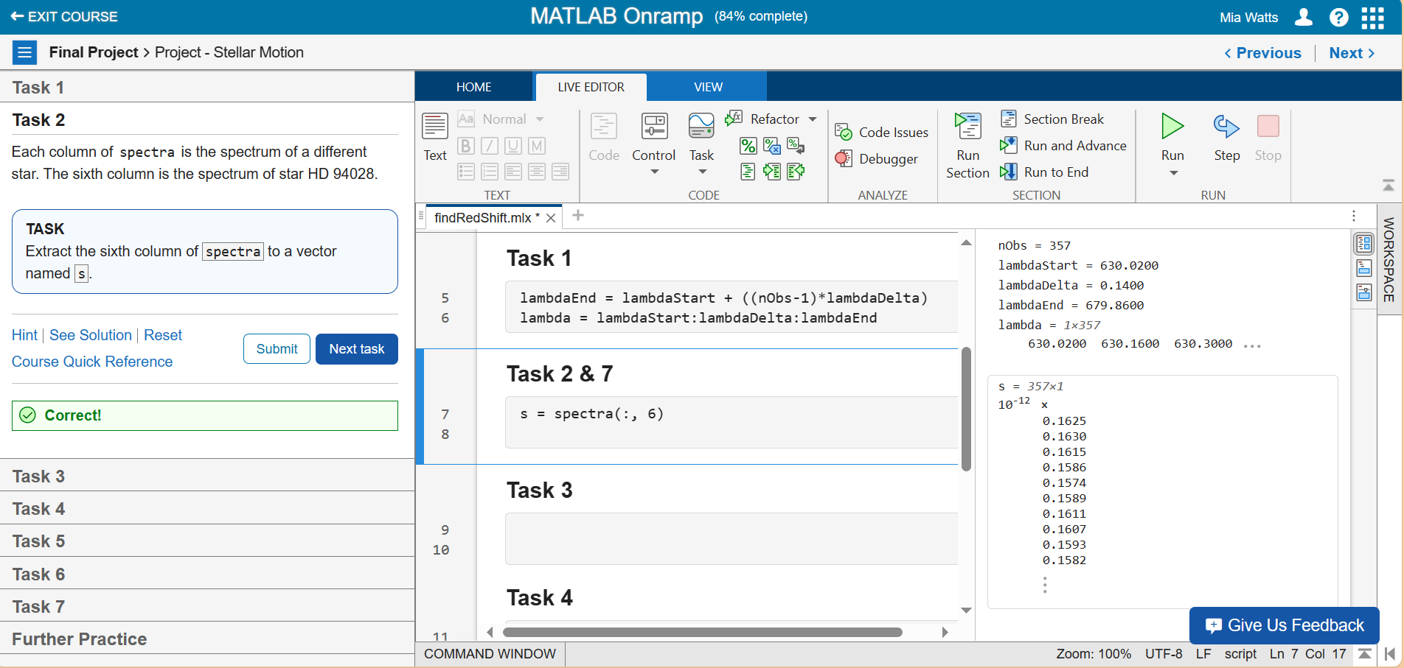

**Task 3 – Plotting the Data**

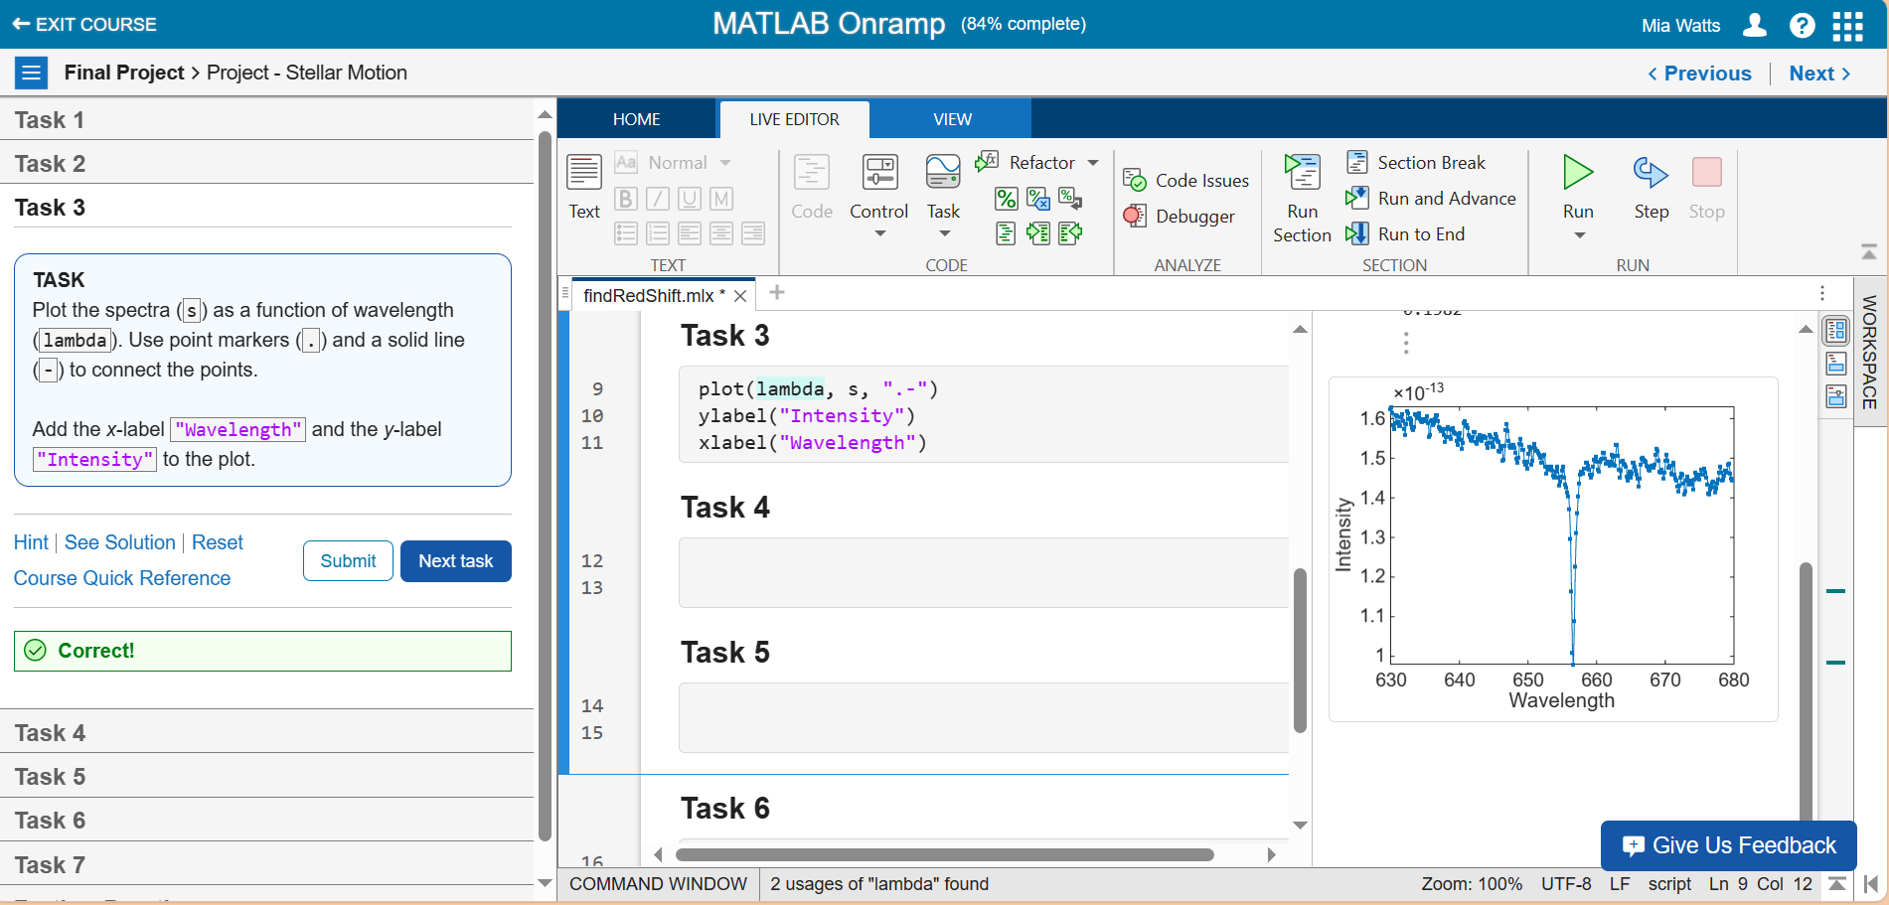

**Task 4 – Finding Minimum Values and Storing Them**

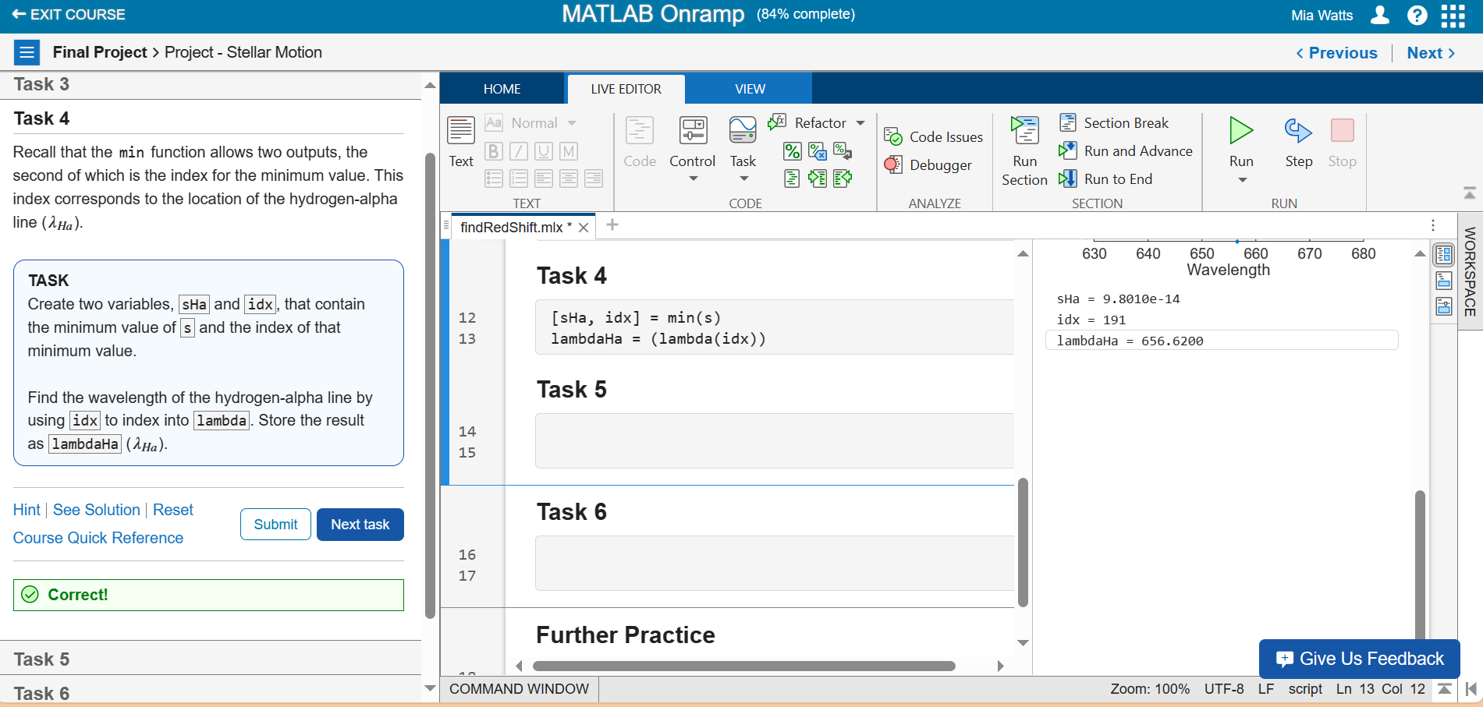

**Task 5 – Plotting a Red Square**

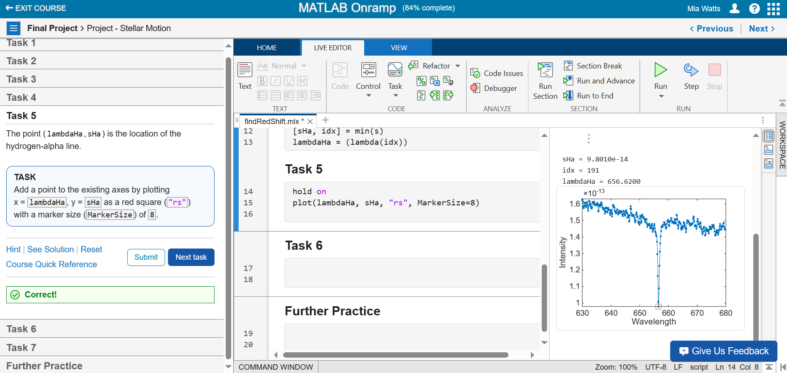

**Task 6 – Calculating Redshift Factor and Speed**

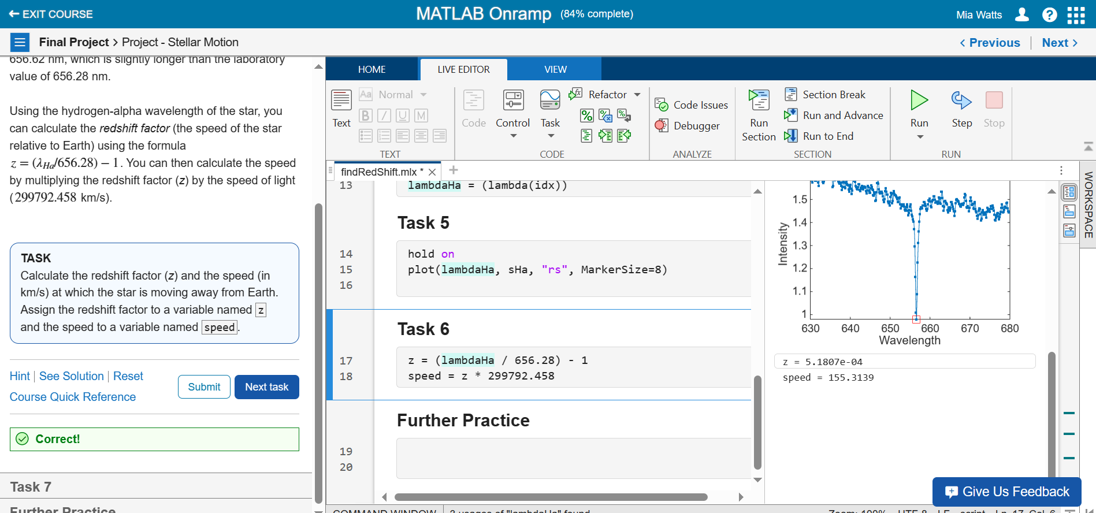

**Task 7 – Calculates Redshift for the Second Star**

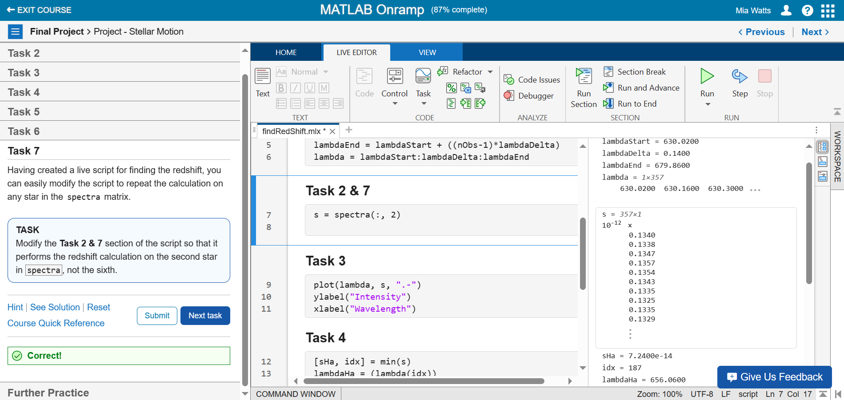

**Further Practice**

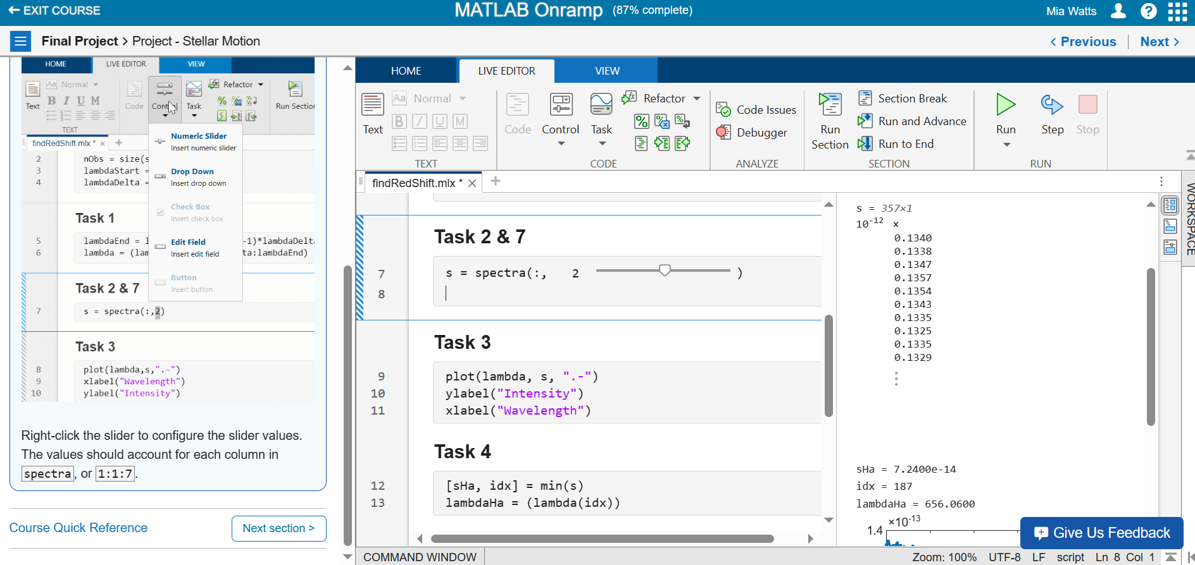

**Final Project – Compare Stellar Spectra**

**Task 1 – Calculating Speeds of All Stars**

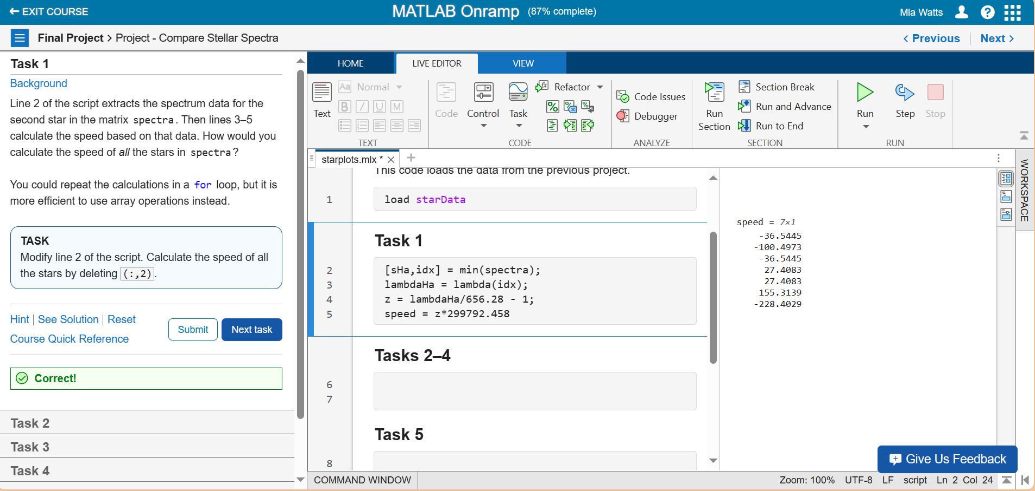

**Task 2 – Creating a For Loop**

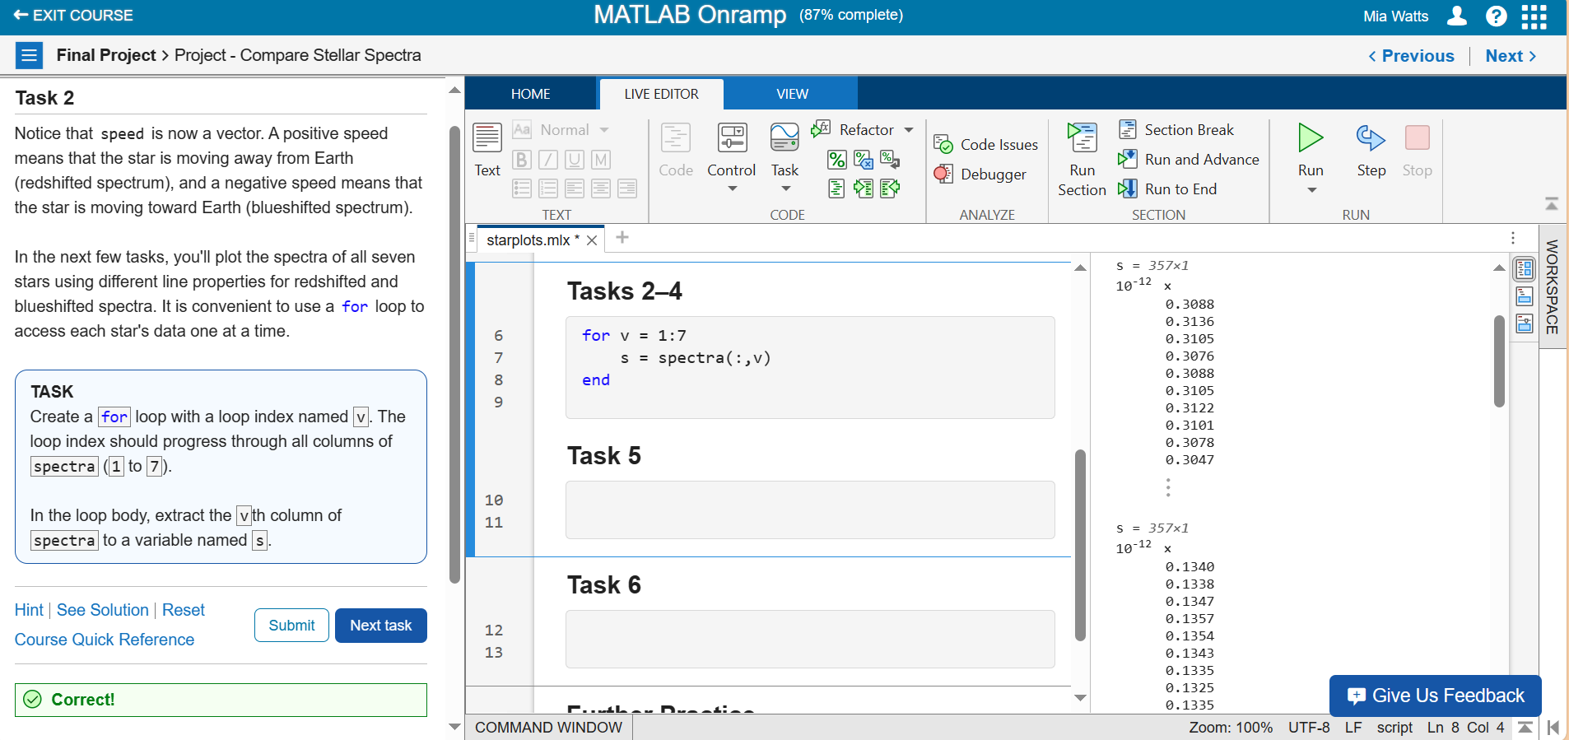

**Task 3 – Adding an If Statement to Plot Under Certain Conditions**

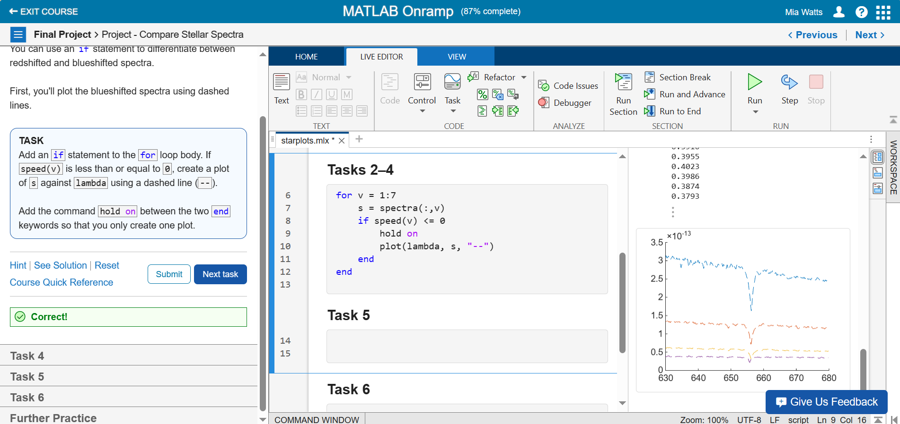

**Task 4 – Added Else Statement**

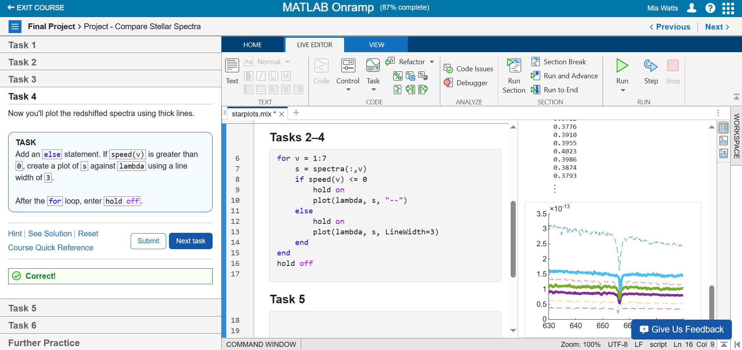

**Task 5 – Added a Legend From an Array**

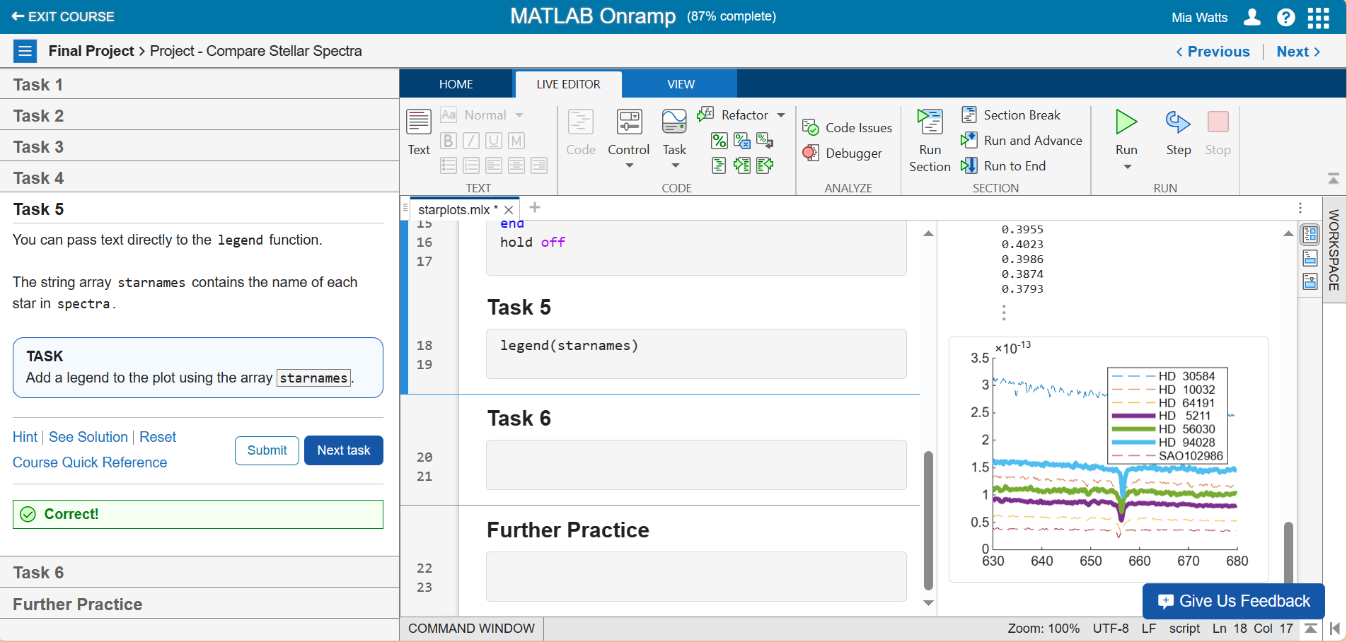

**Task 6 – Storing Values Greater Than 0**

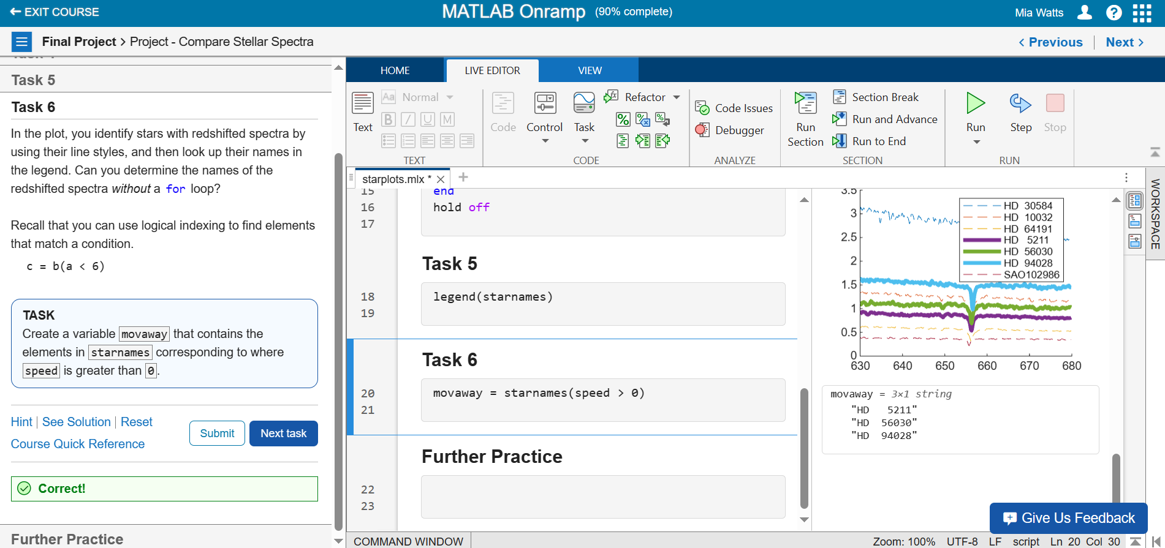

**Further Practice**

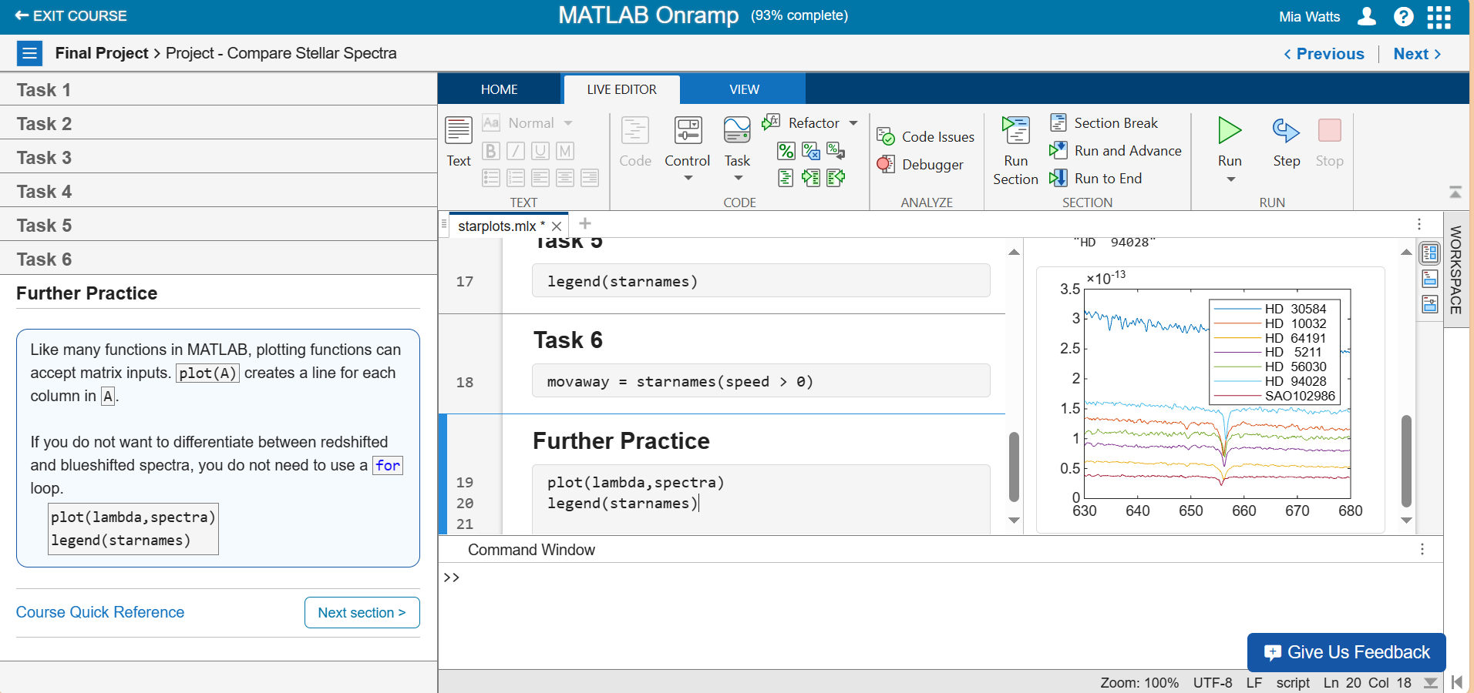

**Proof of Finishing the Course**

